Detail Design Document
Template V0.1
12 August 2026
Project Name: | Participant Kiosk - Detailed Design
Document Owner: | Head of Digital Transformation and Architecture
Contact Details: | Digital Transformation and Architecture
Program Name: | Digital Workplace Transformation
Division/Unit: | Digital
Document Status: | Draft - for review
Document Version: | V1.2
Product ID: | APM-DDD-PK-V1.2

FOR INTERNAL USE ONLY
Commercial in confidence
© APM

Document control
Version History
Version | Date | Author | Key changes
V1.0 | 4/08/2026 | Shaun Struik | Baseline design for the Participant Kiosk solution: device-only identity in the APM corporate tenant, automatic logon with no participant credential, Windows 11 Enterprise, LibreOffice installed locally, device-based licensing, Microsoft 365 access blocked at three layers, restart-based session purge, automated patching through Windows Update for Business and Patch My PC, telemetry to Microsoft Sentinel, device and location based Zscaler enforcement, and every object named to the APM Intune Naming Schema V1.0.
V1.1 | 6/08/2026 | Shaun Struik | Review responses and editorial pass. Thread 1: File Explorer scoped to Downloads, Desktop and removable drives; LibreOffice default save folder moved to Downloads; new section 4.3.1.2; tests T-06/T-09 extended. Thread 2: session account renamed to Kiosk-[SERIAL], created by a signed Intune remediation with a 32-character random credential held only in the Winlogon LSA secret; DR-011 amended, with APM Cyber Security for confirmation; SOE-01 met outright; tests T-01, T-02, T-19 updated. Editorial: duplicated narrative removed; internal contradictions corrected (File Explorer scope in sections 2 and 5, Autopilot group tag example, ephemeral-data claims qualified for downloads); ESP-blocking delivery added for the session account script; review comments carried.

Consultation
Name | Position title | Date

References and Derivation
Version # | Document Title | Reference Location

SDA Approval
Name | Role/Group | Signature | Date

Confidentiality & Disclaimer
This document is provided by Advanced Personnel Management International Pty Ltd and / or its related entities (APM) on a confidential basis. This document is subject to approval of the APM Board and does not constitute an offer capable of acceptance. No agreement binding APM or its related companies in respect of this document is intended or proposed unless and until the terms and conditions between APM or its related entities are agreed in writing in a formal agreement with the named Company or Prospective Client.
APM will not be bound by any pricing or any other material contained in this response until the above has taken place.
Photography
Photographs used in this document are for illustration only
and should not be interpreted to mean that any person or organisation whose assets are shown in them endorses this document.
APM Contact
Communications regarding
this document should be forwarded to:
Head of Digital Transformation & Architecture
P 08 XXXX XXXX
M 08 XXXX XXXX
E samit.chandra@apm.net.au

Contents
1. Introduction 8
1.1 Purpose 8
1.2 Audience 8
2. Overview 10
2.1 Scope 10
2.2 Out of Scope 11
2.3 Guiding Principles 11
2.4 Assumptions 11
3. Business Architecture 13
3.1 Business Context 13
3.2 Business Requirements 13
3.2.1 Participant Kiosk Requirements 13
3.2.2 Participant Kiosk Bookmarks 15
3.2.3 Requirements Traceability 19
3.3 Decision Register 19
4. Application Architecture 27
4.1 Solution Overview 27
4.2 Solution Component Inventory 27
4.3 Intune Configuration Profiles 28
4.3.1 Assigned Access (Multi-App) and Automatic Logon 29
4.3.2 Inactivity Sign-Out and Restart 31
4.3.3 Logon Lockdown and Local Accounts 32
4.3.4 Edge Browser Policies 33
4.3.5 Edge Managed Favourites 34
4.3.6 LibreOffice Deployment and Configuration 35
4.3.7 Profile and Session Purge 37
4.3.8 Corporate Policy and Application Assignment Exclusions 37
4.3.9 Application Control (App Control for Business) 38
4.3.10 Remote support access model 41
4.4 Interface Catalogue 42
5. Technology Architecture 44
5.1 Participant Kiosk 44
5.1.1 Hardware Specification 44
5.1.2 Local Account and Automatic Logon Model 44
5.1.3 Deployment Team - Device Wipe, Prep and Assignment Process 45
5.1.4 Autopilot Self-Deploying Mode 46
5.1.5 Naming Convention 47
5.1.6 End-to-End Device Experience 51
5.2 Image Configuration 52
5.2.1 Image Specification 52
5.2.2 Printing 53
5.2.3 USB Storage 53
5.2.4 Application Delivery and Third-Party Patching 54
5.2.5 Image Lifecycle 56
5.2.6 Desktop Wallpaper and On-Screen Notice 56
5.3 Network and Infrastructure 57
5.3.1 Device Network Configuration 59
5.3.2 DNS Configuration 62
5.3.3 Zscaler Internet Access 62
5.3.4 Zscaler Tenant Configuration (as supplied) 64
5.3.5 Fallback Option 74
5.3.6 Printing Network Considerations 74
5.3.7 Network Responsibilities and Dependencies 75
5.3.8 Network Items Out of Scope 75
6. Information and Data Architecture 76
6.1 Information Model 76
6.2 Information Classification 76
6.3 Session Data Lifecycle 77
6.4 Purge Layers 77
6.5 Why No Data Leaves the Device 78
7. Cyber and Security Architecture 79
7.1 RFFR Overview 79
7.2 Identity and Access Control 79
7.2.1 Licensing Position 79
7.2.2 Entra ID Groups 80
7.2.3 Local Accounts and Windows LAPS 80
7.2.4 Conditional Access 81
7.2.5 Compliance Policy 82
7.2.6 Blocking Microsoft 365 Access from the Device 83
7.2.7 Transport Security 84
7.3 Security Controls Alignment 84
7.3.1 Relationship to the APM Windows SOE Hardening Standard 85
7.3.2 Policies inherited without change 86
7.3.3 Excluded controls and compensating controls 87
7.3.4 Controls the Participant Kiosk Adds Beyond the Standard 88
7.3.5 Alignment Items 89
7.3.6 Edge Hardening at Device Scope (CIS Level 2) 90
7.3.7 ISM Windows 11 Baseline at Device Scope 91
7.4 Web Filtering 91
7.5 Risk Register 92
8. Service Availability and Disaster Recovery 94
8.1 Business Service Tiering 94
8.2 Service Availability 94
8.3 Disaster Recovery and Resilience 94
9. Service Management 96
9.1 Service Management Principles 96
9.2 Monitoring, Logging, Reporting and Alerting 96
9.3 Patching Lifecycle 97
9.4 Decommissioning the Retired Kiosk Components 101
9.5 Implementation Sequence 102
9.5.1 Phase 1 - Foundation 102
9.5.2 Phase 2 - Build 102
9.5.3 Phase 3 - Pilot 102
9.5.4 Phase 4 - Penetration Testing 103
9.5.5 Phase 5 - National Rollout 103
9.5.6 Phase 6 - Decommissioning 103
9.5.7 Phase 7 - Operational Handover 103
9.6 Validation and Test Plan 103
10. Appendix A - Acronyms 106
11. Appendix B - participant-multiapp-launcher.xml 108

1. Introduction

1.1 Purpose
This document provides the detailed technical design for the APM Participant Kiosk solution, part of the APM digital workplace transformation program. It defines the physical device configuration, the device-only identity model, the application set, session hygiene, security architecture and service management model required to deliver a standardised, secure and ephemeral computing environment for participants attending APM sites nationally.
This document is self-contained. It specifies the solution as it will be built and requires no other design document to be read alongside it. Where an existing part of the environment is reused, such as the site network or the estate hardening standard, that reuse is stated in the section that specifies it. Where a component of the kiosk solution in place today is being retired, section 9.4 names the change request that removes it.
The aim of this document is to:
1. Define the technical architecture across all architecture domains (business, application, technology, information, and cyber)
2. Trace business requirements to their detailed technical implementation
3. Specify Intune configuration profiles, Entra ID device groups, application packaging and Conditional Access policies at build-ready depth
4. Document design decisions, assumptions, and open items requiring stakeholder sign-off
5. Outline the implementation sequence, the decommissioning of the retired kiosk components, the service management model and the operational handover plan
This document supports approval to build the Participant Kiosk solution as specified, including key security, usability and operational design decisions.

1.2 Audience
This document is intended for the teams responsible for approving, building, supporting and maintaining the Participant Kiosk solution.
Audience | What they are asked for | Read first
Business Sponsor | Endorse the participant experience and the email-to-case-manager document model | 2, 3.2, 5.2.2
Project Management Office | Accept the implementation sequence, the decommissioning work and the dependencies | 9.4, 9.5
Digital Transformation and Architecture | Approve the architecture and the device-only identity model | 4.1, 5.1, 7.2
Digital Delivery | Build the solution from the configuration specified | 4.3, 5.1, 5.2, 5.3
Digital Operations | Accept the support, monitoring and patching model | 4.3.10, 9.1, 9.2, 9.3
Cyber Security | Review and approve security controls, exceptions and compensating controls. | 7.2, 7.3
End User Computing | Confirm SOE hardening inheritance and device-scope security baselines. | 7.3
Network delivery team (Stratus) | Confirm the Zscaler forwarding and provisioning model for a fleet with no user identity | 5.3.3, 5.3.4

2. Overview
APM delivers Workforce Australia employment services under contract with the Department of Employment and Workplace Relations (DEWR). Participants attending APM sites nationally require access to computing facilities for job search, resume preparation, government service interaction and training. The current device fleet has several problems, including very old hardware, slow internet connections and a lack of manageability.
This document defines the detailed design for the Participant Kiosk solution. It replaces the existing shared device model with a standardised Dell Windows 11 Enterprise kiosk using multi-app Assigned Access, automatic sign-in, Intune management and Entra ID device identity only.
Sessions are ephemeral: inactivity or restart ends the session and removes participant data. Participants retain documents using their own USB media or personal webmail to their case manager.
This document covers the physical Participant Kiosk only. The Standard User SOE, Developer SOE, Privileged Access and ES take-home device use cases are addressed in separate design documents.

2.1 Scope
• Physical Participant Kiosk provisioning and configuration (Dell hardware, Windows 11 Enterprise)
• Windows Autopilot self-deploying enrolment into the existing APM corporate tenant, creating a device object only
• A named local session account (Kiosk-[SERIAL]) created on-device by a signed remediation and signed in automatically, with no participant credential and no sign-in step
• Multi-app Assigned Access restricted user experience (Microsoft Edge, LibreOffice, File Explorer scoped to Downloads, Desktop and removable drives, Zscaler tray, TeamViewer)
• LibreOffice Fresh deployed as an Intune Win32 application, configuration locked by policy, patched by Patch My PC
• Microsoft Edge hardening, managed favourites, and PDF viewing in Edge
• Device-based licensing: Microsoft Intune device licence, Windows 11 Enterprise E5, Microsoft Defender for Endpoint P2
• Conditional Access, browser and web-filtering controls that prevent any Microsoft 365 sign-in from a Participant Kiosk
• Session hygiene: ten-minute inactivity sign-out and restart, and a full purge of participant data on every restart
• USB storage access for participants to carry documents to and from the device
• Zscaler web filtering and logging
• APM Windows SOE Hardening Standard inheritance, Edge CIS Level 2 hardening, and the ISM Windows 11 baseline applied at device scope
• Security and RFFR compliance alignment
• Managed bookmark deployment across job search, government, support, training and transport categories
• Decommissioning of the cloud components of the retired kiosk solution, raised as a separate change request

2.2 Out of Scope
• Standard User SOE, Developer SOE, Privileged Access and ES take-home device designs (separate documents)
• Network infrastructure and site cabling
• Printing from Participant Kiosks, including printer hardware procurement and physical placement (participants email required documents to their case manager for printing)
• Any Microsoft 365 service access from a Participant Kiosk
• End-user training material and laminated instruction sheets (operational deliverable)
• RFFR formal accreditation audit (this document supports but does not constitute the ISMS)
• The Zscaler provisioning model for a fleet with no user identity, which is confirmed in a workshop with Zscaler once a validated device exists (DR-013) and folded into this design at the next revision

2.3 Guiding Principles
ID | Principle
Zero Trust | The device is the only identity. It is Entra-joined, Intune-managed and continuously assessed against a compliance policy. No corporate identity can authenticate from it: Conditional Access blocks every APM account on Participant Kiosk hardware.
Ephemeral by Default | No participant data persists beyond the session. Edge browsing data never reaches the disk, downloads live only inside the profile, and the profile is purged on every restart.
Least Privilege | The participant runs as a standard local account with Edge, LibreOffice and File Explorer scoped to Downloads, Desktop and removable drives. No settings, command prompt, task manager, installation or cloud sign-in.
Simplicity | The end-user experience is frictionless. The device powers on directly into the participant session. There is no username, no password and no credential displayed anywhere.
Compliance | The architecture meets RFFR requirements for the handling of participant personal information, aligning with ISO 27001 and the ASD ISM, and inherits the APM Windows SOE Hardening Standard V3.0.

2.4 Assumptions
Ref | Assumption | Impact If Incorrect
A-01 | Dell hardware is procured with TPM 2.0 and supports Autopilot self-deploying enrolment | Hardware must be re-specified; deployment model changes
A-02 | Hardware hashes are registered in Autopilot at the point of procurement | Manual hash registration required per device on-site
A-03 | Zscaler web filtering is applied at the network layer (existing APM standard) | Device-level web filtering must be designed into the image
A-04 | Device-based licences are available for 540 devices: Windows 11 Enterprise E5, Microsoft Intune device licence, and the Defender for Endpoint P2 entitlement | Licensing must be procured through SoftwareOne before deployment; without an Intune device licence Autopilot self-deploying enrolment fails
A-05 | Participant Kiosks enrol into the existing APM corporate tenant. No new tenant, subscription, domain or DNS namespace is required | A separate identity plane returns, with the operational overhead that carries
A-06 | Participants have an active personal email address for document retrieval; where they do not, the case manager assists | Alternative document handoff method required (USB only)
A-07 | RFFR compliance is managed under APM’s existing ISMS with APM Cyber Security | These are listed in a separate accompanying spreadsheet.  Participant Kiosk RFFR SoA based on ISM September 2025 v7.7m.xlsx
A-08 | Patch My PC Publisher (Server edition) is licensed and integrated with Intune for third-party application patching | LibreOffice updates must be repackaged and published manually each release, against the ISM patching window
A-09 | The APM code-signing certificate is issued in time to sign the App Control policy and the device-side scripts (SOE-02) | App Control cannot be deployed in signed mode and the PowerShell signed-scripts-only execution policy blocks the session scripts
A-10 | Corporate Intune configuration profiles, application assignments and Conditional Access policies that target All Devices or All Users can be scoped to exclude the Participant Kiosk group | Corporate policy and application assignments land on a public-area device, contradicting this design
A-11 | The APM-KIOSK VLAN, hidden SSID and Meraki template remain as approved under DR-003 and DR-005 | Site network re-work is required before rollout

3. Business Architecture

3.1 Business Context
The Participant Kiosk solution is a response to three target business outcomes: consistent data privacy across all sites, standardised device management at scale, and compliance with RFFR accreditation requirements under the Workforce Australia Service Deed.
Two business changes follow. Participants do not sign in, which removes the operational burden of credentials on a public device and the risk of a participant using someone else’s session. Documents are now created in LibreOffice on the device rather than in a browser-based Office suite, which removes the need for the participant to hold any Microsoft identity and keeps every document under the participant’s own control on their own media.

3.2 Business Requirements
The following requirements are drawn from the Unified SOE Requirements V2 and the Participant Kiosk High-Level Design. Each requirement is expressed as a user story with acceptance criteria and priority (Must/Should/Could), and each is met by a named section of this document (3.2.3).

3.2.1 Participant Kiosk Requirements
ID | Category | User Story | Acceptance Criteria | Priority
01 | User Access | As a participant, I want to log in as a guest so I can quickly access the device without needing an account. | The device signs itself in. It powers on directly into the participant session, with no account, no password and no credential displayed anywhere (4.3.1, 5.1.2). | Must
02 | Accessibility | As a participant, I want Windows accessibility features so I can use the device independently | All shortcuts function; features discoverable via Settings/help. Narrator, high contrast, font scaling, speech-to-text, onscreen keyboard  Desktop shortcuts will be available for accessibility tools where technically feasible | Must
03 |  | As a participant with visual or language needs, I want magnifier and browser translation tools so I can comfortably use the device. | Magnifier shortcut works. Edge translation/Read Aloud available.  Desktop shortcuts will be available for accessibility tools where technically feasible | Must
04 | Session Management | As a participant, I want my session wiped whenever the session ends so no one can access my personal data. | The device wipes the profile and all locally stored data on every restart, and every session ends in a restart: after the inactivity timeout, or when the device is restarted manually (6.4) | Must
05 |  | As a participant, I want the system to automatically log me out after inactivity, so my session is not left open. | Inactivity timeout (10 minutes) ends the session and restarts the device, which comes back up in a clean participant session.  Note: if the proposed 10 minutes is longer than the existing SOE timeout, apply the SOE timeout. | Must
06 | Device Maintenance | As a participant, I want forced restarts for system updates to occur only outside business hours, so my work is not interrupted. | System applies updates during an overnight maintenance window. Forced restarts do not occur while a participant is actively using the device. If the overnight restart is missed, the restart occurs on next boot before login. As participant sessions are non-persistent, users must save required documents to USB or personal email before ending their session. | Must
07 | Applications | As a participant, I want a modern browser so I can perform job searches and access online services. | Edge installed  Default homepage set | Must
08 |  | As a participant, I want office applications so I can create resumes and documents. | LibreOffice Writer, Calc and Impress are installed on the device and read and write the Microsoft Word, Excel and PowerPoint formats. Microsoft Office itself is not provided; the assessment is recorded in DR-008. | Must
09 |  | As a participant, I want a PDF reader so I can view job ads, forms, and resumes. | PDFs open in the Microsoft Edge viewer. No additional PDF application is installed (DR-004). | Must
10 |  | As a participant, I do NOT want Teams/Zoom installed because video interviews will not be conducted on these devices. | Teams/Zoom excluded.  No webcam or drivers required. | Could
11 | Web Filtering | As a participant, I want inappropriate sites blocked so I don’t accidentally access harmful content. | Block adult, gambling, explicit, violence, and illegal-content categories.  As per APM standard | Must
12 |  | As a participant, I want required job search websites whitelisted, so they don’t get incorrectly blocked. | Refer to Edge Managed Favourites (section 4.3.5) for the whitelisted sites | Must
13 |  | As a participant, I want Facebook allowed so I can access community job boards. | Facebook allowed  TikTok, Instagram, X blocked by default. | Must
14 |  | As a participant, I want access to public AI tools to help with resumes/interview prep. | Public AI tools allowed unless high risk. Blocked only if categorised unsafe. | Must
15 | USB Storage | As a participant, I want to use a USB drive so I can load or save my resume. | USB mass storage enabled; device mounts successfully; no additional scanning required beyond existing security layers. | Must
16 | Printing | As a participant, I want access to a printer so I can print my resume or documents. | No direct printing from Participant Kiosks is provided. Documents must be sent by email to the participant’s case manager via webmail for printing. This operating model was approved by the APM Business Owner. | Must
17 |  | As IT, I want print jobs limited to a small number of pages, so costs and misuse are controlled. | No direct printing from Participant Kiosks is required. Documents must be emailed to the user’s case manager via webmail for printing. This operating model was approved by the APM Business Owner.  Note: This optional requirement is retained only to assess whether a technical solution exists to implement print job limits. | Could
18 |  | As a participant, I want to print in black and white and collect the printout from staff, so the process remains simple and low-cost. | No direct printing from Participant Kiosks is provided. Users must email required documents to their case manager via webmail for printing. This operating model was approved by the APM Business Owner.  Printing is completed by the case manager as an operational process. | Must
19 | Security & Compliance | As IT, I want existing web logging levels maintained so incidents can be reviewed without increasing costs. | Zscaler/Proxy logs retained per current policy.  No new log depth introduced. | Must
20 |  | As IT, I want devices isolated from the corporate network, so they don’t pose security risks. | Devices use the re-purposed APM-KIOSK VLAN with connectivity restricted to approved Azure, Microsoft, and APM-managed service dependencies only. No general access to corporate systems, internal business applications, or personal device connectivity is permitted. | Must

3.2.2 Participant Kiosk Bookmarks
Link Name | URL | Comments
Workforce Australia Online for Individuals
Video - Your Workforce Australia Homepage | https://www.youtube.com/watch?v=AFnNpzrBGbg
Video - Link Workforce Australia account in myGov | https://youtu.be/lVLdwUecxhc?si=cs11EOO2N-rgPk75
Video - How to create your profile on Workforce Australia Online for Individuals | https://www.youtube.com/watch?v=Ac04__5k2xk&pp=0gcJCcUKAYcqIYzv
Compliance Framework | https://www.workforceaustralia.gov.au/individuals/obligations/learn/dont-meet-your-obligations/compliance-demerits
Contact Us | https://www.workforceaustralia.gov.au/individuals/contact-us/
How to submit multiple Job Search efforts | https://youtu.be/xSyU4Y8B1I4?si=gemhL8Odn4FTQt0Y
Your Workforce Australia Job Plan explained | https://www.youtube.com/watch?v=1YTeDgjivcw
Video - Your Points Target Explained (for Workforce Australia Services only) | https://www.youtube.com/watch?v=kzK5JBN8eUw
Video - Earning and reporting points (for Workforce Australia Services only) | https://www.youtube.com/watch?v=PErET8hpo-I
Video - How to gain points for study and training (only for Workforce Australia Services) | https://www.youtube.com/watch?v=rXjUN_xW7t4&pp=0gcJCcUKAYcqIYzv
Video - How to gain points for paid work (only for Workforce Australia Services) | https://www.youtube.com/watch?v=OwsyN6Tsqsw
Centrelink/Services Australia Website
Centrelink Medical Certificate form (SU415) | https://www.servicesaustralia.gov.au/su415
Verification of medical conditions form (SU684) | https://www.servicesaustralia.gov.au/su684
Centrelink online account help - Report employment income | https://www.servicesaustralia.gov.au/centrelink-online-account-help-report-employment-income#:~:text=a%20mobile%20device.-,Step%201:%20get%20started,information%2C%20go%20to%20Step%203.
Job Search and Job Application Resources
Resume Templates (various themes and designs) | https://create.microsoft.com/en-us/templates/resumes
Cover Letter Templates (various themes and designs) | https://create.microsoft.com/en-us/templates/cover-letters
Improve Your Job Search | https://www.workforceaustralia.gov.au/individuals/coaching/job-search
Seek.com (for Job Search) | https://www.seek.com.au/
Jora (for Job Search) | https://au.jora.com/
Indeed (for Job Search) | https://au.indeed.com/
Gumtree (for Job Search) | https://www.gumtree.com.au/
Ethical Jobs (for Job Search) | https://www.ethicaljobs.com.au/
APS Jobs (for Job Search) | https://www.apsjobs.gov.au/s/
Facebook (for Job Search) | https://www.facebook.com/
Workforce Australia Online for Individuals - Job Search | https://www.workforceaustralia.gov.au/individuals/jobs/search
National Police Check Australia | https://cvcheck.com/national-police-check/
Essential Support Services
Ask Izzy | https://askizzy.org.au/
Beyond Blue | https://www.beyondblue.org.au/
Headspace | https://headspace.org.au/
Drug Foundation Help and Support | https://adf.org.au/resources/druginfo/
Financial Counselling | Financial counselling - Moneysmart.gov.au
Other Services
Fair Work - Home Page | https://www.fairwork.gov.au/
Fair Work - Pay and Conditions Tool | https://calculate.fairwork.gov.au/
Volunteering Australia | https://govolunteer.com.au/
Transport Canberra | https://www.transport.act.gov.au/ | ACT
Transport for NSW | https://www.transport.nsw.gov.au/ | NSW
Department of Transport NT | https://nt.gov.au/driving | NT
Department of Transport and Main Roads - QLD | https://www.tmr.qld.gov.au/ | QLD
Department of Infrastructure and Transport - SA | https://www.dit.sa.gov.au/ | SA
Department of Transport and Planning - VIC | https://www.vic.gov.au/department-transport-and-planning | VIC
Department of Transport WA | https://www.transport.wa.gov.au/ | WA
Transport Services - TAS | https://www.transport.tas.gov.au/ | TAS
Training
Duke | https://duke.co/
MCI | https://www.mciinstitute.edu.au/
Alffie | https://www.alffie.com/
TAFE QLD | https://tafeqld.edu.au/ | QLD
TAFE ACT | https://www.tafecourses.com.au/courses/act/ | ACT
TAFE NSW | https://www.tafensw.edu.au/ | NSW
TAFE VIC | https://www.vic.gov.au/tafe | VIC
TAFE WA | https://www.tafe.wa.edu.au/ | WA
TAFE NT | https://www.tafecourses.com.au/courses/northern-territory/ | NT
TAFE SA | https://www.tafesa.edu.au/ | SA
TAFE TAS | https://www.tastafe.tas.edu.au/ | TAS

3.2.3 Requirements Traceability
Every requirement above is met by a named section of this document.
ID | Requirement | Met by
01 | Access the device without an account | 4.3.1 Assigned Access and automatic logon; 5.1.2 local account model
02, 03 | Accessibility features and tools | 5.2.1 image specification; 4.3.1 allowed applications
04 | Session wiped when the session ends | 6.3 session data lifecycle; 6.4 purge layers
05 | Automatic sign-out after inactivity | 4.3.2 inactivity sign-out and restart
06 | Forced restarts outside business hours | 9.3 patching lifecycle
07 | Modern browser | 4.3.4 Edge policies; 4.3.5 managed favourites
08 | Office productivity applications | 4.3.6 LibreOffice deployment and configuration
09 | PDF reader | 4.3.4 Edge policies (PDF viewer); DR-004
10 | No Teams or Zoom | 4.3.1 allowed applications; 4.3.8 application control
11, 13, 14 | Web category filtering, Facebook allowed, AI tools allowed | 7.4 web filtering; 5.3.4.3.5 Zscaler URL filtering
12 | Required job search sites permitted | 4.3.5 managed favourites; 7.4 web filtering
15 | USB storage | 5.2.3 USB storage exception policies; 7.3.3 excluded controls and compensating controls
16, 17, 18 | Printing by email to the case manager | 5.2.2 printing; DR-001
19 | Existing web logging levels maintained | 5.3.3.3 monitoring and logging; 9.2 monitoring
20 | Devices isolated from the corporate network | 5.3.1 network configuration; 7.2.4 Conditional Access; 7.2.6 blocking corporate service access

3.3 Decision Register
The following design decisions have been raised during the requirements and design process. Items marked Pending require formal sign-off before build. Identifiers are never re-sequenced, so the numbering is not contiguous; each row records the decision, the options assessed, the stakeholder position and where the decision is specified.
ID | Decision | Status | Resolution | Stakeholder Comments | Design Treatment
DR-001 | Printing approach | Agreed | No direct printing from Participant Kiosks. Participants email required documents to their case manager for printing via webmail. Approved by the APM Business Owner. | APM Digital lead: "Not ideal. Need to drill into this further. Thought RFFR requires printers isolated from non-staff access." | Email-to-case-manager is the agreed model. No direct device-to-printer workflow. See 5.2.2.
DR-002 | Bookmark consolidation | Agreed | Combine bookmarks into a single list with clear folders. | APM Digital lead: "As long as folders are clearly visible." | Implemented. Unified bookmark set with categorised folders, 4.3.5.
DR-003 | Wi-Fi VLAN | Agreed | Re-use the existing VLAN, single subnet per site via the Meraki template, hidden SSID with a pre-shared key EAP-TLS authentication through device certificates deployed through Intune. | Approved by APM Infrastructure lead.  Discussed with Raj, Nick, Vijay and should work but needs to be tested. | The APM-KIOSK network is reserved for Participant Kiosks only. See 5.3.1.
DR-004 | PDF viewer | Agreed | PDFs are viewed in Microsoft Edge. | No other applications are being installed for this purpose. | Edge is the registered PDF handler, 4.3.4.
DR-005 | SSID naming | Approved - APM Infrastructure lead | APM-KIOSK, hidden, pre-shared key deployed via Intune. | Hidden SSID and pre-shared key. | Retained as approved. See DR-015 on naming.
DR-006 | Available IP addresses | Agreed | 135 addresses required in total; a /26 per site from the supernet. | 253 usable per site subnet. | Up to five devices per site, 540 devices in total. See 5.3.1.1.
DR-007 | Identity model for the fleet | Approved - APM Cyber Security, APM Digital lead | No user identity. The participant session runs as a local account created and managed by Assigned Access, on a device that is Entra-joined and Intune-managed. Options assessed: (a) one Entra ID account per device with a passphrase published on the device lock screen, rejected because it requires a dedicated tenant, a licence per device, a credential pipeline to generate and rotate the passphrase, and a published credential to protect nothing; (b) one shared Entra ID account for the fleet, rejected because a single credential across 540 public devices cannot be bound to hardware or revoked without a fleet outage; (c) a local automatic-logon account, selected. | APM Cyber Security confirmed that a password is not required on this fleet and that automatic logon is acceptable given the device holds no corporate data and can reach no corporate service. | Specified in 5.1.2 and 7.2.3. The credential pipeline that exists today is retired under 9.4.
DR-008 | Productivity suite | Approved - APM Digital lead | LibreOffice Fresh, installed locally. Options assessed: (a) Microsoft 365 Office for the web, rejected because it requires a licensed identity for every participant and writes every document to a cloud store; (b) Microsoft 365 Apps installed locally, rejected on the same licensing basis; (c) LibreOffice installed locally, selected: no identity, no cloud store, no licence, and it reads and writes the Microsoft file formats participants receive and send. | A locally installed suite was the business preference once cloud identity was removed from the model. | Specified in 4.3.6, with the configuration locked by policy and patched by Patch My PC (5.2.4).
DR-009 | Licensing model | Approved - APM Digital lead | Device-based licensing only: Microsoft Intune device licence, Windows 11 Enterprise E5 and the Defender for Endpoint P2 entitlement. No Microsoft 365 user licences. | Confirmed with the licensing reseller (SoftwareOne) as the model for a fleet with no user accounts. | Component inventory 4.2 and licensing position 7.2.1.
DR-010 | Microsoft 365 access from the device | Approved - APM Cyber Security | Block outright. There is no business need for a participant to sign in to any APM or Microsoft 365 service from a Participant Kiosk. | APM Cyber Security position: if the device needs no corporate service, it should be unable to reach one. | Three layers specified in 7.2.6: a Conditional Access device-filter block, an Edge URL blocklist, and Zscaler URL filtering. Personal webmail remains available.
DR-011 | Session credential | Approved with amendment - APM Cyber Security confirmation required | No password known to any person. The session account Kiosk-[SERIAL] is created on the device by a signed remediation with a 32-character random password generated in memory, held only in the Winlogon LSA secret for automatic logon, and never displayed. Options assessed: (a) Assigned Access AutoLogonAccount, where Windows creates and credentials an account itself - the strongest credential story, rejected because the account name is not configurable and APM Security Operations require the endpoint to be identifiable by account name (review thread with Zscaler); (b) a named account with a blank password restricted to console logon, rejected because it conflicts with the 14-character minimum in the SOE hardening standard and anyone at the logon screen could use it; (c) a named account with a device-generated random credential in the LSA secret, selected. | APM Cyber Security approved automatic logon with no password. The amendment - an account named from the serial with the credential in the LSA secret rather than Windows-managed - is with Cyber for confirmation, because the LSA secret is extractable with local administrator rights (LAPS-gated and audited). | 4.3.1 and 5.1.2. Scripts: Detect/Remediate-KioskSessionAccount.ps1 in config/, signed under SOE-02.
DR-012 | Remote-support account credentials | Approved - APM Cyber Security | Windows LAPS with Entra ID backup manages the local support account password per device. Options assessed: (a) Azure Key Vault with an Automation rotation runbook, rejected because it requires cloud infrastructure that nothing else in this design needs; (b) a shared support password, rejected outright; (c) Windows LAPS, selected: native, licensed, rotated automatically and audited on each retrieval. | Aligns the fleet with the estate approach to local administrator credentials. | Specified in 7.2.3.
DR-013 | Zscaler enforcement model without user identity | Model approved - APM Cyber Security; mechanism open | Enforcement is device and location based. There are no users on this fleet, so the Entra user group, the SAML enterprise application, SCIM provisioning and the identity provider in the supplied configuration are not created, and the app profile and URL filtering rules bind to the device group and the site location instead. Two mechanisms remain to choose between, both device based: (a) location-based forwarding over the site IPSEC tunnel with policy by location, requiring nothing on the device, the working assumption; (b) Zscaler Client Connector in machine-tunnel mode with device posture. A workshop with Zscaler confirms which, once a validated device exists. | APM confirmed there is no user identity, no password and no user group on this fleet, and that all Zscaler binding must therefore be device based. apmkiosk.net.au is not required by this design. | 5.3.3 and 5.3.4. The supplied configuration is reproduced verbatim as the agreed baseline, with a per-sub-section applicability table at the head of 5.3.4 stating what applies, what binds to the device group or location, and what is not created at all.
DR-014 | Operating system edition | Approved - APM Digital lead | Windows 11 Enterprise on the standard servicing channel, replacing Windows 11 IoT Enterprise LTSC. | Aligns the fleet with the rest of the Windows 11 estate and with the SOE hardening standard as written. | 5.1.1 and 5.2.1. Update rings and feature-version pinning in 9.3.
DR-015 | Naming of network objects after the fleet rename | Agreed | The fleet, its device names, groups and Intune profiles are renamed to Participant Kiosk. The APM-KIOSK VLAN and SSID keep the names approved under DR-001 and DR-005. | Renaming an approved, deployed network object would require site-by-site network change for no functional gain. | Naming convention in 5.1.5; the network object names are unchanged throughout 5.3.
DR-016 | Decommissioning of the retired kiosk components | Agreed | Every component of the kiosk solution in place today that this design does not use is removed under change control, not left dormant. Components that another use case needs are retained and handed over rather than deleted. | Requested by APM Cyber Security: dormant identities, policies and public endpoints are an unowned attack surface. | Raised as a separate change request, referenced in 9.4 and sequenced after the pilot is validated.
DR-017 | Signed versus unsigned App Control policy for the enforced fleet policy | Approved - APM Cyber Security | Sign the enforced policy and deploy it through the ApplicationControl CSP. Options assessed: (a) unsigned policy on the built-in Intune profile, simple and removable by deleting the profile, rejected for the enforced fleet because a removable policy is weakest exactly where this fleet lives, in a public area; (b) signed policy through the ApplicationControl CSP, selected, with the trade that removal requires a policy update signed by the same certificate; (c) signed policy with no rollback artefact, rejected outright. | The recovery question raised in review: what happens if the signed policy is wrong on 540 devices. | 4.3.9 specifies the delivery mechanism for each policy. 8.3 carries the rollback: a pre-signed audit-mode replacement policy held in escrow with the certificate, tested under T-21. The audit policy stays on the built-in profile.
DR-018 | Automating the device rename from the Entra location groups | Approved - APM Digital lead | A scheduled Azure Automation runbook running the rename script every 15 minutes under a system-assigned managed identity. Options assessed: (a) one Autopilot deployment profile per site carrying the Loc# in its device-name template, which needs no job at all, rejected because Intune caps Autopilot profiles at 350 per tenant against roughly 750 sites; (b) Graph change notifications on group membership, rejected because it needs one subscription per group with renewal automation and a public HTTPS listener, the same endpoint class 9.4 decommissions; (c) an operator-run script only, rejected because the Loc# would appear only when someone remembered to run it; (d) scheduled polling under a managed identity, selected. | Requirement from APM: a device must show its Loc# wherever it appears, so it can be located from Entra ID, Intune or Defender without a spreadsheet. | 5.1.5.2. This re-adds one Azure resource to a design that removed them all, and the distinction is deliberate: it holds no secret, has no inbound endpoint, and is not in the sign-in or policy path. If it stops, devices keep working under their PD-[SERIAL] names.

4. Application Architecture

4.1 Solution Overview
The Participant Kiosk solution is a single tier: a physical device running Windows 11 Enterprise as a locked-down multi-app Assigned Access endpoint. The device is Entra-joined and Intune-managed, and Entra ID holds a device object for it and nothing else. Every application the participant uses runs locally on the device: Microsoft Edge for browsing, personal webmail and PDF viewing, and LibreOffice for documents. No application depends on a signed-in identity, and no application stores data anywhere but the local profile, which is destroyed at the end of every session, or the participant’s own USB media.
Figure 1 shows the solution in context: what the device is managed by, what it is permitted to reach, and what it is explicitly prevented from reaching.
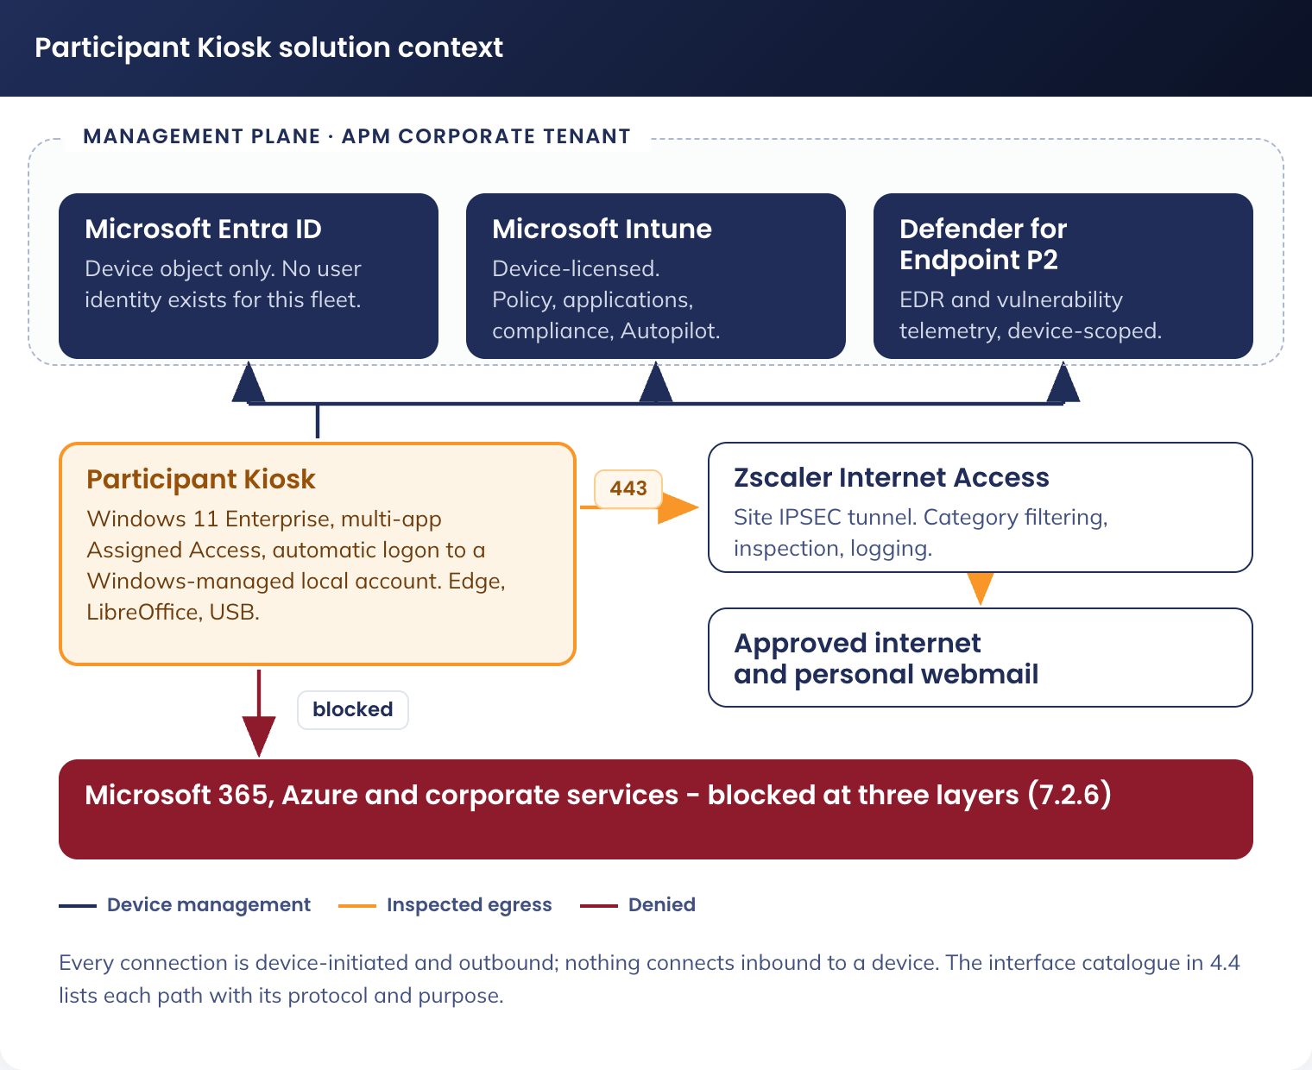
Figure 1. Participant Kiosk solution context - management plane, permitted destinations and blocked corporate services

4.2 Solution Component Inventory
Component | Product / Service | Version | Licensing | Purpose
Device operating system | Windows 11 Enterprise | Validated feature version, standard channel | Windows 11 Enterprise E5, per device | Participant Kiosk operating system. Changed from Windows 11 IoT Enterprise LTSC (DR-014)
Productivity suite | LibreOffice | Fresh release, 64-bit | Open source, Mozilla Public Licence 2.0. No licence cost | Writer, Calc and Impress for document creation, reading and writing the Microsoft file formats. New in this design (DR-008)
Browser and PDF viewer | Microsoft Edge | Stable channel | Included with Windows | Job search, government services, personal webmail, PDF viewing
Endpoint protection | Microsoft Defender for Endpoint P2 | Latest platform and intelligence | Entitlement included with Windows 11 Enterprise E5 | Real-time protection, EDR telemetry to Defender, feeds the Intune compliance policy
Device management | Microsoft Intune | Current | Microsoft Intune device licence | Configuration profiles, application deployment, compliance, Autopilot
Identity provider | Microsoft Entra ID | Current | Existing APM tenant licensing | Device join and device object only. No user identity is created for this fleet
Local credential management | Windows LAPS with Entra ID backup | Built in to Windows 11 | Included | Rotates and escrows the local support account password per device (DR-012)
Web filtering | Zscaler Internet Access, site IPSEC tunnel | Existing APM standard | APM licensed | Category-based web filtering and logging
Third-party patching | Patch My PC Publisher, Server edition | Current | APM licensed (A-08) | Publishes LibreOffice updates into Intune as superseding Win32 applications
Remote support | TeamViewer | Single pinned major version | APM licensed | Attended and administrative remote support, 4.3.10

Two components a reader may expect are deliberately absent. Microsoft Defender for Identity does not apply to this fleet, because there is no user identity and no on-premises directory for it to monitor. Microsoft Purview Information Barriers are not required, because no identity exists on the device that could reach a corporate store. Neither is a reduction in control; both were compensating for an identity that no longer exists.

4.3 Intune Configuration Profiles
The following Intune configuration profiles are applied to the Participant Kiosk solution. All profiles target the device group sg-dyn-dvc-cdg-participant-kiosk. No profile targets a user group, because there is no user.

4.3.1 Assigned Access (Multi-App) and Automatic Logon
• Setting Name: CDG-W11-REM-Kiosk Session Account-P-1.0
• Setting Type: Intune remediation pair (Detect-KioskSessionAccount.ps1, Remediate-KioskSessionAccount.ps1, both signed), run at enrolment and daily
• Scope: sg-dyn-dvc-cdg-participant-kiosk
• Mechanism: the remediation renders the Assigned Access XML (Appendix B) with this device's session account name and applies it through the WMI bridge (MDM_AssignedAccess, ./Vendor/MSFT/AssignedAccess/Configuration)
This is the primary control enforcing the locked-down experience, and it also delivers the sign-in model. The session account is named from the device serial so the endpoint is identifiable to network and security tooling by account as well as by hostname, a requirement raised by APM Security Operations in review. Because the account name differs per device, the configuration cannot ship as one static OMA-URI profile; the script composes and applies it per device. Remediations do not block the Enrolment Status Page, so the same script is also packaged as a Win32 application and placed in the ESP blocking application list: no device reaches a participant without its session account, and the remediation enforces the state from then on.
Element | Value | Purpose
Session account | Kiosk-[SERIAL], for example Kiosk-63TFTJ4. Created by the remediation from the BIOS serial, capped at the 20-character account-name limit | One account per device, identifiable in Windows, Zscaler and Sentinel telemetry, and matching the device it belongs to
Account display name | Participant | The name shown on the account tile if the breakout sequence is used
Account type | Local standard user, not a member of Administrators | Least privilege. The account cannot install, configure or elevate
Password | 32 characters from a cryptographic random source, generated in memory on the device by the remediation. Set on the account, written only to the Winlogon LSA DefaultPassword secret, then discarded. Never logged, transmitted, displayed or known to any person | No credential exists for a human to obtain or type (DR-011). The LSA secret is readable only with local administrator rights, which Windows LAPS gates and audits (7.2.3)
Credential rotation | The password is regenerated on every remediation pass that repairs the account, and can be forced fleet-wide by re-running the remediation | No rotation schedule is required for a credential no one holds; rotation exists as a response action
Autologon mechanism | Winlogon AutoAdminLogon with DefaultUserName Kiosk-[SERIAL]. No cleartext DefaultPassword registry value is ever written, and AutoLogonCount is removed so autologon does not expire | The credential lives only in the LSA secret store. The detection script fails the device if a cleartext value is found
Profile applied | The restricted profile in Appendix B, referenced by GUID, with Configs > Config > Account naming the session account | Presents only the allowed applications, bound to the named account
Breakout sequence | Ctrl+Alt+Del (default) | Allows a support operator to leave the restricted session and sign in with the LAPS-managed local administrator account. Holding Shift at boot bypasses autologon and presents the logon screen, where the session account is unusable because its password is not known to anyone
Taskbar | Shown | Participants need the clock, network and volume affordances

Allow/Block | Applications
Allowed | Microsoft Edge, LibreOffice Writer, LibreOffice Calc, LibreOffice Impress, File Explorer (Downloads, Desktop and removable drives), Zscaler tray, TeamViewer, and the accessibility tools in 4.3.1.1
Blocked | Everything else, including Settings, Command Prompt, PowerShell, Task Manager, the Microsoft Store and every installer

4.3.1.1 Accessibility Tools
Requirements 02 and 03 make Windows accessibility features a Must, and multi-app Assigned Access will not launch an application that is not on the allowed list. Each tool is therefore allow-listed explicitly in Appendix B, and each is also covered by the App Control policy through the Windows signer set (4.3.9). Where a feature is not a launchable application, the way it is delivered is stated rather than assumed.
Feature | Delivery | How the participant reaches it
Narrator | %SystemRoot%\System32\Narrator.exe, allow-listed and pinned to Start | Start pin, or Ctrl+Windows+Enter
Magnifier | %SystemRoot%\System32\Magnify.exe, allow-listed and pinned to Start | Start pin, or Windows+Plus
On-screen keyboard | %SystemRoot%\System32\osk.exe, allow-listed and pinned to Start | Start pin, or Windows+Ctrl+O
Voice access (speech to text) | %SystemRoot%\System32\VoiceAccess.exe, allow-listed | Start pin. Voice typing (Windows+H) is part of the input stack and needs no allow-list entry
High contrast (contrast themes) | Applied by policy default. Settings is not reachable in the restricted experience, so the participant cannot select a theme from Settings | Left Alt + Left Shift + Print Screen toggles the configured contrast theme
Text scaling | Set by policy to the validated default for the fleet | Not participant-adjustable. A site requiring a different default raises a change
Edge Read Aloud and translation | Built in to Edge, enabled by policy (4.3.4) | Edge toolbar

4.3.1.2 File Explorer Scope and Participant Folders
Requirement from the business review: participants who download documents must be able to find them without understanding a folder tree, because most participants are not confident technology users. File Explorer in the restricted session therefore shows exactly three places, and everything a participant does lands in one of them.
Location | How files get there | What happens to them
Downloads | Edge downloads (DefaultDownloadDirectory, 4.3.4) and LibreOffice saves (WritePath, 4.3.6.2) both default here | Inside the participant profile: destroyed on every restart by the purge (6.4). No script is added for this; the profile purge already covers it
Desktop | A participant can save there deliberately from either application | Inside the participant profile: destroyed on every restart, exactly as Downloads. The wallpaper (5.2.6) tells participants files are deleted after 10 minutes of inactivity
Removable drives | The participant's own USB media (5.2.3) | Theirs. Removed with them, untouched by the purge

The Assigned Access configuration in Appendix B scopes File Explorer with AllowedNamespace entries for Downloads and Desktop plus AllowRemovableDrives. Nothing else is browsable: no system drive, no Documents, no network locations. Test T-06 saves to each of the three locations and T-09 verifies the two profile locations are empty after restart.

4.3.2 Inactivity Sign-Out and Restart
• Setting Name: CDG-W11-REM-Idle Restart-P-1.0
• Setting Type: Intune platform script (registers a scheduled task; the idle monitor runs as the interactive user, not SYSTEM)
• Scope: sg-dyn-dvc-cdg-participant-kiosk
• Setting: after 600 seconds with no keyboard or mouse input, restart the device
Multi-app Assigned Access has no native inactivity control, and the tools Windows provides are wrong for this use case: the machine inactivity limit and the screen saver only lock the session, which on an automatic-logon device would leave a locked session no one can unlock. The device therefore restarts, and the restart is what purges the session (6.4). One event ends the session and cleans it up, so there is a single code path rather than two.
Setting | Value | Rationale
Idle threshold | 600 seconds | Requirement 05. Matches the agreed 10 minutes and is stricter than the standard’s 900-second machine inactivity limit
Idle measurement | Win32 GetLastInputInfo, polled every 30 seconds by a scheduled task with a logon trigger and a repeating interval | Measures true keyboard and mouse inactivity in the interactive session
Warning | Full-screen notice at 540 seconds, dismissed by any input, counting down the final 60 seconds | A participant who has paused is not interrupted without warning
Action at threshold | shutdown /r /t 0 /f | Restart returns a known-good state, re-establishes the Zscaler tunnel and triggers the purge
Arming condition | The watchdog arms on the first input event of a session | An unused device does not restart in a loop overnight
Script signing | Signed with the APM code-signing certificate (SOE-02) | The inherited baseline sets the PowerShell execution policy to signed scripts only

4.3.3 Logon Lockdown and Local Accounts
• Setting Name: CDG-W11-SEC-Logon Lockdown-P-1.0
• Setting Type: Intune remediation (runs as system) and Settings Catalog
• Scope: sg-dyn-dvc-cdg-participant-kiosk
A Participant Kiosk carries exactly three local accounts, and no domain or cloud identity may sign in to it.
Account | Type | Purpose and controls
Participant (Assigned Access managed) | Local standard user | The automatic-logon session account. Created, credentialled and signed in by Windows. Runs the restricted experience only
APM-PKAdmin | Local administrator | Break-glass and remote administrative support. Password rotated and escrowed by Windows LAPS (7.2.3). Not a privileged-tier (xy or zz) identity and not a domain account
Administrator (built-in) | Disabled and renamed | Disabled and renamed by the inherited Windows 11 OS baseline. Guest is likewise disabled

Setting | Value | Purpose
Allow log on locally | BUILTIN\Administrators and the Kiosk-[SERIAL] session account | An allow-list, not a deny-list, applied per device by the signed logon-lockdown remediation because the account name differs per device and cannot be expressed in a tenant-wide profile. Any other account is refused at the credential screen
Deny log on locally | Privileged-tier identities (xy and zz) | Consistent with the standard’s Deny Local Log On position. No privileged identity signs in on a public-area device
Accounts > Allow Microsoft account connection | Block | No personal or work Microsoft account can be added to Windows
Hide fast user switching | Enabled | Removes the switch-user path out of the restricted session
Do not display last signed-in user | Enabled | Inherited from the baseline; nothing about the account is advertised
Password never expires, on the Kiosk-[SERIAL] session account only | Set (PasswordExpires = False on that account) | The inherited baseline sets a maximum password age for local accounts. The session credential is generated on-device and never rotated by a person, so an inherited expiry would stop automatic logon on every device on the same day. The account is exempted explicitly by the remediation and verified by test T-19

No corporate identity can sign in to Windows on this device, and no corporate identity can authenticate to a cloud service from it either. The second half of that statement is enforced by Conditional Access rather than by Windows, and is specified in 7.2.4.

4.3.4 Edge Browser Policies
• Setting Name: CDG-W11-SEC-Edge Hardening-P-1.0
• Setting Type: Settings Catalog, device scope
• Scope: sg-dyn-dvc-cdg-participant-kiosk
Every Edge policy on this fleet is set at device scope. The corporate Edge configuration is largely user-scoped, and a user-scoped policy does not apply to a device with no corporate user; the conversion of those settings to device scope is covered in 7.3.6.
Policy Key | Value | Purpose
RestoreOnStartup | 4 (Open a list of URLs) | Launch to the approved start page
ForceEphemeralProfiles | Enabled | The Edge profile lives in memory only. Nothing is written to disk to be recovered
ClearBrowsingDataOnExit | Enabled | Second layer, for the case where a profile directory is created
BrowserSignin | 0 (Disabled) | No sign-in to Edge with any account, corporate or personal
SyncDisabled | Enabled | No profile sync
PasswordManagerEnabled | Disabled | No credential saving
AutofillAddressEnabled | Disabled | No address autofill
AutofillCreditCardEnabled | Disabled | No payment autofill
SavingBrowserHistoryDisabled | Enabled | No history retention
SearchSuggestEnabled | Disabled | No search suggestions leaving the device
InPrivateModeAvailability | 1 (InPrivate disabled) | The whole profile is already ephemeral; a second mode only complicates support
DefaultGeolocationSetting | 2 (Block) | No location prompts
PrintingEnabled | Disabled | Printing is by email to the case manager (5.2.2)
DownloadRestrictions | 0 (No restrictions) | Downloads are permitted; they are destroyed with the profile at session end
DefaultDownloadDirectory | %USERPROFILE%\Downloads | Inside the purged profile, not on a shared path
AlwaysOpenPdfExternally | Disabled | PDFs open in the Edge viewer. Edge is the PDF reader (DR-004, requirement 09)
TranslateEnabled | Enabled | Accessibility requirement 03
SmartScreenEnabled and SmartScreenPuaEnabled | Enabled, no override | Inherited from the Edge security baseline
DnsOverHttpsMode | off | Zscaler must retain DNS visibility
EditFavoritesEnabled | Disabled | The managed favourites set is fixed
URLBlocklist | Microsoft 365 corporate service URLs, see 7.2.6 | Removes the corporate service surface from the browser
ManagedFavorites | JSON configuration, see 4.3.5 | Preloaded managed bookmarks

4.3.5 Edge Managed Favourites
Bookmarks are deployed via the ManagedFavorites Edge policy as JSON, in the folder structure below. The full link set is in 3.2.2. No Microsoft 365 web application links are included, because those applications are not part of this solution (7.2.6).
Folder | Contents | Count
Favourites Bar | Workforce Australia Online, SEEK, myGov | 3
Workforce Australia | Portal, compliance framework, contact, job search and the instructional videos | 11
Centrelink / Services Australia | Medical certificate (SU415), verification of medical conditions (SU684), report employment income | 3
Job Search | SEEK, Jora, Indeed, Gumtree, Ethical Jobs, APS Jobs, Facebook, Workforce Australia job search | 8
Essential Support | Ask Izzy, Beyond Blue, Headspace, Drug Foundation, Financial Counselling | 5
Other Services | Fair Work, Pay and Conditions Tool, Volunteering Australia | 3
Transport | State by state: ACT, NSW, NT, QLD, SA, VIC, WA, TAS | 8
Training | Duke, MCI, Alffie, and TAFE by state (QLD, ACT, NSW, VIC, WA, NT, SA, TAS) | 11
Resume and Cover Letters | Microsoft resume templates, cover letter templates | 2
National Police Check | CVCheck national police check | 1

4.3.6 LibreOffice Deployment and Configuration
LibreOffice replaces Microsoft 365 Office for the web as the productivity suite (DR-008). It is installed locally, needs no identity, no licence and no cloud store, and reads and writes the Microsoft file formats participants receive from and send to employers and case managers. Documents are saved to the participant’s own USB media or attached to a message from personal webmail; nothing is stored on the device beyond the session.

4.3.6.1 Application Package
Field | Value
Application name | CDG-W11-APPC-LibreOffice-P-1.0
Source | LibreOffice Fresh, 64-bit Windows MSI, downloaded from libreoffice.org and checksum-verified against the published SHA-256
Package type | Intune Win32 application (.intunewin), install context System
Assignment | Required, sg-dyn-dvc-cdg-participant-kiosk. Available to no user group
Install command | msiexec /i LibreOffice_[version]_Win_x86-64.msi /qn /norestart CREATEDESKTOPLINK=0 ISCHECKFORPRODUCTUPDATES=0 QUICKSTART=0 REGISTER_ALL_MSO_TYPES=1 UI_LANGS=en_AU
Uninstall command | msiexec /x {ProductCode} /qn /norestart
Detection rule | MSI product code, with a version check on the installed product version
Requirements | Windows 11, x64, 64-bit
Restart behaviour | No specific action. The device restarts nightly and on session end
Dependencies | None. The MSI is self-contained
Delivery during provisioning | Included in the Enrolment Status Page blocking application list, so no device reaches a participant without it

The install command turns off two defaults deliberately. The desktop shortcut is not created, because the restricted experience presents applications from the Start pins, not the desktop. The product update check is turned off at install time and again by policy below, because updates are delivered by Intune through Patch My PC (5.2.4), not by the application reaching the internet on its own.

4.3.6.2 Locked Configuration
LibreOffice reads Windows Group Policy from HKLM\SOFTWARE\Policies\LibreOffice. Values written there are read-only to the user and cannot be changed in the application’s own options dialogue, which is what makes this configuration locked rather than merely defaulted. The values are delivered by ingesting the LibreOffice ADMX template into Intune and configuring it through the Settings Catalog imported administrative templates; the equivalent registry values are given so the build can be verified directly.
Configuration node (under HKLM\SOFTWARE\Policies\LibreOffice) | Value | Purpose
org.openoffice.Setup\Office\Factories\com.sun.star.text.TextDocument\ooSetupFactoryDefaultFilter | MS Word 2007 XML | Writer saves as .docx by default
org.openoffice.Setup\Office\Factories\com.sun.star.sheet.SpreadsheetDocument\ooSetupFactoryDefaultFilter | Calc MS Excel 2007 XML | Calc saves as .xlsx by default
org.openoffice.Setup\Office\Factories\com.sun.star.presentation.PresentationDocument\ooSetupFactoryDefaultFilter | Impress MS PowerPoint 2007 XML | Impress saves as .pptx by default
org.openoffice.Office.Common\Security\Scripting\DisableMacrosExecution | true | No macro executes, from any document, from any source. This is the primary application-hardening control
org.openoffice.Office.Common\Security\Scripting\MacroSecurityLevel | 3 (Very high) | Second layer. Only macros from trusted locations may run, and no trusted location is defined
org.openoffice.Office.Common\Security\Scripting\BlockUntrustedRefererLinks | true | Blocks links to external content from untrusted documents
org.openoffice.Office.Common\Security\Scripting\DisableActiveContent | true | Blocks OLE and other active content embedded in a document
org.openoffice.Office.Common\Misc\FirstRun | false | No first-run wizard, registration prompt or online account offer
org.openoffice.Office.Common\Misc\ShowTipOfTheDay | false | No tip dialogue on a public device
org.openoffice.Office.Common\History\PickListSize | 0 | No recent-documents list, so the previous participant’s file names are never visible
org.openoffice.Office.Common\Save\Document\AutoSave | false | No autorecovery copies written to disk
org.openoffice.Office.Common\Save\Document\CreateBackup | false | No backup copies written to disk
org.openoffice.Office.Common\Passwords\UseStorage | false | No credential storage in the application
org.openoffice.Office.Jobs\Jobs\UpdateCheck\AutoCheckEnabled | false | Updates come from Intune, not from the application
org.openoffice.Office.Common\Menus\ShowMenuHelp | false | Removes online help and update entries from the menu
org.openoffice.Office.Paths\Paths\Work\WritePath | %USERPROFILE%\Downloads | Default save folder is Downloads, the same folder Edge downloads to and File Explorer shows, so a participant has one place to look. Inside the profile that is purged at session end

Two behaviours are accepted rather than configured. LibreOffice offers a Send Document as Email command; the device has no mail client, so the command fails with a local error and no message is sent. Participants attach the file from their webmail instead, which is the agreed document handoff model (5.2.2). LibreOffice also writes a user profile under the participant’s AppData; it is destroyed with the rest of the profile on every restart (6.4).

4.3.7 Profile and Session Purge
• Setting Name: CDG-W11-REM-Profile Purge-P-1.0
• Setting Type: ADMX (Settings Catalog) plus a signed shutdown script
• Scope: sg-dyn-dvc-cdg-participant-kiosk
The purge is specified in full in section 6.4, because what it destroys is an information-architecture question. In summary: Edge browsing data never reaches the disk, downloads land inside the participant profile, the profile is deleted as the device shuts down, and the profile-cleanup policy removes any profile that survives a hard power-off at the next restart.

4.3.8 Corporate Policy and Application Assignment Exclusions
Every corporate policy, application and script targeting All Devices, All Users or a broad dynamic group lands on this fleet unless excluded - the single largest configuration risk in this design: a corporate assignment would install software App Control does not trust, or grant a public-area device a permission this design forbids.
Every assignment below is scoped to exclude sg-dyn-dvc-cdg-participant-kiosk before the first device enrols. The register is reviewed at each design review and whenever a new broad assignment is created.
Assignment class | Action | Reason
Microsoft 365 Apps and any corporate line-of-business application assignment | Exclude the device group | Only Edge, LibreOffice, Zscaler and TeamViewer are trusted by App Control. Anything else fails to install or fails to run
Company Portal and corporate self-service applications | Exclude | There is no user to sign in to a portal
Corporate Edge configuration profiles (user scope) | Exclude, and apply the device-scoped equivalents in 4.3.4 and 7.3.6 | A user-scoped policy does not apply to this fleet, leaving Edge unmanaged if not converted
Corporate Conditional Access policies that grant access | Exclude the device filter, or leave them to be overridden by the block policy in 7.2.4 | A grant policy must never apply on Participant Kiosk hardware
Corporate Wi-Fi, VPN | Exclude | The fleet uses the APM-KIOSK SSID on an isolated vlan.
Corporate PowerShell platform scripts and remediations | Exclude | Unreviewed scripts on a device whose execution policy is signed-scripts-only will fail and generate noise, and any that succeeded would be outside this design
Estate App Control policy (APM-W11-SEC-AppControl) | Exclude | Application control is an established APM estate control delivered by App Control for Business (WDAC), not a new capability introduced by this design. The fleet is excluded from the estate policy only because it needs a tighter variant, specified in 4.3.9
Estate USB and BitLocker removable-drive policies | Exclude | Replaced by the exception profiles in 5.2.3, per 7.3.3
Estate Windows Update rings | Exclude, unless the estate ring can meet the 03:00 daily restart | The fleet needs an unattended daily restart window, which is why dedicated rings are specified in 9.3. Where an existing estate ring already meets that window, the fleet joins it rather than duplicating a policy object
Corporate compliance policies | Exclude | Replaced by CDG-W11-COM-Participant Kiosk-P-1.0 in 7.2.5

4.3.9 Application Control (App Control for Business)
The fleet is excluded from the estate App Control policy assignment and receives its own pair, because the fleet allow-list is a fraction of the size of a staff device’s and can therefore be far tighter. Application control is the control that stops an executable brought in on a USB drive from running, so it carries the compensating weight for the removable-media exclusions in 7.3.3 and is enforced, not audited.
Two policies are deployed, matching the estate pattern: an audit policy for the pilot and an enforced policy for production. The pilot ring runs the audit policy for the duration of Phase 3 so that any unforeseen block is caught before the fleet moves to enforcement.
Field | Value | Purpose
Policy names | CDG-W11-SEC-AppControl Audit-T-1.0  CDG-W11-SEC-AppControl Enforced-P-1.0 | Audit for the pilot ring, enforced for the fleet
Assignment | Audit: sg-stc-dvc-cdg-participant-kiosk-ring1  Enforced: sg-dyn-dvc-cdg-participant-kiosk | Pilot validates before fleet enforcement
Base policy | Windows built-in trusted signers (Inherit Default Policy enabled) | Trusts Windows and Microsoft-signed components only
Delivery - audit policy | Intune endpoint security, App Control for Business profile, deployed unsigned | Same mechanism as the estate audit policy. An unsigned policy can be removed by removing the profile, which is what a pilot needs
Delivery - enforced policy | Signed and deployed as a signed binary through the ApplicationControl CSP by custom OMA-URI: ./Vendor/MSFT/ApplicationControl/Policies/{PolicyGUID}/Policy. The XML is converted with ConvertFrom-CIPolicy and signed with the APM code-signing certificate, which is listed in the policy’s own UpdatePolicySigners | The built-in Intune App Control profile deploys an unsigned policy, so it cannot deliver the enforced policy in signed form. A signed policy is the point: it cannot be removed or replaced by an attacker with local access, only by a policy update signed with the same certificate (DR-017)

Rule options. The fleet policy differs from the estate policy in two respects, both tightenings.
Rule option | Estate | Participant Kiosk | Reason for the difference
Enabled: UMCI | Yes | Yes | Applies control to user-mode applications and DLLs
Enabled: Inherit Default Policy | Yes | Yes | Inherits the Microsoft default trusted rules
Required: Enforce Store Applications | Yes | Yes | Store applications are in scope. The Store itself is turned off on the Participant Kiosk
Enabled: Revoked Expired As Unsigned | Yes | Yes | Revoked or expired signatures are treated as unsigned
Enabled: Boot Audit On Failure | Yes | Yes | Falls back to audit rather than failing to boot
Disabled: Script Enforcement | Yes (script control off) | No (script control ON) | The estate policy leaves PowerShell, HTA and similar unconstrained, which the standard itself flags as an item to close. On this fleet it is enabled, because a Participant Kiosk runs no line-of-business scripting and the removable-media exclusions make script execution from USB the most likely attack path. Without it, application control does not constrain a script carried in on a USB drive
Enabled: Managed Installer | Yes | No | Applications are installed only by Intune from a trusted publisher, so a managed installer would only widen the trust surface
Enabled: Allow Supplemental Policies | Yes | No | Nothing extends the base policy. Any change is a change to the base policy itself, under change control
Enabled: Advanced Boot Options Menu | Yes | No | The F8 advanced boot menu is not appropriate on an unattended device in a public area
Enabled: Unsigned System Integrity Policy | Yes | No, the policy is signed | The policy is signed with the APM code-signing certificate, so it cannot be replaced or removed by an attacker with local access. This uses the same certificate as the script-signing dependency in SOE-02

Allow-list. Only the applications presented by multi-app Assigned Access are permitted to execute, plus the Windows and Intune components required for the device to manage itself and the vendor-signed application packages Intune delivers. Everything else is denied.
Application | Rule basis | Notes
Microsoft Edge | Publisher rule, Microsoft Corporation signer | Delivered with Windows and serviced by Windows Update
LibreOffice | Publisher rule, The Document Foundation signer | Updates published by Patch My PC retain the vendor signature, so a new release runs without an App Control policy change (5.2.4)
Patch My PC | Publisher rule, Patch My PC LLC signer | The Intune packages Patch My PC publishes execute a vendor-signed wrapper script during install. With script enforcement enabled, that wrapper does not run unless its signer is trusted, and the update fails as an application install error rather than a security event. This rule is what keeps the automated patch channel working (5.2.4)
File Explorer | Inherited from the Windows built-in signer set | Scoped by Assigned Access to Downloads, Desktop and removable drives (4.3.1.2)
Zscaler client | Publisher rule, Zscaler Inc. signer | Tray application only
TeamViewer | Publisher rule, TeamViewer Germany GmbH signer, pinned to the deployed major version | Remote support, see 4.3.10
Windows and Intune platform components | Inherit Default Policy plus the Microsoft signer set | Intune management extension, Defender, PowerShell host for the signed device scripts
APM device scripts | Publisher rule, APM code-signing certificate | Idle watchdog, shutdown purge, startup purge and device rename. All must be signed (SOE-02)
Everything else, including any untrusted installer | Denied by default | No user, including a local administrator, can install an application. The only software that reaches the device is a trusted-publisher package delivered by Intune

Application installation by a person is therefore blocked twice: by App Control, which denies execution of any binary outside the trusted publisher set, including MSI and EXE installers, and by Assigned Access, which exposes no shell from which one could be launched. A local administrator signing in for support gets a full desktop but still cannot install software, because App Control is a kernel-enforced device policy and is not scoped by user. The one path that does work is the intended one: Intune installing a package signed by a trusted publisher (5.2.4).

4.3.10 Remote support access model
Remote support is required. Site staff cannot troubleshoot a device in a public area, and the fleet is national, so the alternative to remote support is a truck roll for every fault. TeamViewer is retained as the remote-support tool and is allow-listed in both Assigned Access and App Control. Because the estate hardening standard disables every other remote-access path (Remote Assistance, Remote Shell, inbound Remote Desktop), this is a documented variation to that position rather than an oversight, and the controls below are what make it acceptable.
This is not Remote Desktop. RDP, Remote Assistance and Remote Shell stay disabled by the inherited baseline; installing TeamViewer changes none of them. Nothing listens on TCP 3389 - the session is established outbound to the vendor service on 443, so no inbound path into the default-deny VLAN exists. RDP could not serve here anyway: the session account credential is known to no one, and a console takeover would disconnect the participant rather than assist them.
Alternatives assessed. Quick Assist is a Store application on a fleet with the Store off, and cannot reach an unattended device. Microsoft Remote Help would remove the third-party tool but is per-helper licensed and assumes a signed-in user context; recorded as the preferred replacement to reassess if APM licenses it.
Aspect | Design
Support scenarios | Two. Assisted support, where a support operator joins the session the participant is signed in to, with the participant present. Administrative support, where a support operator signs in with a support account to a device with no participant session, for diagnosis and remediation
Consent for assisted support | Attended only. The participant must accept the incoming connection at the device. Unattended access is not enabled for the participant session
Unattended access | Permitted only for the administrative scenario, on a device with no participant present. It is the mechanism that allows a support operator to reach an idle device, typically outside site hours
Support account | APM-PKAdmin, a local account on that device only, not a privileged-tier (xy or zz) identity and not the Assigned Access session account. It is a member of the local Administrators group on that device so a support operator can read logs and restart services. It has no Entra ID role and no access to any other device
Support account credentials | Unique per device, generated, rotated every 30 days and escrowed by Windows LAPS to Entra ID (7.2.3). Retrieved by the support operator from Entra ID at the point of use, which produces an audit record per retrieval, and reset automatically eight hours after the session
Operator authentication | Support operators authenticate to the TeamViewer tenant with their own named account and multi-factor authentication. Device access is granted by group membership, not by a shared connection password. No shared or per-device TeamViewer password is used
Authorised operators | A named support group. Membership is reviewed quarterly by the service owner
Session logging | TeamViewer connection reports (who connected, to which device, when, for how long) are exported to Microsoft Sentinel alongside the Windows security log, so a remote session is correlatable with what happened on the device. Windows audit policy already records the interactive logon under the inherited OS baseline
File transfer | Disabled in the TeamViewer policy for Participant Kiosks. Support operators have no file-transfer path onto or off a Participant Kiosk
Network position | TeamViewer egress is permitted only to the vendor’s published endpoints through the Zscaler tunnel, in the same default-deny egress model as all other device traffic (5.3). Inbound connections to the device are not permitted; the session is always device-initiated outbound
Version control | A single deployed major version, pinned in the App Control publisher rule and updated through the image lifecycle (5.2.4), so an attacker cannot side-load a different build

The residual risk is that a compromised TeamViewer operator account, or a compromise of the vendor’s platform, yields access to a Participant Kiosk. The blast radius is one device, or the fleet, holding no corporate information, carrying no corporate credential, on a network segment with default-deny egress and no route to APM corporate systems (5.3), and from which no corporate identity can authenticate (7.2.4). Multi-factor authentication on operator accounts, no shared connection passwords, no file transfer, per-device LAPS credentials and Sentinel session logging reduce the likelihood; the network position and the absence of any corporate identity on the device limit the consequence.

4.4 Interface Catalogue
Every connection a Participant Kiosk makes is listed below. All are device-initiated and outbound; nothing connects inbound to a device. Each interface maps to an arrow in Figure 1.
ID | Source | Destination | Protocol / port | Purpose
INT-01 | Participant Kiosk | Microsoft Entra ID (login.microsoftonline.com, enterpriseregistration.windows.net) | HTTPS 443 | Device authentication and Entra join. No user authentication occurs
INT-02 | Participant Kiosk | Microsoft Intune (manage.microsoft.com, r.manage.microsoft.com) | HTTPS 443 | MDM check-in, policy, application and script delivery
INT-03 | Participant Kiosk | Windows Update and Delivery Optimization endpoints | HTTPS 443 | Operating system and Microsoft component patching (9.3)
INT-04 | Participant Kiosk | Microsoft Defender for Endpoint cloud service | HTTPS 443 | EDR telemetry, intelligence updates and response actions
INT-05 | Participant Kiosk | Zscaler Internet Access, via the site IPSEC tunnel | IPSEC, HTTPS 443 | All internet traffic, filtered and logged (5.3.3)
INT-06 | Zscaler Internet Access | Approved internet destinations | HTTPS 443 | Job search, government services, personal webmail, training
INT-07 | Participant Kiosk | TeamViewer service endpoints | HTTPS 443, outbound only | Remote support session establishment (4.3.10)
INT-08 | Participant Kiosk | Intune content delivery (Microsoft CDN) | HTTPS 443 | LibreOffice package and update content published by Patch My PC (5.2.4)
INT-09 | Participant | USB removable media on the device | USB mass storage | Participant carries documents to and from the device (5.2.3)
INT-10 | Support operator | Participant Kiosk, via the TeamViewer service | HTTPS 443 | Attended and administrative remote support (4.3.10)

5. Technology Architecture

5.1 Participant Kiosk

5.1.1 Hardware Specification
Dell hardware running Windows 11 Enterprise. All Participant Kiosks connect over Wi-Fi, as no Ethernet capability is available close to these devices; the Ethernet port is retained and enabled for servicing only (5.3.1.8). Each device carries TPM 2.0 for Autopilot self-deploying attestation and BitLocker.
Element | Minimum specification | Rationale
Processor | 64-bit, 2 cores, on the Windows 11 supported processor list | Windows 11 Enterprise hard requirement
Memory | 8 GB | Edge and LibreOffice run concurrently in the same session. 4 GB was adequate for a browser-only IoT LTSC build and is not adequate here
Storage | 128 GB SSD | Windows 11 Enterprise, LibreOffice, servicing headroom and the monthly quality update
Trusted Platform Module | TPM 2.0 | Autopilot self-deploying device attestation and BitLocker key protection
Firmware | UEFI with Secure Boot enabled | Required by the inherited baseline and by App Control
Network | Wi-Fi 6 (802.11ax), plus a retained Ethernet port | Site Wi-Fi is the operational path; Ethernet is for the Deployment Team servicing
Display and input | Attached display, keyboard and mouse | Participants type documents on the device

5.1.2 Local Account and Automatic Logon Model
This fleet has no cloud user identity. The participant session runs as a local account that Windows creates, credentials and signs in on its own behalf, declared in the Assigned Access configuration (4.3.1, Appendix B). The model in one sentence: the device authenticates to Entra ID as a device, and the human who uses it authenticates to nothing.
Aspect | Design
Account creation | Created on the device by the signed remediation CDG-W11-REM-Kiosk Session Account-P-1.0, named Kiosk-[SERIAL] from the BIOS serial. No account is created in any directory
Account scope | Local to the device. It exists on that device only and has no meaning on any other device or service
Credential | 32 random characters generated on the device, held only in the Winlogon LSA secret. Not set by a person, not stored in Intune, Key Vault or any document, never displayed. Extractable only with local administrator rights, which LAPS gates and audits
Credential rotation | Regenerated whenever the remediation repairs the account, and on demand fleet-wide. There is no schedule, runbook or key material for APM to hold, so the Cryptography and Key Management Standard's rotation obligation does not attach to it. The account is exempted from the baseline's maximum password age (4.3.3), because an expiry on a credential nobody holds would end automatic logon fleet-wide
Sign-in | Automatic at every boot. The participant never sees a credential prompt
Privilege | Standard user. Not a member of Administrators. Cannot install, elevate, or change configuration
Profile | Recreated at each sign-in and destroyed at each shutdown (6.4)
Break-glass | Ctrl+Alt+Del leaves the restricted session and presents the standard logon screen, where the LAPS-managed local administrator account can sign in
Failure mode | If the remediation has not run, no session account and no automatic logon exist and the device presents the standard logon screen with no account a member of the public can use. The device is unusable rather than open, which is the correct failure direction. Intune reports the remediation as failed and the device is repaired before it returns to service

With no cloud identity there is no password to rotate, no licence to assign and no sign-in log to monitor. Device-level control replaces them: the compliance policy, App Control, the Conditional Access device filter (7.2.4) and Defender for Endpoint telemetry.

5.1.3 Deployment Team - Device Wipe, Prep and Assignment Process
• Check the location device allocation list, validate how many devices are required per site and note the site Loc#
• Unpack the device, power on and assess if dead on arrival
• Add or update the device in the asset register
• Trigger a full device wipe (not an Autopilot Refresh)
• Confirm TPM 2.0 and UEFI Secure Boot support
• Prepare the USB image with Windows 11 Enterprise
• Install Windows 11 Enterprise
• Connect to Ethernet if available, otherwise connect to Wi-Fi during OOBE using Shift+F10 and then ms-settings: to configure Wi-Fi
• Confirm the device is in Autopilot and assigned the correct profile
• – If the device is not in Autopilot, run the Get-WindowsAutopilotInfo PowerShell script to upload the hardware hash, or store it in a CSV to be provided back to APM
• – For example: Get-WindowsAutopilotInfo -OutputFile C:\AP\hash.csv -GroupTag PARTICIPANT (the tag must match the dynamic group rule in 7.2.2)
• Assign the device to its Entra ID location group - sg-stc-dvc-site-LOC[Loc#] for the site the device is being shipped to. This step is not optional and not deferrable: it is the only place the site is recorded against the device, and it is what gives the device its name (5.1.5.2), its location-based policy and its position in the asset register
• – Confirm the group is the one for the destination site, not the staging site. A device in the wrong group is renamed to the wrong site and will be reported as being somewhere it is not
• – Confirm the device appears in exactly one location group. A device in two groups is skipped by the rename job and reported as an exception
• – The rename job appends the site digits within 15 minutes and the name applies at the next restart, so a device leaves staging already carrying its site (5.1.5.3)
• Restart the device to start Autopilot provisioning
• Validate that the device boots directly into the participant session with no credential prompt
• Validate that Edge and LibreOffice launch, and that Wi-Fi is operational
• Repackage the device
• Create a label with the device name and attach it to the outside of the box
• Insert the instruction sheet inside the box
• Send to the location

5.1.4 Autopilot Self-Deploying Mode
Participant Kiosks are provisioned through Windows Autopilot in self-deploying mode, into the existing APM corporate tenant. Provisioning is hands-off and no user signs in at any point:
1. The device is registered in Autopilot at the point of procurement (hardware hash upload)
2. The device boots and connects to Wi-Fi; OOBE detects the Autopilot registration
3. Autopilot joins the device to the APM tenant using TPM-backed device attestation; no user signs in during OOBE
4. The device is Entra ID joined and enrolled into Intune against its Intune device licence
5. Intune applies the security baseline, the Assigned Access profile, the device configuration and the required applications
6. The Enrolment Status Page blocks until all required applications and policies are applied
7. The device restarts, the remediation has created the Kiosk-[SERIAL] session account, and Windows signs it in automatically, landing in the participant session
Setting | Value
Name | CDG-W11-CFG-Autopilot Self-Deploying-P-1.0
Deployment mode | Self-deploying
Join type | Microsoft Entra ID join, APM corporate tenant
User sign-in | Not required and not possible. Self-deploying joins the device by TPM-backed attestation
Device name template | APM-PK-%RAND:3% at provisioning, completed to APM-PK-[RRR][LLLL] by the rename job (5.1.5)
Skip EULA and privacy settings | Yes
Convert all targeted devices to Autopilot | Yes
Enrolment Status Page | Enabled, blocking. Required applications: LibreOffice, Zscaler Client Connector, TeamViewer
Assigned to | sg-dyn-dvc-cdg-participant-kiosk-autopilot

5.1.5 Naming Convention
Every object this design creates is named to the APM Intune Naming Schema V1.0. The schema’s convention is Scope-Platform-Type-Function-Ring-Version for Intune objects and sg-[assignment]-[entity]-[scope]-[function] for Entra ID security groups. This fleet uses the schema’s existing CDG scope (Client Device Group), which the schema already defines for the participant and CTA device population, so no new scope value is required.
Object class | Name | Schema derivation
Autopilot deployment profile | CDG-W11-CFG-Autopilot Self-Deploying-P-1.0 | CDG scope, Windows 11, general configuration, production, version 1.0
Assigned Access delivery | CDG-W11-REM-Kiosk Session Account-P-1.0 | Remediation type: creates the session account, configures autologon and applies the Assigned Access configuration per device (4.3.1)
Delivery Optimization profile | CDG-W11-CFG-Delivery Optimization-P-1.0 | As above
Edge hardening | CDG-W11-SEC-Edge Hardening-P-1.0 | Security policy
Logon lockdown | CDG-W11-SEC-Logon Lockdown-P-1.0 | Security policy
Windows LAPS | CDG-W11-SEC-LAPS-P-1.0 | Security policy
USB and BitLocker exceptions | CDG-W11-SEC-USB Exception-P-1.0  CDG-W11-SEC-Bitlocker Exception-P-1.0 | Security policy. Matches the estate exception profiles the schema already carries
App Control | CDG-W11-SEC-AppControl Audit-T-1.0  CDG-W11-SEC-AppControl Enforced-P-1.0 | The audit policy runs on the pilot, so it takes the T (test) ring; the enforced policy takes P
Idle restart and profile purge remediations | CDG-W11-REM-Idle Restart-P-1.0  CDG-W11-REM-Profile Purge-P-1.0 | Remediation type
LibreOffice application | CDG-W11-APPC-LibreOffice-P-1.0 | Application configuration
Compliance policy | CDG-W11-COM-Participant Kiosk-P-1.0 | Business compliance
Update rings | CDG-W11-UPD-Windows Update-T-Ring 1  CDG-W11-UPD-Windows Update-P-Ring 2 | Update type, with the version field replaced by the ring qualifier, as the schema permits and its own example shows
Expedite policy | CDG-W11-UPD-Expedite-P-1.0 | Update type
Conditional Access policy | APM-USER-CAP-Block Participant Kiosk Access-P-1.0 | Global scope and the device-agnostic USER platform, because the policy targets all staff identities rather than this fleet’s devices
Device group | sg-dyn-dvc-cdg-participant-kiosk | Dynamic, device-based, CDG scope
Autopilot group | sg-dyn-dvc-cdg-participant-kiosk-autopilot | As above
Pilot ring group | sg-stc-dvc-cdg-participant-kiosk-ring1 | Static, because membership is chosen rather than derived
Location groups | sg-stc-dvc-site-[LOC#], for example sg-stc-dvc-site-LOC00001001 | The schema’s existing location device group format. Approximately 750 groups, one per site, already created

5.1.5.1 Device Name
The device name is APM-PK-[RRR][LLLL]: the APM-PK- prefix, three random digits, and the last four digits of the site’s Loc#. For example, a device at LOC00001001 with the random component 123 is named APM-PK-1231001.
Component | Value | Example
APM | Global scope prefix, per the naming schema | APM
PK | Participant Kiosk type identifier | PK
RRR | Three random digits, generated by the Autopilot device-name template (%RAND:3%) at provisioning | 123
LLLL | Last four digits of the site’s Loc#, taken from the device’s Entra ID location group | 1001
Full device name | APM-PK-[RRR][LLLL], 14 characters | APM-PK-1231001

The name is 14 characters, one inside the 15-character hostname limit: APM- (4) + PD- (3) + three random digits + four Loc# digits. A hyphen before the site digits would make it 15; the 14-character form is specified.
The name carries no serial number. Hardware traceability is held in Intune and the asset register (5.1.3). The random component prevents same-site collisions and is assigned by Autopilot at first boot, so it is stable for the life of the device.
Naming is applied in two stages, because neither stage can do the whole job alone. The Autopilot device-name template sets APM-PK-%RAND:3% at provisioning, which is enough for the device to fall into the dynamic group on the APM-PK- prefix and start receiving policy. The Loc# digits are appended afterwards by the rename job below.

5.1.5.2 Rename Mechanism
The naming authority for the site code is the Entra ID location group. APM maintains approximately 750 of these, one per site, with the Loc# in the group name, and the Deployment Team assigns each device to its location group during preparation (5.1.3). That means the site code is directory data, not device data, and the rename is therefore issued from the cloud rather than computed on the device.
An on-device rename script is deliberately not used: it would need a directory credential on a public-area device to read its own group membership. The rename is issued from the cloud (DR-018); one fewer device-side script also narrows SOE-02.
Element | Value | Rationale
Script | Rename-ParticipantKiosk.ps1 (held with this design in config/) | Microsoft Graph PowerShell SDK v2. Idempotent and safe to re-run
Run by | A named operator from an APM-managed admin workstation, or a scheduled job in APM’s existing admin tooling | No credential is placed on a Participant Kiosk, and every run is attributable to a person
Graph permissions | Group.Read.All, Device.Read.All, DeviceManagementManagedDevices.PrivilegedOperations.All, delegated | Read the groups and devices, and issue the rename. Nothing else
Group name pattern | Configurable. Default ^sg-stc-dvc-site-LOC(?<loc>\d+)$, with the last four digits of the capture used in the name | Matches the location device group format in the APM Intune Naming Schema V1.0
Target name | APM-PK-[RRR][LLLL], where RRR is the random component Autopilot already assigned and LLLL is the last four digits of the Loc# | The job appends the site component to the name the device already has, so the random component is never regenerated and a device’s name is stable for its life
Action issued | Intune setDeviceName on the matching managed device | The device receives the result; it computes nothing
Applies | At the next restart: the daily 03:00 update restart, or the next inactivity restart | A device renamed during the day carries its new name by the following morning
Devices in two location groups | Skipped and reported, not renamed | Two site codes cannot both be right. This is a data-quality problem at the site, and a script should surface it rather than guess
Devices already correctly named | Skipped | Allows the job to run on a schedule as new devices arrive
Output | CSV log per run: device, serial, current name, target name, action, detail | The evidence record for the rollout, and the input to any exception follow-up

5.1.5.3 Automatic Rename on Location Group Membership
The requirement is that a device renames itself as soon as it is added to its location group, so that the Loc# is visible wherever the device appears. Neither Entra ID nor Intune can attach a script to a group: there is no membership-change trigger to hook. The outcome is therefore produced by a scheduled job that polls, and the script is written to be idempotent precisely so that polling is cheap and self-healing.
Element | Value | Rationale
Runner | Azure Automation runbook executing Rename-ParticipantKiosk.ps1 with -AuthMode ManagedIdentity -Unattended | No secret is stored, no virtual machine is required and nothing is internet-facing. Alternatives that work equally well: a scheduled task on an existing APM admin server with a certificate-based app registration, or a Logic App with a managed identity
Identity | System-assigned managed identity on the Automation account | There is no credential to store, rotate or leak, which is the property that made this acceptable to re-add
Graph application permissions | Group.Read.All, Device.Read.All, DeviceManagementManagedDevices.PrivilegedOperations.All | Read the location groups and devices, and issue the rename. Nothing else is granted
Schedule | Every 15 minutes | A device added to its group is renamed inside a quarter of an hour. The job does nothing when there is nothing to do
Idempotency | Devices already correctly named are skipped | Makes frequent polling free, and means a device moved to another site is corrected on the next pass rather than by hand
Throttle | MaxRenames parameter, set to the fleet size for steady state and to 10 for the pilot | A misconfigured group pattern cannot rename the fleet before anyone notices
Logging | CSV per run, plus the runbook job history | Every rename is attributable, and the skipped and failed rows are the exception queue
Failure behaviour | Kiosks keep their APM-PK-[RRR] name and remain fully managed | The job is not in the sign-in path or the policy path. Its failure costs visibility of the Loc#, nothing else

The two rejected mechanisms (per-site Autopilot profiles; Graph change notifications) and their rejection reasons are recorded in DR-018.
setDeviceName queues the rename; Windows applies it at the next restart (the 03:00 daily restart or an inactivity restart). The Entra ID display name follows at re-registration, so the Loc# shows in Entra ID, Intune and Defender together.

5.1.6 End-to-End Device Experience
When a provisioned device is powered on at a site:
1. The device boots and signs itself in. There is no logon screen, no username and no password
2. Multi-app Assigned Access presents the restricted session: Edge, LibreOffice Writer, Calc and Impress, File Explorer scoped to Downloads, Desktop and removable drives, the Zscaler tray and TeamViewer
3. The participant browses to the approved job search, government, support and training sites, and to their own webmail
4. The participant writes a resume in LibreOffice and saves it to their USB drive, or attaches it to a message from their webmail
5. After ten minutes without input the device warns, then restarts, and every trace of the session is destroyed (6.4). It comes back up in the participant session, ready for the next person
A support operator reaches a full desktop through the breakout sequence and the LAPS-managed local administrator account. That account still cannot install software, because App Control is enforced at device level and is not scoped by user (4.3.9). Figure 2 sets out the provisioning sequence behind this experience.
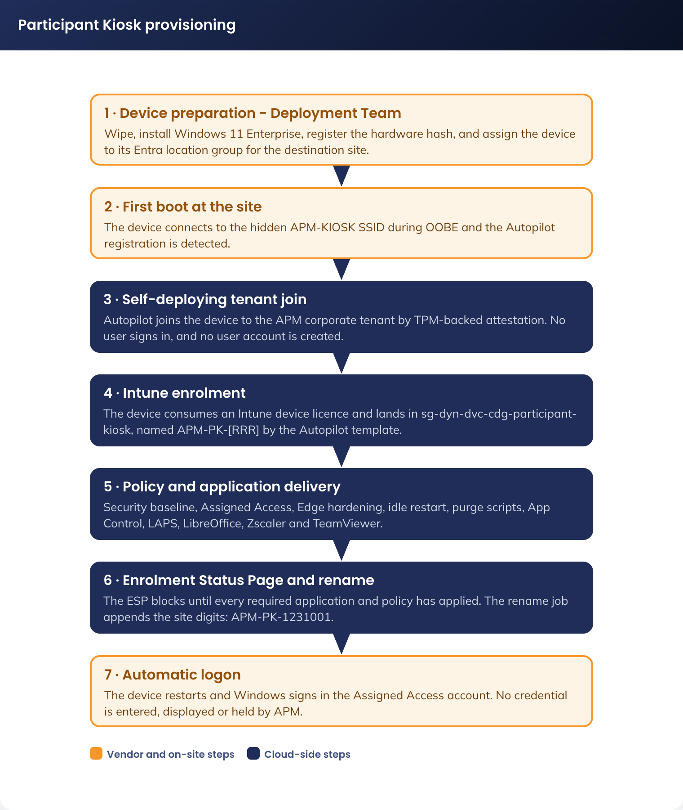
Figure 2. Participant Kiosk provisioning - the Deployment Team preparation, Autopilot self-deployment and automatic logon

5.2 Image Configuration

5.2.1 Image Specification
Operating system | Windows 11 Enterprise
Microsoft Edge | Managed browser with hardened device-scoped policies and preloaded managed favourites. Also the PDF viewer
LibreOffice | Fresh release, Writer, Calc and Impress, installed locally with the configuration in 4.3.6 locked by policy
Microsoft Defender for Endpoint | Enabled and onboarded at device scope; feeds the Intune compliance policy
Zscaler | Client and site IPSEC tunnel as required by the APM standard
TeamViewer | Single pinned major version for remote support
Custom wallpaper | The approved APM participant wallpaper (5.2.6), carrying the on-screen notice about monitoring and data retention
Accessibility tools | Narrator, Magnifier, high contrast, font scaling, speech-to-text and the on-screen keyboard
Not installed | Microsoft 365 Apps, Teams, Zoom, OneDrive sync client, Company Portal, any store application

5.2.2 Printing
No direct printing from Participant Kiosks is provided. Participants email required documents to their case manager from personal webmail for printing. This operating model was approved by the APM Business Owner (DR-001).

5.2.3 USB Storage
Participant Kiosks require access to USB storage so that participants can load or save a resume, and this remains the only document transfer path on the fleet. Because these are participant-owned drives that must remain readable on participant-owned computers of varying types and operating systems, BitLocker and BitLocker To Go cannot be enabled on them: compatibility cannot be guaranteed, and requiring it would encrypt a member of the public’s own media.
Two exception policies are created from the existing Windows security configuration, with the settings below modified from the estate defaults. All other security layers, including Zscaler, Defender for Endpoint and App Control, remain applied. The compensating controls for this exception are set out in 7.3.3.

5.2.3.1 USB Configuration Exception Policy
Setting | Value
Name | CDG-W11-SEC-USB Exception-P-1.0
Removable Disk Deny Write Access | Disable
Removable Disk Deny Write Access (User) | Disable
Deny write access to removable drives not protected by BitLocker | Disabled
Control use of BitLocker on removable drives | Disabled

5.2.3.2 BitLocker Configuration Exception Policy
Setting | Value
Name | CDG-W11-SEC-Bitlocker Exception-P-1.0
Write access to removable data drive not protected by BitLocker | Not configured (Enabled)

5.2.4 Application Delivery and Third-Party Patching
Only four applications run on a Participant Kiosk, and each arrives by a controlled path. The operating system and Edge come from Windows Update for Business (9.3). LibreOffice, the Zscaler client and TeamViewer are Intune Win32 applications assigned to the device group. LibreOffice updates are published into Intune by Patch My PC Publisher, so a new LibreOffice release becomes a superseding Win32 application with no manual repackaging.
Figure 3 shows the delivery chain and, alongside it, the trust chain that decides whether the delivered binary is allowed to execute.
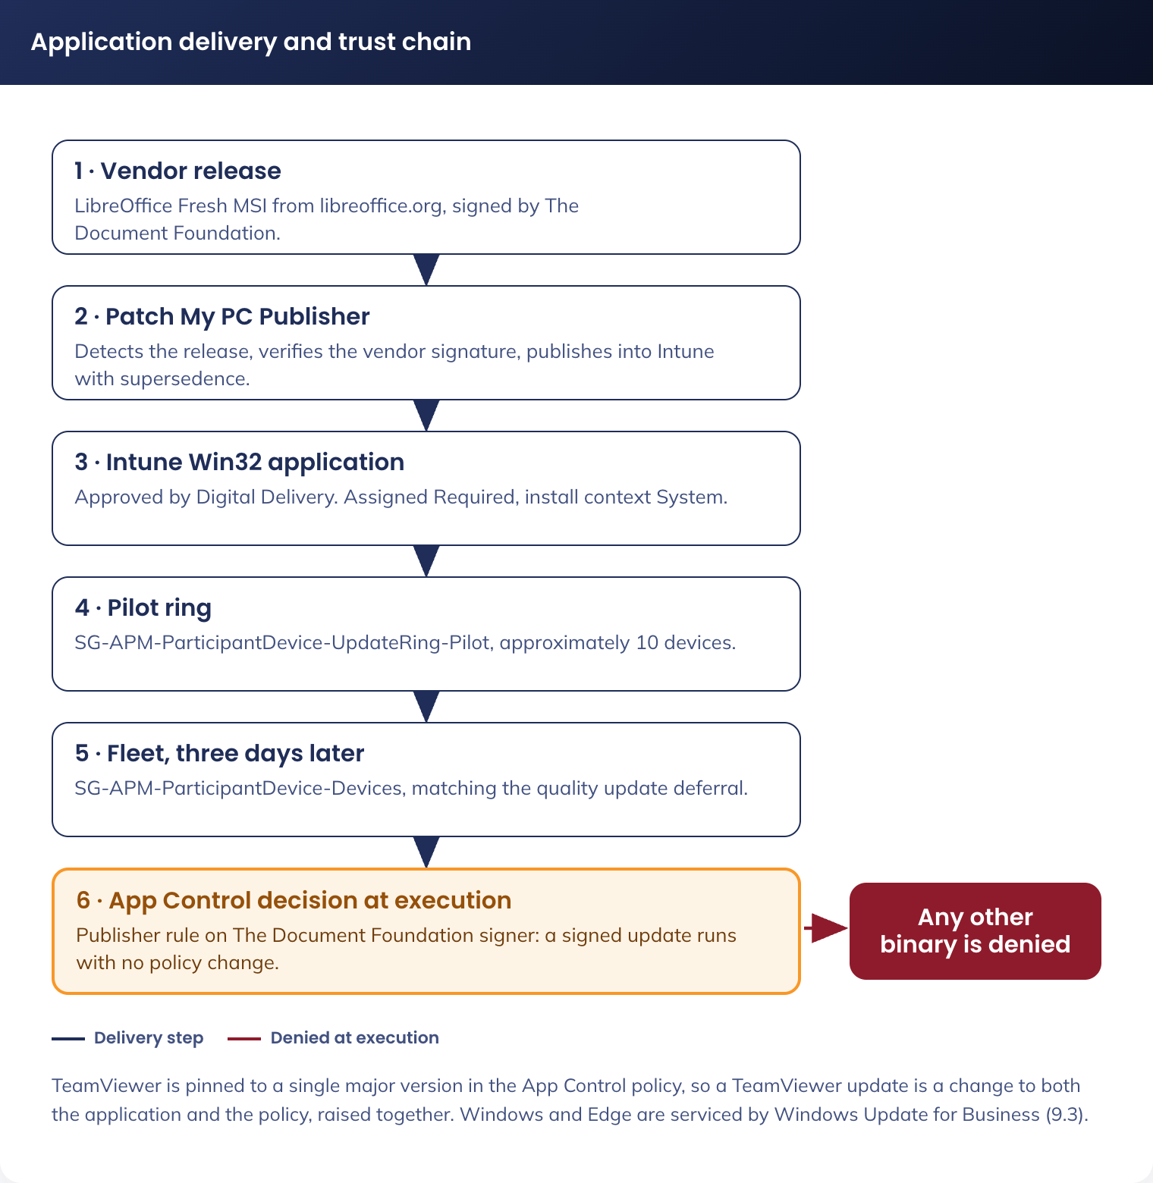
Figure 3. Application delivery and trust chain - source, packaging, delivery ring and App Control decision
Stage | Owner | Detail
Release monitoring | Patch My PC Publisher (Server edition) | Detects a new LibreOffice Fresh release, downloads the vendor MSI and verifies the vendor signature
Packaging | Patch My PC Publisher | Publishes into Intune as a Win32 application with supersedence over the previous version, retaining the vendor-signed binaries
Approval | Digital Delivery | Each published update is approved before assignment. Automatic publishing without approval is not enabled
Pilot ring | sg-stc-dvc-cdg-participant-kiosk-ring1 | The update installs on the pilot devices first, on the same ring used for quality updates
Fleet | sg-dyn-dvc-cdg-participant-kiosk | Assigned three days after the pilot ring reports success, matching the quality update deferral in 9.3
Trust decision | App Control for Business (4.3.9) | The publisher rule trusts The Document Foundation signer, so a signed update runs without a policy change. An unsigned or differently signed binary does not run, whatever delivered it
Verification | Intune application install report, and the Defender for Endpoint software inventory | Both must show the new version on the fleet before the change is closed

TeamViewer is treated differently and deliberately so. Its App Control rule is pinned to the deployed major version (4.3.9), so a TeamViewer update is a change to the App Control policy as well as to the application, raised and approved together. This is the trade for pinning: it prevents an attacker side-loading a different build, at the cost of making version upgrades a controlled change rather than a background one.

5.2.5 Image Lifecycle
1. The image is built from Windows 11 Enterprise and configured entirely by Intune. There is no captured or golden image to maintain
2. The operating system, Edge and Defender are patched monthly through the update rings in 9.3
3. LibreOffice is patched through Patch My PC as each Fresh release ships (5.2.4)
4. The feature version is pinned and moves only after APM validation on the pilot ring

5.2.6 Desktop Wallpaper and On-Screen Notice
The wallpaper carries the participant-facing notice, so it is configuration rather than decoration. APM’s approved artwork is deployed with one line amended: APMES0153 ES Site Desktop Wallpapers V5 CTA, held with this design in config/.
Element | Value | Notes
Source artwork | APMES0153_ES Site Desktop Wallpapers V5 CTA.pdf, amended | APM-approved artwork. One line of copy amended, see below
Deployed image | config/wallpaper-participant-v5.1.png | The amended render. Staged locally to C:\APM\PK\wallpaper.png by the Intune Win32 packaging step
Applied by | PersonalizationCSP DesktopImageUrl, pointing at the local path | Device scope, not user scope, so it applies to the Assigned Access session without a user policy
Lock screen | Not used | The device signs itself in and never presents a lock screen. Nothing is displayed there at any point
Resolution | Supplied at 16:9. Provide the artwork at the native resolution of the procured display and set DesktopImageUrl per resolution if the fleet carries more than one panel size | A stretched notice is a notice nobody reads
Change control | A wallpaper copy change is a change to a participant-facing control and follows the same change process as a policy change | Owner: APM Digital with the Business Owner

The approved copy (monitoring notice, employment use, save to your own cloud storage or USB) matches this design: USB is permitted (5.2.3) and personal cloud storage and webmail remain reachable (7.4).
Copy amendment. The approved artwork said desktop files are "deleted overnight"; this fleet purges on every restart, ten minutes after last input. The deployed line reads:
Don’t save files to the desktop. They’ll be deleted after 10 minutes of inactivity.

Figure 4. Approved participant wallpaper as deployed, carrying the monitoring notice and the amended retention line
Everything else in the artwork - layout, brand elements, monitoring notice, save-to-cloud-or-USB guidance - is unchanged. The deployed render is config/wallpaper-participant-v5.1.png.

5.3 Network and Infrastructure
The Participant Kiosk solution uses the existing site network at APM sites. There are no Azure resources for the fleet to reach, so the egress allow-list carries no cloud destinations beyond device management, and there is no Azure subscription in the solution at all.
Devices connect to the existing VLAN, repurposed and renamed to APM-KIOSK. This is not a new network deployment; the existing wireless service is updated to support the fleet, including an increase to 20 Mbps per site and the removal of the CAPTCHA requirement. The APM-KIOSK SSID is not publicly visible and access is controlled with EAP-TLS authentication using device certificates deployed to devices by Intune policy. The network object names APM-KIOSK and VLAN 73 are retained as approved under DR-003 and DR-005 (see DR-015).

The design uses the organisation’s existing public internet breakout. All device traffic egresses through Zscaler. The solution provides no access to APM corporate systems, internal business applications or unrestricted internet services, and all permitted traffic is inspected and policed by APM-managed network security controls, including the Palo Alto east-west firewalls through Zscaler policy / Meraki MX rules. All other traffic is blocked.
Figure 5 shows the logical network and security zones end to end, from the device at the site to the approved destinations.

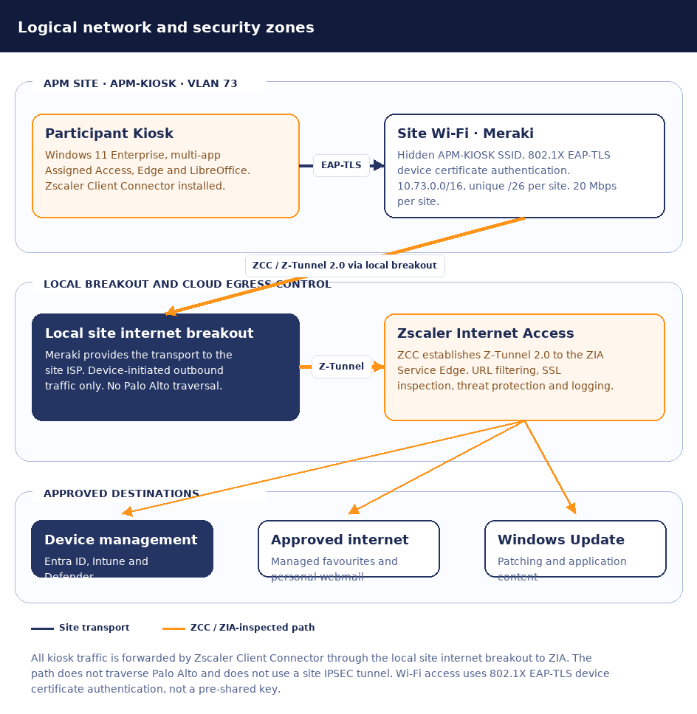

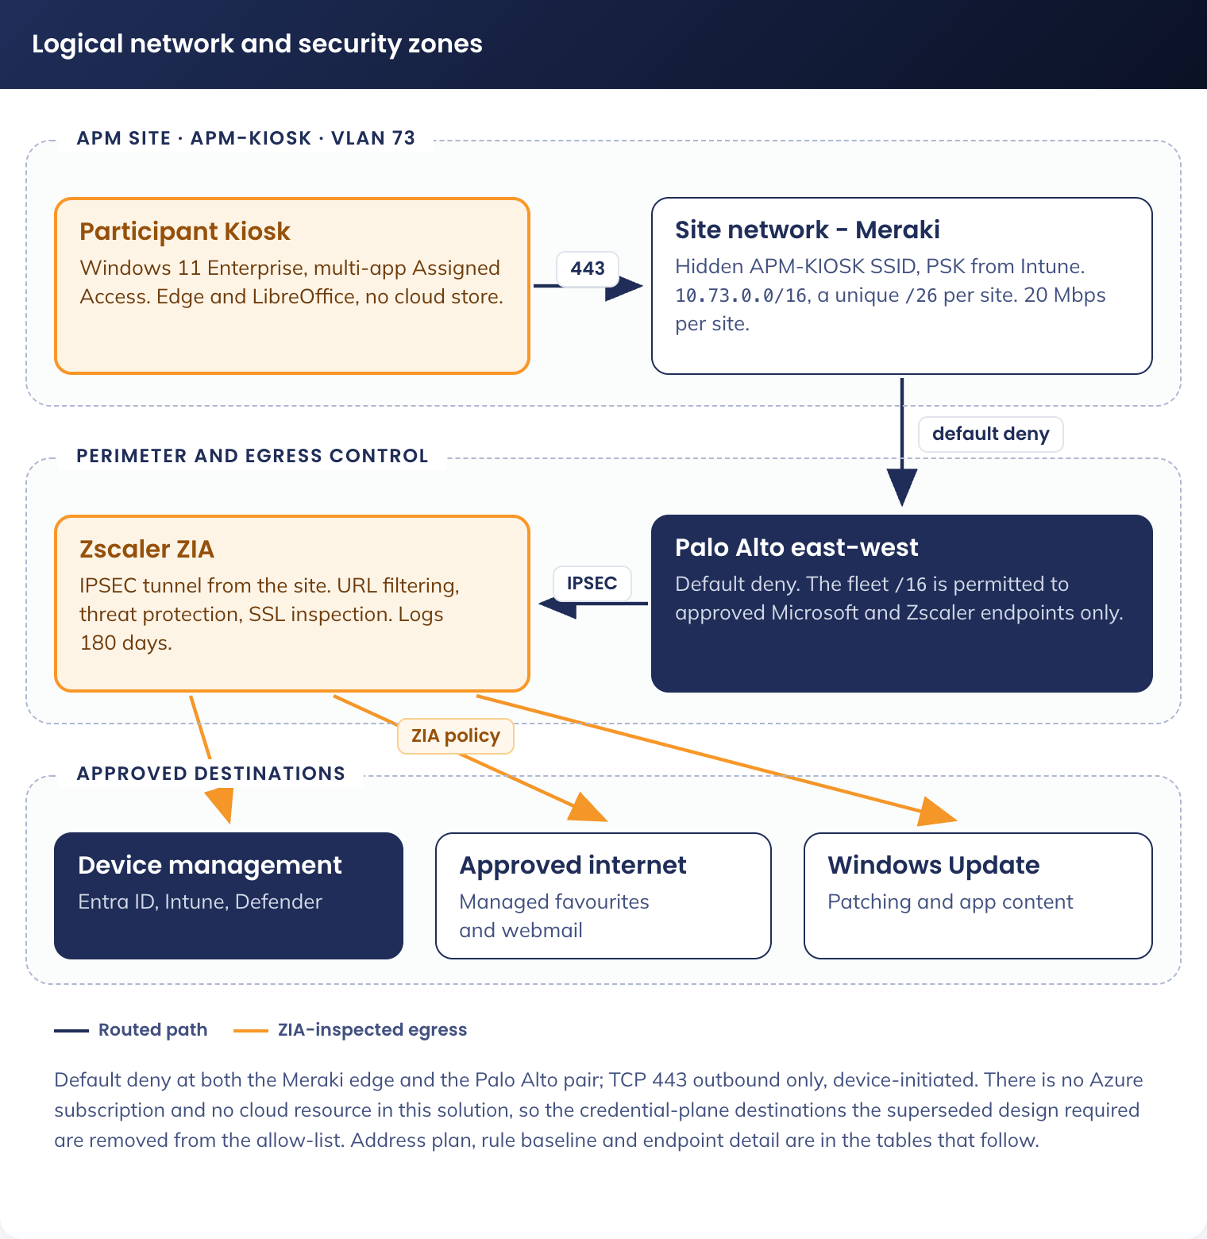
Figure 5. Participant Kiosk logical network and security zones

5.3.1 Device Network Configuration

5.3.1.1 Network Design
Element | Specification | Rationale
Network type | Re-purposed VLAN (APM-KIOSK) | Provides a controlled access network with restricted connectivity and no general corporate or personal device access
Supernet | 10.73.0.0/16 | A unique /26 from 10.73.0.0/16 is assigned to each site through the Meraki template
Per-site allocation | /26 (64 addresses, 62 usable) | Up to five devices per site, 540 devices in total (DR-006). The /26 leaves headroom for growth without re-addressing
VLAN ID | 73 | Existing VLAN, retained
Segmentation | Layer 3 segmentation with firewall enforcement | Prevents unrestricted internet usage while allowing required service access
Internet access | Restricted to approved destinations only | Prevents unrestricted internet usage while allowing the destinations the fleet requires
Security model | Default deny with explicitly permitted connectivity | Only explicitly allowed services are reachable

5.3.1.2 Connectivity Controls
Element | Specification | Rationale
Allowed destinations | Microsoft Entra ID and Intune enrolment and management endpoints, Windows Update and Delivery Optimization, Microsoft Defender for Endpoint, the Intune content delivery network, Zscaler, TeamViewer service endpoints, and the approved web destinations reached through Zscaler | Enables required functionality only. No Azure resource is required by this design
Blocked destinations | All non-approved internet, corporate and unrelated service destinations, including all Microsoft 365 service endpoints other than those required for device management | Enforces strict access control and supports DR-010
DNS | Restricted resolution for approved Microsoft and APM-managed service dependencies. DNS servers to be used are 208.67.222.123 and 208.67.220.123 | Prevents resolution of unauthorised domains
Traffic direction | Device-initiated outbound connectivity only | No inbound exposure to Participant Kiosks

5.3.1.3 Firewall and Filtering (Meraki)
Element | Specification | Rationale
Policy model | Default deny, egress filtering | Strong security baseline
Allowed ports | TCP 443 (HTTPS), plus IPSEC to the Zscaler service edge | Minimises attack surface
Filtering method | FQDN and IP-based allow rules for the approved Microsoft, Zscaler and APM-managed dependencies | Fine-grained control
Inspection | TLS inspection subject to the APM internet security policy and service compatibility | Enhances monitoring and compliance

Source | Destination | Action
10.73.0.0/16 | Microsoft Entra ID and Intune endpoints (login.microsoftonline.com, enterpriseregistration.windows.net, manage.microsoft.com, r.manage.microsoft.com), Windows Update and Delivery Optimization, Defender for Endpoint, the Intune content delivery network, and the Zscaler service edge | Allow
10.73.0.0/16 | Any | Deny

5.3.1.4 Rate Limiting (Meraki)
Element | Specification | Rationale
Per site bandwidth | 20 Mbps | Direct web browsing, application updates and monthly patching for up to five devices at a site

5.3.1.5 Endpoint and Device Management
Element | Specification | Rationale
Device management | Microsoft Intune, device licensed | Centralised governance without a user licence
Compliance | CDG-W11-COM-Participant Kiosk-P-1.0 (7.2.5) | Enforces security posture
Updates | Windows Update for Business rings (9.3) and Patch My PC for LibreOffice (5.2.4) | Controlled patching through approved endpoints
Authentication | Microsoft Entra ID, device authentication only | Device identity; no user authenticates from this fleet

5.3.1.5.1 Endpoint and Device Management
Element | Specification | Rationale
Endpoint identity | Device certificate | Supports the kiosk device identity model
Intune configuration | New kiosk-specific SCEP profile | Provides assignment, reporting and future change isolation from standard Windows endpoints.
Certificate enrolment | Existing NDES URL | Reuses the established SCEP enrolment service and Microsoft Entra Application Proxy publication.
PKI | Existing root and issuing infrastructure
Network authentication | Existing NPS RADIUS | NPS validates the EAP-TLS certificate and applies the relevant wireless policy.
Connectivity | Internet-only (local breakout) via Zscaler | The endpoint reaches Intune and the published NDES URL over HTTPS.

5.3.1.6 Device Restrictions
Element | Specification | Rationale
OS mode | Multi-app Assigned Access, restricted user experience | Prevents user tampering
Peripheral access | USB mass storage permitted; other peripheral classes restricted by policy | Minimises misuse while allowing the approved participant function
Local storage | No persistent participant data | Protects personal information

5.3.1.7 Monitoring and Logging
Element | Specification | Rationale
Logging | Intune and Defender for Endpoint | Operational visibility
Network monitoring | Zscaler logs to Microsoft Sentinel | Detect anomalies
Device monitoring | Intune device diagnostics and Entra ID device sign-in (device authentication) events | Track device health and behaviour. There is no user sign-in log for this fleet

5.3.1.8 Ethernet Port Configuration (Re-Imaging)
Although Participant Kiosks operate on Wi-Fi, the Ethernet ports remain enabled to support servicing.
• Ethernet connectivity is required by the Deployment Team for device recovery, re-imaging, troubleshooting and Autopilot or Intune remediation where Wi-Fi is unavailable or unstable during staging
Purpose:
• Ensures devices can be serviced without bypassing security controls
• Avoids ad-hoc cabling to corporate networks

5.3.2 DNS Configuration
Participant Kiosks connect to the local site network and DNS resolution is provided by the site’s standard DNS forwarders, typically the site network appliance. The devices do not join the APM Active Directory domain and require no resolution of internal domain names; every FQDN they need is a public internet endpoint (Entra ID, Intune, Windows Update, Defender for Endpoint, Zscaler and the approved web destinations). DNS over HTTPS is disabled in Edge so that Zscaler retains DNS visibility (4.3.4).
The DNS servers to be used are 208.67.222.123 and 208.67.220.123.

5.3.3 Zscaler Internet Access
Zscaler is the web filtering and logging control for the fleet. Site traffic is forwarded directly from each Participant Kiosk using Zscaler Client Connector (ZCC)
Requirements
• Zscaler Client Connector is installed on all Participant Kiosk devices as a required Intune application.
• Each device establishes a direct connection to the Zscaler service edge.

Traffic flow
- The Participant Kiosk establishes a Zscaler Client Connector tunnel directly to the nearest ZIA service edge.
- Internet-bound traffic is inspected and filtered by ZIA according to the assigned kiosk policy set.

5.3.3.1 Interaction Flow

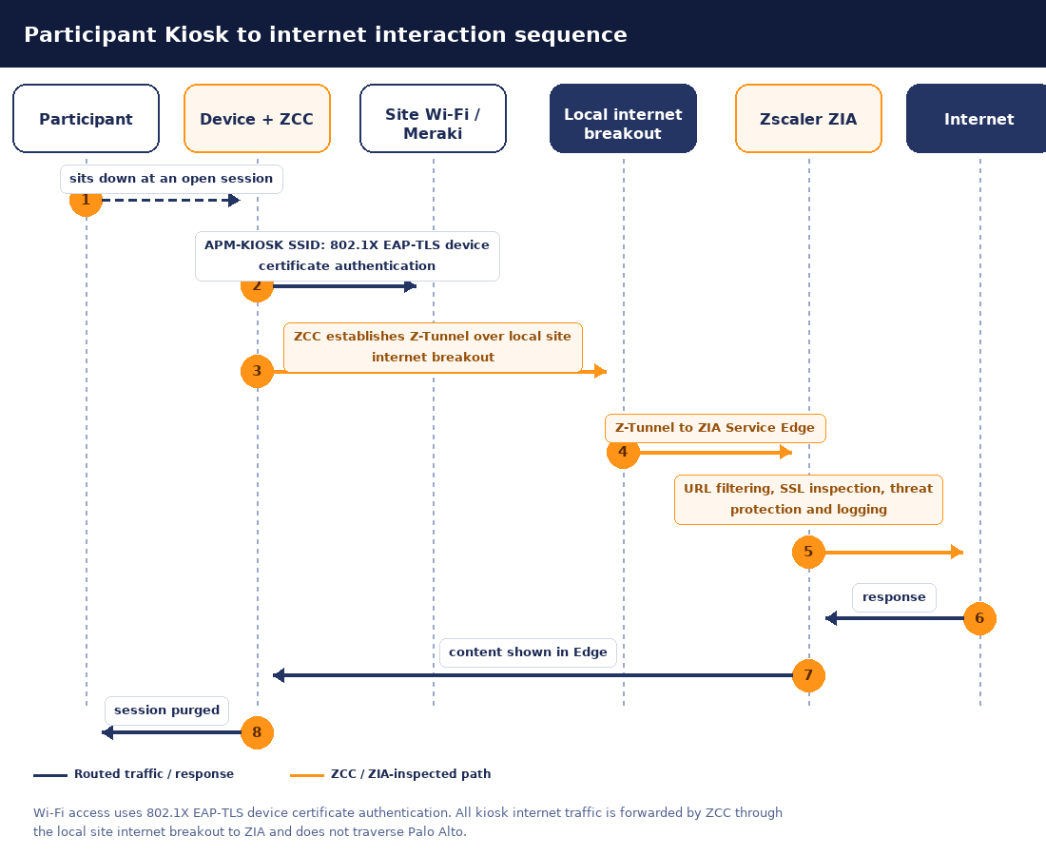

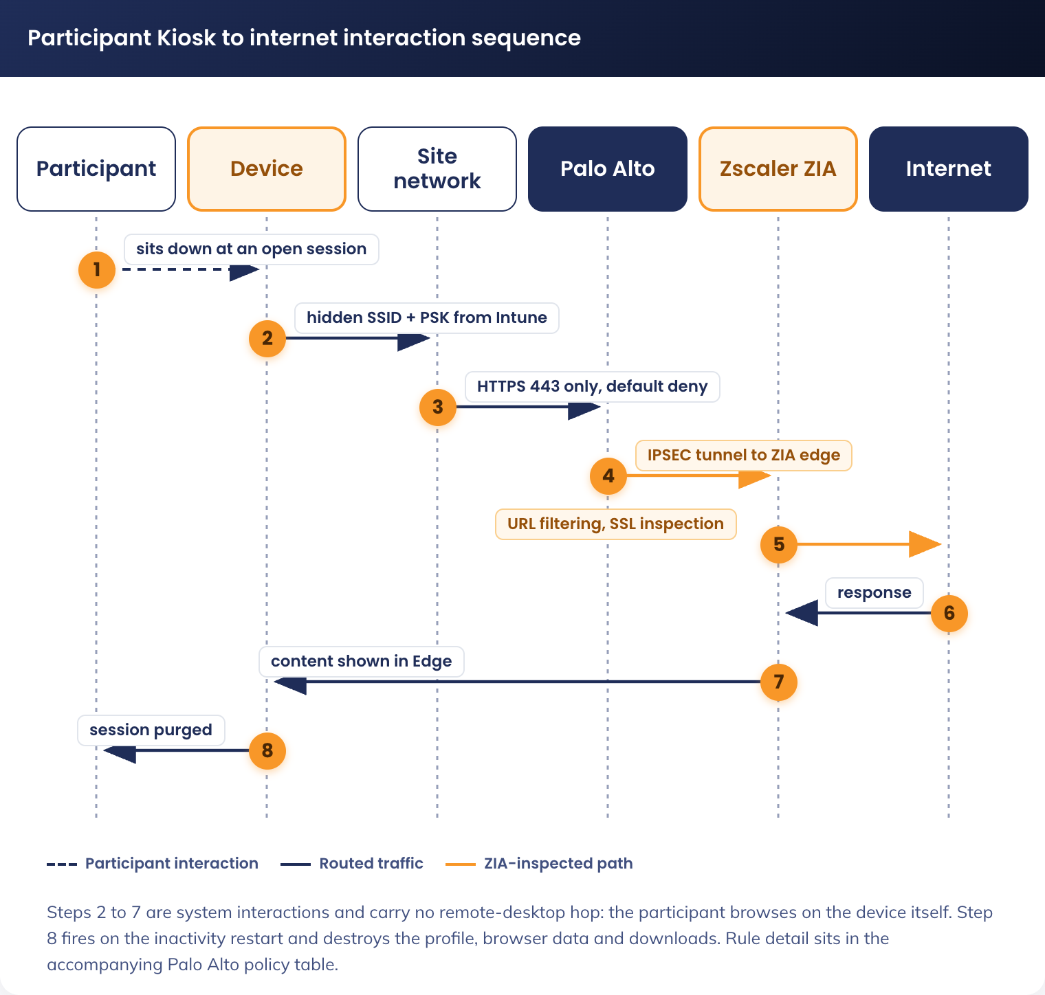
Figure 6. Participant Kiosk to internet interaction sequence

5.3.3.2 Key Components
Component | Purpose
Zscaler Client Connector | Device-based forwarding and policy enforcement
Zscaler Internet Access (ZIA) | Central policy enforcement: URL filtering, threat protection and SSL inspection

5.3.3.3 Monitoring and Logging
All logs are sent to Microsoft Sentinel, per the current state. The retention period for these logs is currently 180 days.
Element | Specification | Rationale
Logging | Sentinel, approximately 180 days | Operational visibility and anomaly detection
Logging | ZIA (Zscaler), approximately 180 days | IP-specific logs and web activity

5.3.4 Zscaler Tenant Configuration (as supplied)
The following is the Zscaler tenant configuration provided by the network delivery team, reproduced here as supplied, in the same order, for review. It was written for a user-identity model that this solution does not use, so the elements that depend on a user identity - the Entra group, the enterprise application, SAML single sign-on, SCIM provisioning, the identity provider and the user-group bindings in the app profile and URL filtering rules - cannot apply as written to a fleet with no user identity. They are reproduced unchanged rather than rewritten speculatively, and are revalidated in the DR-013 workshop. The tunnel, forwarding profile, PAC file and URL filtering categories are unaffected by the identity change.
Sub-section | Status | Why
5.3.4.2.1 Entra Groups | Not applicable, replaced | apm-js-kiosk-users-internet is a group of user identities and this fleet has none. Enforcement binds to the device group sg-dyn-dvc-cdg-participant-kiosk and to the site location instead
5.3.4.2.2 Enterprise Application (SAML, SCIM) | Not applicable, removed | SAML single sign-on authenticates a user and SCIM provisions one. There is no user to authenticate or provision, so neither object is created
5.3.4.3.1 Identity Provider | Not applicable, removed | The identity provider exists to authenticate users against a tenant, and its authentication domain apmkiosk.net.au is retired with that tenant. No identity provider is configured for this fleet
5.3.4.3.2 PAC File (registration) | Applies, without the domain field | A hosted PAC file is a forwarding artefact. The Domain value, which named the retired authentication domain, is not required
5.3.4.3.3 Forwarding Profile | Applies as written | Tunnel version, transport, timeouts, MTU and fallback behaviour are device settings and are unaffected
5.3.4.3.4 App Profile | Applies, bound to the device group | Every setting applies. The User groups value is replaced by device-group or location assignment
5.3.4.3.5 URL Filtering | Applies, bound to location | The allowed and blocked category sets are the control that matters and are unchanged. Both rules are rebound from the user group to the site location
5.3.4.3.6 PAC File content | Applies as written | The APM bypass, Microsoft Update and Azure bypasses, private-IP handling and default forwarding all remain correct

The identity plane is removed, not revalidated: there are no users on this fleet, so enforcement is device and location based throughout (DR-013). The supplied configuration is reproduced verbatim below as the agreed baseline; each sub-section’s applicability is stated above. Open under DR-013 is the mechanism only - site IPSEC location forwarding or Client Connector machine tunnel, both device based.
apmkiosk.net.au is not required by this design. It appears below only as the retired authentication domain; the registration is retained for 12 months as an anti-phishing measure under the decommissioning change request.

5.3.4.1 Overview
The kiosk fleet connects through Zscaler Client Connector on the device, forwarding via a PAC file. Zscaler Cloud is the single internet egress point: it forwards general internet traffic to the internet and authenticates against Azure/M365 via SCIM, while APM Office and the kiosk device reach Zscaler Cloud over HTTPS.
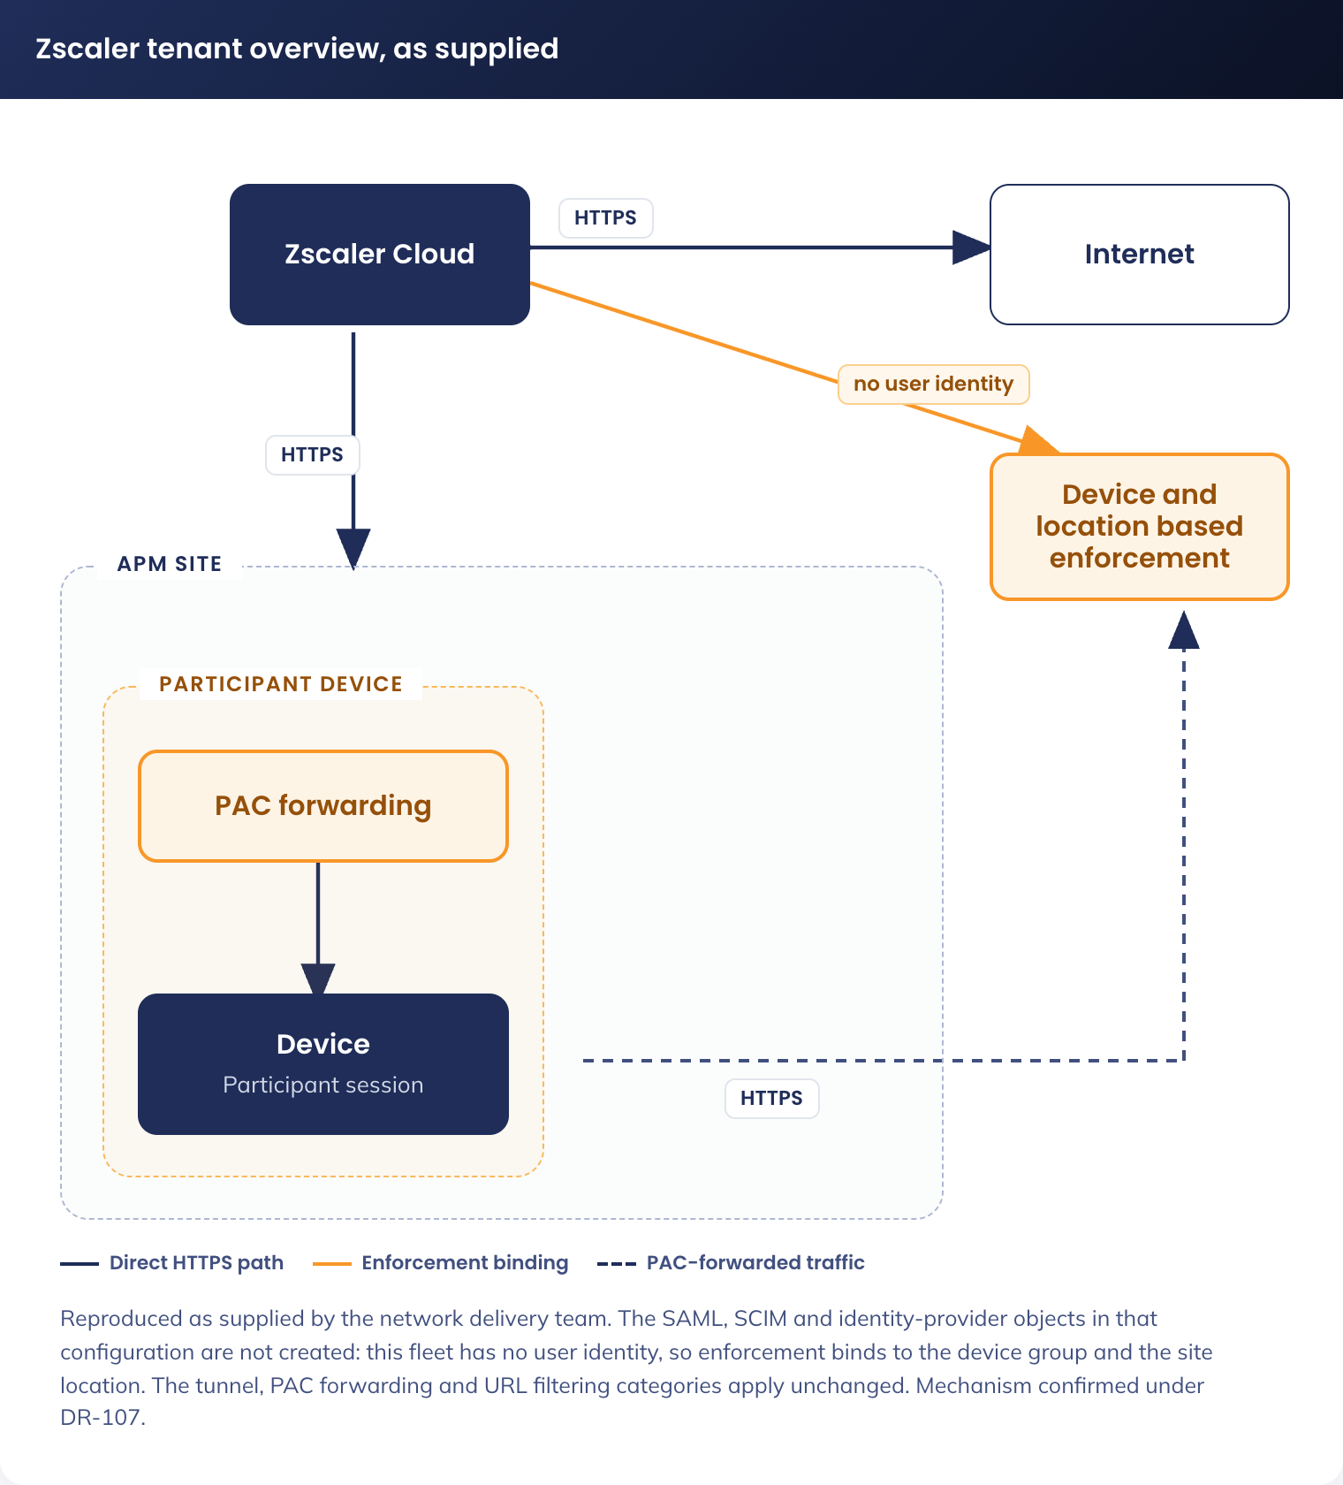
Figure 7. Zscaler tenant overview as supplied - device, PAC forwarding, Zscaler Cloud and the identity elements under revalidation

5.3.4.2 Azure Configuration

5.3.4.2.1 Entra Groups
Group Name | Purpose
apm-js-kiosk-users-internet | Group to apply Zscaler configuration to kiosk users and devices.

Configure: Entra ID -> Groups

5.3.4.2.2 Enterprise Application
Setting | Value
Enterprise App Template | Zscaler Internet Access ZSCloud
Assigned Users | apm-js-kiosk-users-internet
Single Sign-On | SAML
Basic SAML Config - Identifier | https://login.zscloud.net/sfc_sso/38777108
Basic SAML Config - Reply URL | https://login.zscloud.net/sfc_sso
Basic SAML Config - Sign on URL | https://login.zscloud.net/sfc_sso
Basic SAML Config - Users and groups | apm-js-kiosk-users-internet
Provisioning - Tenant URL | https://scim.zscloud.net/38777108/4349816/scim
Provisioning - Secret Token | <from Zscaler>
Provisioning - Mappings | Default
Provisioning - Scope | Sync only assigned users and groups
Provisioning - Status | On

5.3.4.3 Zscaler Configuration

5.3.4.3.1 Identity Provider
Setting | Value
Name | apmkiosk idp
Status | Enabled
SAML Portal URL | https://login.microsoftonline.com/fa7adf0d-de2d-4570-8f5f-4bca4772988f/saml2
Login Name Attribute | NameID
Org-Specific Entity ID | Enabled
IDP SAML Certificate | <from Entra>
Vendor | Microsoft Entra ID
Authentication Domains | apmkiosk.net.au
Enable SCIM Provisioning | On

5.3.4.3.2 PAC File
PAC File Name | Description | Domain | Obfuscate URL
apm-js-kiosk-users | Jobseeker Kiosk Users | apmkiosk.net.au | Yes

Configure: Infrastructure -> Internet & SaaS -> Traffic Forwarding -> Traffic Steering -> Hosted PAC Files. Content: the PAC file script at the end of this section.

5.3.4.3.3 Forwarding Profile
Setting | Value
Profile Name | apm-js-kiosk-users-fp
Trusted Network Criteria | None
Trusted Network Evaluation | All disabled
Windows Driver Selection | Packet Filter-Based
On-Trusted Network | Tunnel
Tunnel version selection | Z-Tunnel 2.0
Primary Transport Selection | DTLS
DTLS Connection Timeout | 9
TLS Connection Timeout | 5
MTU for Zscaler Adapter | 0
Path MTU Discovery | On
Allow TLS Fallback | On
Z-Tunnel 2 setup failure | Fallback to Z-Tunnel 1.0 and Bypass non-web traffic
Redirect Web Traffic to ZCC | No
Use Z-Tunnel 2.0 for Proxied Web Traffic | Not selected
Block Unreachable domains Traffic | On
Drop IPv6 in Dual Stack | On
Drop IPv6 in IPv6 Only | Off
Dynamic ZIA Service Edge | Off
VPN Trusted Network | Select same as "On-Trusted Network"
Off-Trusted Network | Select same as "On-Trusted Network"

Configure: Infrastructure -> Connectors -> Client -> Forwarding Profiles -> Forwarding Profile for Platforms

5.3.4.3.4 App Profile
Setting | Value
Name | apm-js-kiosk-users-ap
Rule Order | 2
Forwarding Profile | apm-js-kiosk-users-fp
Status | Enabled
ZIA Posture Profile | Leave blank
Install Zscaler SSL Certificate | On
Install WFP Driver | On
Location Policy Override | Off
Notification Template | Legacy Notification Template
User groups | apm-js-kiosk-users-internet
Users | None
Follow Global Settings for Partner Login | Off
Allow Users of this Tenant to Login to Other Tenants | Off
Custom PAC URL | {TBC - from apm-js-kiosk-users PAC file - generated at creation}
Fallback to gateway domain | Selected
Use Preferred port from PAC for Tunnel 1.0 | Not selected
Use Preferred port from PAC for Tunnel 2.0 | Not Selected
Strict Enforcement Mode | Not Selected
Override WPAD | On
Disable Loopback Restriction | Off
Restart WinHTTP Service | On
V8 Javascript-based PAC Parser | On
Cache System proxy on startup | Off
App Failover Settings - ZIA Cloud Not reachable | Follow Global Config
App Failover Settings - Z-Tunnel Failover | Follow Global Config
Firewall | All Off
Passwords (all) | {set - record in passwordstate}
Authentication - Prevent Auto Reauth During Device Lock | Off
Authentication - Follow Global Settings for ZPA Reauth | On
Notification and Logging - Log mode | Default
Notification and Logging - Log File Size | 100 (MB)
Notification and Logging - Use Zscaler Notification Framework | Off
Notification and Logging - Captive Portal Detection | On
Notification and Logging - Captive portal disable web security | 10 (minutes)
Notification and Logging - Embedded Captive Portal | Off
Notification and Logging - Packet Capture Captive Portal | On
Client Connect UI - Default Language | Use System Language
Client Connect UI - SCCM Client Configuration | Off
Client Connect UI - Command Line Interface | Off
Advanced - Enable Anti Tampering | On
Advanced - Override Anti-tampering install parameter | Off
Advanced - Send Disable Service Reason | On
Advanced - Enable Client Connector Revert | Off
Advanced - Highlight Active Control | On
Advanced - Clear Kerberos DC | Off
Description | Jobseeker Kiosk Users Zscaler App Profile.

Configuration: Infrastructure -> Connectors -> Client -> Platform Settings -> Windows -> App Profiles

5.3.4.3.5 URL Filtering
Order | Name | Enabled | Categories / Groups | Groups | Action | Description
1 | js-kiosk-allow | Yes | Business and Economy, Education, Entertainment/Recreation, Government and Politics, Health, Advertising [TBC], CDN, FileHost, General AI & ML Applications, Generative AI and ML Applications, Other Information Technology, Portals, Safe Search Engine, Translators, Web Search, Blogs, Discussion Forums, Internet Services, Online Chat, Other Internet Communication, Web Conferencing, Webmail, Zscaler Proxy Ips, Job Search, News and Media, Social and Family Issues, Society and Lifestyle, Special Interests/Social Organisations, Travel, Vehicles | apm-js-kiosk-users-internet | Allow | Allowed JS Kiosk users internet access.
2 | js-kiosk-deny-all | Enabled | All | apm-js-kiosk-users-internet | Block | Block all unapproved JS Kiosk user internet access

Configuration: Policies -> Internet & SaaS -> URL Control -> URL Filtering. Note: Policies are applied top down; allowed categories will be permitted, all others will be blocked.

5.3.4.3.6 PAC File (as supplied)
function wssBypass(url, host) {
return (
shExpMatch(host, '*.ad.apm.net.au') || shExpMatch(host, 'ad.apm.net.au') ||
shExpMatch(host, '*.apm.net.au') || shExpMatch(host, 'apm.net.au')
);
}

function FindProxyForURL(url, host) {

// APM Bypass
if (wssBypass(url, host)) return "DIRECT";

// Microsoft Update Exceptions
if (((localHostOrDomainIs(host, "download.visualstudio.microsoft.com"))||
(localHostOrDomainIs(host, "au.download.windowsupdate.com"))||
(localHostOrDomainIs(host, "download.windowsupdate.com")) ) &&
(url.substring(0,5) "http:" || url.substring(0,6) "https:"))
return "DIRECT";

// Azure Bypass
if(dnsDomainIs(host,"login.microsoft.com")||
dnsDomainIs(host,"login.microsoftonline.com")||
dnsDomainIs(host,"manage.microsoft.com")||
dnsDomainIs(host,"r.manage.microsoft.com")||
dnsDomainIs(host,"login.windows.net")||
dnsDomainIs(host,"microsoftonline-p.com")||
dnsDomainIs(host,"devices.myki.io")||
dnsDomainIs(host,"login.live.com")||
dnsDomainIs(host,"intunendes3-advancedpersonnelmanagement.msappproxy.net")||
dnsDomainIs(host,"msftauth.net"))
return "DIRECT";

var privateIP = /^(0|10|127|192\.168|172\.1[6789]|172\.2[0-9]|172\.3[01]|169\.254|192\.88\.99)\.[0-9.]+$/;
var resolved_ip = dnsResolve(host);
// var country = "${COUNTRY}";

/* Don't send non-FQDN or private IP auths to us */
if (isPlainHostName(host) || isInNet(resolved_ip, "192.0.2.0","255.255.255.0") || privateIP.test(resolved_ip))
return "DIRECT";

/* FTP goes directly
if (url.substring(0,4) "ftp:")
return "DIRECT"; */

/* test with ZPA */
if (isInNet(resolved_ip, "100.64.0.0","255.255.0.0"))
return "DIRECT";

/* Updates are directly accessible */
if (((localHostOrDomainIs(host, "trust.zscaler.com")) ||
(localHostOrDomainIs(host, "trust.zscaler.net")) ||
(localHostOrDomainIs(host, "trust.zscalerone.net")) ||
(localHostOrDomainIs(host, "trust.zscalertwo.net")) ||
(localHostOrDomainIs(host, "trust.zscalerthree.net")) ||
(localHostOrDomainIs(host, "trust.zscalergov.net")) ||
(localHostOrDomainIs(host, "trust.zsdemo.net")) ||
(localHostOrDomainIs(host, "trust.zscloud.net")) ||
(localHostOrDomainIs(host, "trust.zsfalcon.net")) ||
(localHostOrDomainIs(host, "trust.zdxcloud.net")) ||
(localHostOrDomainIs(host, "trust.zdxpreview.net")) ||
(localHostOrDomainIs(host, "trust.zdxbeta.net")) ||
(localHostOrDomainIs(host, "trust.zsdevel.net")) ||
(localHostOrDomainIs(host, "trust.zsbetagov.net")) ||
(localHostOrDomainIs(host, "trust.zspreview.net")) ||
(localHostOrDomainIs(host, "trust.zscalerten.net")) ||
(localHostOrDomainIs(host, "trust.zdxten.net")) ||
(localHostOrDomainIs(host, "trust.zdxdevel.net")) ||
(localHostOrDomainIs(host, "trust.zdxgov.net")) ||
(localHostOrDomainIs(host, "trust.zscaler.us")) ||
(localHostOrDomainIs(host, "trust.zsqa.net")) ) &&
(url.substring(0,5) "http:" || url.substring(0,6) "https:"))
return "DIRECT";

/* for users of Canada if you want to direct traffic to only canada gateways*/
// if (shExpMatch(country, "Canada")) {
// return "PROXY ${COUNTRY_GATEWAY_FX}:80; PROXY ${COUNTRY_SECONDARY_GATEWAY_FX};DIRECT";
// }

/* for all users if you want to direct traffic to country gateways by default */
// return "PROXY ${COUNTRY_GATEWAY_FX}:80; PROXY ${COUNTRY_SECONDARY_GATEWAY_FX};DIRECT";

/* Default Traffic Forwarding. Forwarding to Zen on port 80, but you can use port 9400 also */
return "PROXY ${GATEWAY_FX}:80; PROXY ${SECONDARY_GATEWAY_FX}:80; DIRECT";
}

5.3.5 Fallback Option

5.3.5.1 Traffic Routing
• All internet traffic from Participant Kiosks is routed through the existing Zscaler infrastructure

5.3.5.2 Web Filtering Enforcement
Zscaler policies enforce:
• Blocked categories:
• – Adult
• – Gambling
• – Explicit content
• – Violence
• – Illegal content
• Explicitly allowed:
• – Facebook
• – Personal webmail providers
• – Approved public AI tools, unless categorised unsafe
• Whitelisted:
• – All URLs defined in the managed Edge favourites
No additional logging depth beyond existing APM standards.

5.3.5.3 Authentication Model
• Zscaler enforcement is based on network location and device identity
• No user authentication is available on this fleet, which is the subject of DR-013

5.3.6 Printing Network Considerations
No direct printing from Participant Kiosks is provided. Documents are emailed to the case manager from personal webmail for printing (5.2.2).

5.3.7 Network Responsibilities and Dependencies
Area | Responsibility
APM-KIOSK Wi-Fi SSID | Network team
VLAN and segmentation (Meraki) | Network team
IP addressing and DHCP | Network team
Zscaler routing, policy and provisioning model (DR-013) | Network delivery team (Stratus) with APM Cyber Security
Intune network profiles (Wi-Fi) / Device certificates | Identity and Endpoint
Wireless client isolation on the APM-KIOSK SSID | Network team. Must be disabled for Delivery Optimization peer caching to function (9.3)
Intra-VLAN TCP 7680 (Delivery Optimization peer transfer) | Network team. Permitted between devices on the VLAN; no change to the default-deny egress posture

5.3.8 Network Items Out of Scope
• Site cabling remediation
• Switch hardware upgrades
• Wi-Fi coverage optimisation
• Internet bandwidth upgrades
• Printer physical placement

6. Information and Data Architecture

6.1 Information Model
The Participant Kiosk solution introduces no persistent data store of any kind. There is no cloud store, no mailbox, no OneDrive and no server-side profile. All data exists transiently on the device during a session, and on the participant’s own USB media if they choose to save it there. The information model is defined by what passes through a session:
• Participant input: resumes, cover letters, job applications and form submissions, created in LibreOffice or typed into a website
• Browser data: history, cookies, cached pages, form data and downloads, held in memory only
• Application data: the LibreOffice user profile, recent-document state (disabled by policy) and temporary files in the local profile
• Device telemetry: Intune compliance state, Defender for Endpoint telemetry, Zscaler web logs
Absent by design: participant accounts, sign-in records, mailboxes, cloud documents and directory objects naming a member of the public. The only identity in the system is the device.

6.2 Information Classification
The solution processes participants' personally identifiable information with session-only retention. Every element below is destroyed when the session ends, other than the operational telemetry, which contains no participant identity.
Data Element | Classification | Retention | Protection Mechanism
Resume and cover letter content | PII - Sensitive | Session only | Written to the local profile, which is purged on restart (6.4), or to the participant’s own USB media
Job applications | PII - Sensitive | Session only | Edge ephemeral profile; profile purge on restart
Centrelink medical forms | PII - Health | Session only | Edge ephemeral profile; profile purge on restart
Webmail credentials, if entered | PII - Credentials | Session only | Edge ephemeral profile, password manager and autofill disabled, nothing written to disk
Financial information | PII - Financial | Session only | Edge ephemeral profile, autofill disabled
Browsing history | Activity data | Session only | ForceEphemeralProfiles; ClearBrowsingDataOnExit as a second layer
Zscaler web logs | Activity data | Per APM retention policy (approximately 180 days) | Retained in Zscaler and Sentinel per the existing standard. Attributed to a device and a site, not to a person
Device management and security logs | Operational data | Per APM retention policy | Intune, Defender for Endpoint and Entra ID device events. No participant identity is present

6.3 Session Data Lifecycle
A session begins when the device powers on and Windows signs the Kiosk-[SERIAL] session account in, and ends when the device restarts, either because the inactivity watchdog fired or because a participant or staff member restarted it. Nothing carries from one session to the next. Figure 8 places the controls on the session timeline.
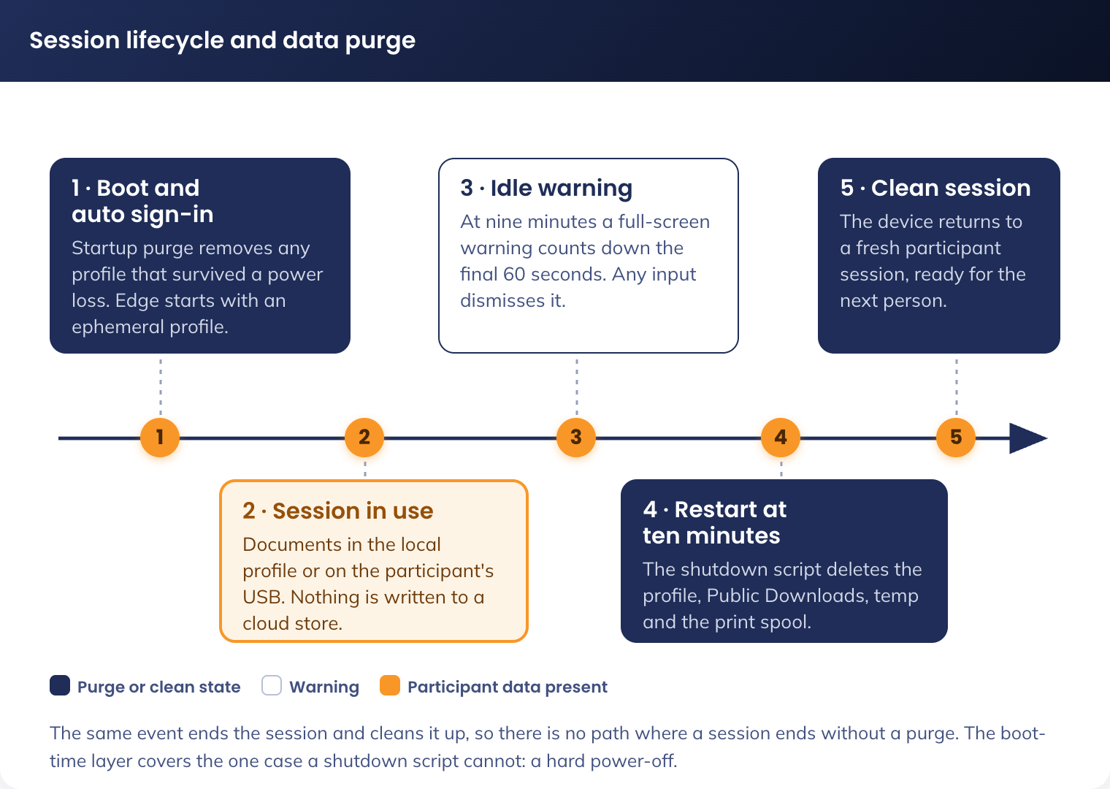
Figure 8. Session lifecycle and data purge - what is written, when it is destroyed, and what survives
The guarantee holds for three reasons: Edge browsing data never reaches the disk (ForceEphemeralProfiles), and downloads land only inside the profile; the purge triggers on the same event that ends the session, so no session can end without one; and the boot-time layer covers hard power-off.

6.4 Purge Layers
Three layers, in the order they act.
Layer | Mechanism | Detail
1. Nothing written | Edge ForceEphemeralProfiles, LibreOffice autorecovery and backup copies disabled, recent-documents list disabled (4.3.4, 4.3.6.2) | The majority of session data never reaches the disk. This is prevention, and it is the layer that does not depend on anything running correctly later
2. Shutdown purge | Signed PowerShell shutdown script, run as SYSTEM by Group Policy shutdown-script assignment during the restart sequence, after the user session has ended | Deletes the participant profile via the Win32_UserProfile CIM class, then clears C:\Users\Public\Downloads, C:\Windows\Temp and the print spool directory. The profile is not loaded at this point in the shutdown sequence, so deletion is clean. Errors are logged and never block shutdown
3. Boot purge | ADMX policy: Delete user profiles older than a specified number of days on system restart, set to 0 days, plus the same purge routine registered as a SYSTEM startup task | Removes any profile that survived, which is the hard power-off case. Runs before the Assigned Access account signs in, so the session that starts is always on a fresh profile

What is deliberately not purged: the participant’s own USB media, which is theirs and is removed with them, and the operational telemetry in Intune, Defender and Zscaler, which carries no participant identity and is retained under the existing APM retention policy.
The scripts in layers 2 and 3 are signed with the APM code-signing certificate, because the inherited Windows 11 baseline sets the PowerShell execution policy to signed scripts only. That dependency is tracked as SOE-02 (7.3.5).

6.5 Why No Data Leaves the Device
Microsoft 365 web applications cannot create a document without writing it to OneDrive; LibreOffice is local, with no cloud store and no account. No participant file leaves the device unless the participant sends it themselves from their own webmail, so nothing is written to a cloud store during a session and nothing needs purging from one afterwards.

7. Cyber and Security Architecture

7.1 RFFR Overview
APM operates under the Workforce Australia Service Deed, which requires compliance with the Right Fit for Risk (RFFR) cybersecurity accreditation framework administered by DEWR. RFFR is based on ISO 27001 and the ASD ISM.
RFFR compliance is managed under APM’s existing ISMS, with the Compliance Manager responsible and Cyber Security consulted, providing assurance. This document supports the accreditation process but does not constitute the ISMS. The Statement of Applicability for this fleet is maintained separately (A-07).
The fleet’s RFFR position rests on three facts: no standing cloud identities and no published credential; no key material and no credential endpoint for the Cryptography and Key Management Standard to attach to; and no Microsoft 365 data plane, so participant information cannot reach a cloud service.

7.2 Identity and Access Control

7.2.1 Licensing Position
The fleet is licensed by device. No user licence of any kind is assigned, because there is no user object to assign one to.
Licence | Basis | What it provides and why it is needed
Windows 11 Enterprise E5 | Per device, 540 | The operating system edition required by the SOE hardening standard, and the entitlement for Microsoft Defender for Endpoint P2 on the device
Microsoft Intune device licence | Per device, 540 | Device enrolment, Autopilot self-deploying, configuration profiles, Win32 application delivery, compliance evaluation and remediation scripts. Without it, self-deploying enrolment fails
Microsoft Defender for Endpoint P2 | Included with Windows 11 Enterprise E5 | EDR, attack surface reduction, vulnerability management and device-level alerting
Microsoft 365 F3 or any user licence | Not assigned | No user identity exists. Nothing in the design requires one
Microsoft Entra ID P1 or P2 | Not assigned to this fleet | No participant identity is licensed. The Conditional Access policy in 7.2.4 is evaluated against APM staff identities, which already hold their own Entra ID licensing, so no additional licence is required to enforce it
Windows LAPS | Included with Windows 11 and Entra ID | Rotation and escrow of the local administrator password (7.2.3)

Confirm the exact Windows 11 Enterprise E5 and Intune device SKUs and their per-device counts with SoftwareOne before the pilot (A-04). The Defender for Endpoint entitlement in particular should be confirmed as covering a device with no assigned user, which is the point of the Windows Enterprise per-device model.

7.2.2 Entra ID Groups
Group Name | Type | Membership | Purpose
sg-dyn-dvc-cdg-participant-kiosk-autopilot | Device (dynamic) | Autopilot group tag: device.devicePhysicalIds -any (_ -eq "[OrderID]:PARTICIPANT") | Targets the Autopilot deployment profile. Keyed on the group tag applied at registration, so devices are in scope before they are renamed
sg-dyn-dvc-cdg-participant-kiosk | Device (dynamic) | Device name starts with APM-PK- | Targets every Intune configuration profile, application and compliance policy in this design
sg-stc-dvc-cdg-participant-kiosk-ring1 | Device (assigned) | Approximately 10 devices: the staging lab plus one or two low-traffic sites | Update ring and application update piloting (5.2.4, 9.3)
sg-stc-dvc-site-[LOC#] | Device (assigned) | Per-location devices, approximately 750 groups, one per site | Location-specific policy and asset management, and the source of the site digits in the device name (5.1.5.2). the Deployment Team assigns each device to its location group during preparation

There is no user group in this design. The kiosk user group in place today, its group-based licensing rule and its Conditional Access assignments are retired under the change request referenced in 9.4.

7.2.3 Local Accounts and Windows LAPS
The three local accounts are listed in 4.3.3. Only one of them has a password APM manages, and it is managed by Windows LAPS rather than by anything this design builds.
Setting | Value
Policy name | CDG-W11-SEC-LAPS-P-1.0
Backup directory | Microsoft Entra ID
Administrator account name | APM-PKAdmin
Password age | 30 days
Password length | 20 characters
Password complexity | Large letters, small letters, numbers and special characters
Post-authentication actions | Reset the password and sign out the managed account
Post-authentication action delay | 8 hours
Retrieval | Entra ID, restricted to the named support group. Each retrieval is recorded in the Entra audit log

This is the control that replaces the Key Vault and Automation credential pipeline for support access (DR-012). It is native to Windows, already licensed, rotates without any APM code, escrows to a directory APM already audits, and resets the password automatically after a support session ends. Nothing about it is specific to this fleet, which is the point: a support engineer uses the same method here as on any other APM Windows device.

7.2.4 Conditional Access
Conditional Access has one job in this design, and it is denial rather than grant: to guarantee that no APM identity can be used from this hardware. There is no participant identity to protect, so the policy set is a single block rather than the layered gates a password-only identity would require.
One policy is added. Figure 9 shows how it sits alongside the device and network controls.
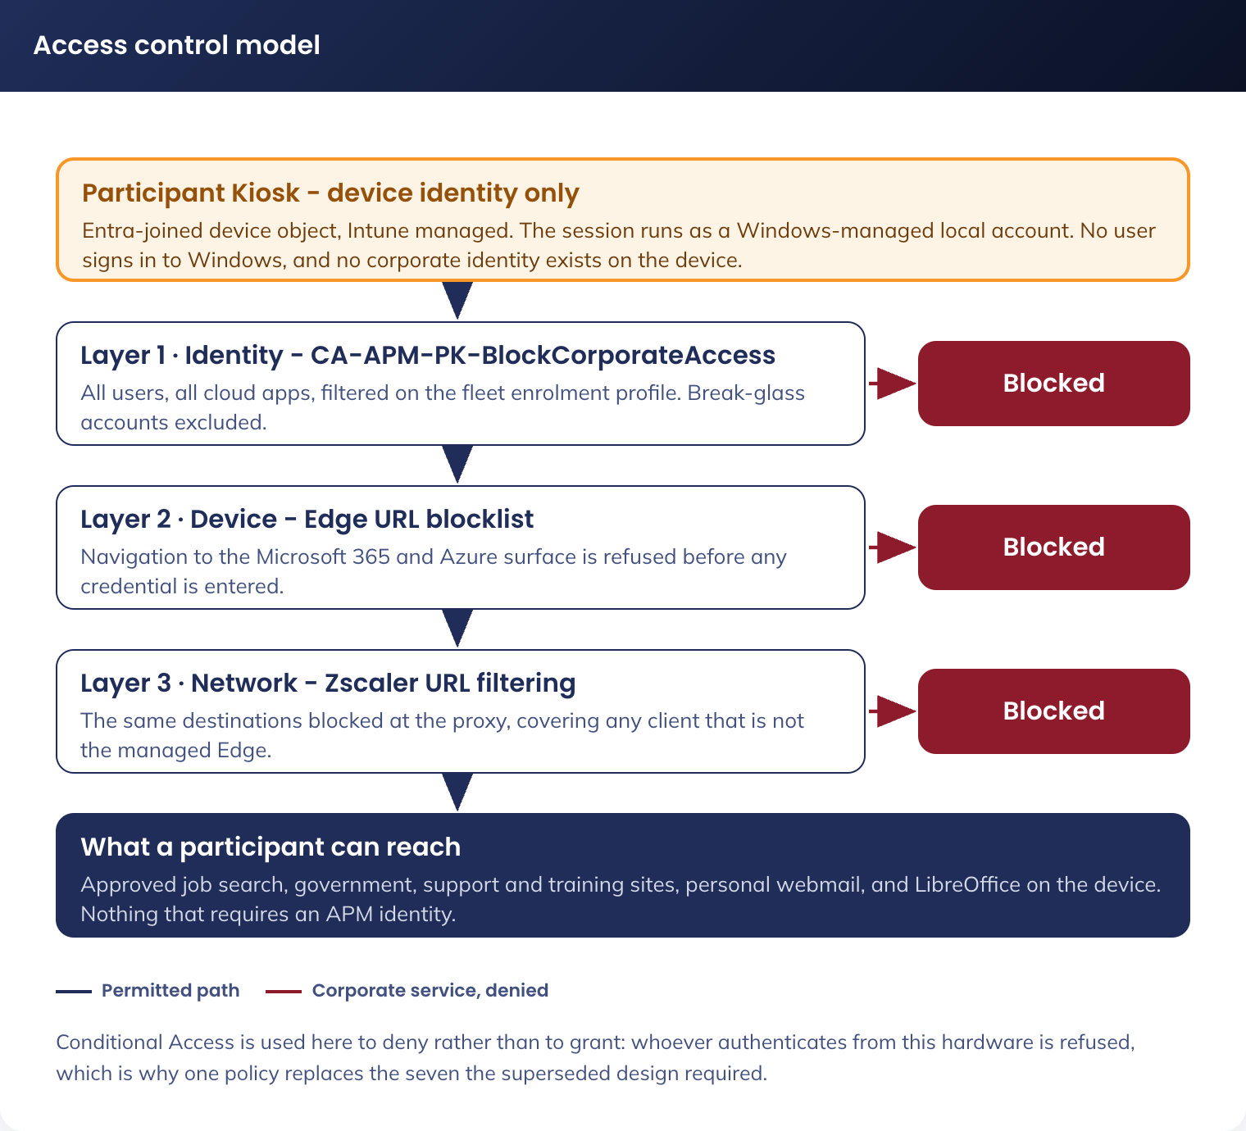
Figure 9. Access control model - device-only identity, and the three layers that keep corporate services off the device
Field | Value
Name | APM-USER-CAP-Block Participant Kiosk Access-P-1.0
Users | Include: All users  Exclude: the two emergency access accounts
Target resources | All cloud apps
Conditions > Filter for devices | Include devices where: device.trustType -eq "AzureADJoined" -and device.enrollmentProfileName -eq "CDG-W11-CFG-Autopilot Self-Deploying-P-1.0"
Grant | Block access
Session | n/a
Rollout state | Report-only for the pilot, enforced before national rollout, per APM Cyber Security practice

Whoever authenticates from a Participant Kiosk is refused. The policy covers every Microsoft 365 workload, the Azure portals and every Entra-federated application, and needs no maintenance as applications are added, because it targets all resources rather than a list.
The filter evaluates on the Entra device object, so it applies to any authentication carrying a device claim. A device the tenant does not know is not evaluated, which is why the browser and network layers in 7.2.6 back it. The emergency access accounts are excluded, as in every tenant policy.
No other new policy is required. The tenant’s existing policies (multi-factor authentication for all users, phishing-resistant multi-factor authentication for administrators, legacy authentication block, authentication flow restrictions) continue to apply to APM staff identities and are unaffected by this fleet. The kiosk identity exclusions that exist in those policies today are retired with the identities themselves, under 9.4.

7.2.5 Compliance Policy
Policy: CDG-W11-COM-Participant Kiosk-P-1.0 | Scope: sg-dyn-dvc-cdg-participant-kiosk
Setting | Required Value
Operating system | Windows 11
Minimum OS version | Pinned to the validated Windows 11 Enterprise feature version (9.3)
Microsoft Defender antimalware | Enabled
Security intelligence up to date | Required
Real-time protection | Required
Antispyware | Required
BitLocker | Enabled
Secure Boot | Required
Firewall | Enabled
TPM | Required
Action for noncompliance | Mark noncompliant immediately, and raise an alert to Digital Operations. No user is present to notify

The policy mirrors the nine device-health and system-security gates in the Windows compliance policy of the APM Windows SOE Hardening Standard V3.0, so a Participant Kiosk is assessed on the same basis as a staff device, and additionally pins a minimum operating system version, which closes the one open observation the standard records against its own policy.

7.2.6 Blocking Microsoft 365 Access from the Device
DR-010 is the decision that participants have no reason to sign in to any APM or Microsoft service from a Participant Kiosk, and that the surface should therefore be removed rather than narrowed. It is enforced at three layers so that no single failure re-opens it.
Layer | Control | What it stops
Identity | APM-USER-CAP-Block Participant Kiosk Access-P-1.0 (7.2.4) | Any APM or Entra-federated identity authenticating from this hardware, including a staff member who sits down at the device
Device | Edge URLBlocklist and URLAllowlist (4.3.4) | Navigation to the corporate service surface, before any credential is entered. Applies even if the identity layer is misconfigured
Network | Zscaler URL filtering (5.3.4.3.5) | The same destinations at the proxy, which also covers any browser or client that is not the managed Edge instance

The blocked and allowed sets are deliberately precise, because participants must retain personal webmail while corporate services are removed.
Disposition | Destinations | Reason
Blocked | login.microsoftonline.com, www.office.com, portal.office.com, admin.microsoft.com, outlook.office.com, outlook.office365.com, teams.microsoft.com, *.sharepoint.com, myapps.microsoft.com, myaccount.microsoft.com, portal.azure.com | The Microsoft 365 and Azure service surface. Blocking the Entra sign-in endpoint in the browser removes the front door to all of it, without affecting device authentication, which does not use the browser
Allowed | outlook.live.com, login.live.com, mail.google.com, accounts.google.com, and other webmail permitted by the Zscaler Webmail category | Personal webmail is how a participant sends a document to their case manager (5.2.2). Blocking the corporate Outlook surface must not block consumer Outlook.com
Allowed | create.microsoft.com | The resume and cover letter template bookmarks. It requires no sign-in

7.2.7 Transport Security
Every connection a Participant Kiosk makes is outbound and TLS-encrypted (4.4). The fleet hosts no service endpoint of its own, so what is specified here is the client position: the versions and cipher suites the device will negotiate, set by the inherited Windows 11 baseline and verified on a pilot device against the APM Cryptography and Key Management Standard.
Element | Position | Enforcement
Minimum TLS version | TLS 1.2, with TLS 1.3 negotiated wherever the service supports it | Schannel configuration in the inherited Windows 11 baseline
TLS 1.0 and TLS 1.1 | Disabled, client and server | Inherited baseline. Verified on a pilot device before rollout
TLS 1.2 cipher suites | Ephemeral key exchange only: TLS_ECDHE_ECDSA_WITH_AES_256_GCM_SHA384, TLS_ECDHE_RSA_WITH_AES_256_GCM_SHA384, TLS_ECDHE_ECDSA_WITH_AES_128_GCM_SHA256, TLS_ECDHE_RSA_WITH_AES_128_GCM_SHA256. Anonymous Diffie-Hellman is not permitted | Schannel cipher suite order, per the Cryptography and Key Management Standard clause 4.2
TLS 1.3 cipher suites | TLS_AES_256_GCM_SHA384, TLS_AES_128_GCM_SHA256, TLS_CHACHA20_POLY1305_SHA256 | As above
Certificate validation | Certificate error overrides are prevented in Edge; the user cannot proceed past an invalid certificate | Microsoft Edge security baseline (7.3.2)
Zscaler TLS inspection | ZIA inspects TLS per the APM internet security policy. The Zscaler root certificate is installed in the device trust store by the Zscaler client, and no other private root is trusted | Zscaler configuration (5.3.4) and the device trust store
Data at rest | BitLocker XTS-AES 256-bit on the fixed drive | Inherited BitLocker policy (7.3.2), with the pre-boot authentication variation in SOE-05

7.3 Security Controls Alignment
Control Area | Solution Component | Implementation Detail
Access control | Entra ID device identity and Conditional Access | No user identity exists. Corporate access from this hardware is blocked outright (7.2.4, 7.2.6)
Session management | Inactivity restart and profile purge | Restart after 600 seconds idle; the participant profile is destroyed on every restart
Data protection | Zero persistence architecture | Edge browsing data never reaches the disk; downloads and documents live only in the profile, purged on every restart; no cloud store exists
Data at rest | BitLocker | Required on all devices by the compliance policy. See SOE-05 on pre-boot authentication
Application control | App Control for Business (WDAC), fleet variant, enforced with script enforcement on | The estate already runs App Control; this fleet inherits the capability and tightens the policy. Only six publishers are trusted, and no installer runs for any user (4.3.9)
Application hardening | LibreOffice locked configuration | Macro execution disabled outright, active content blocked, no recent-document list, no autorecovery on disk (4.3.6.2)
Web filtering | Zscaler | Category filtering, allow-list for approved sites, logging to Sentinel
Endpoint protection | Microsoft Defender for Endpoint P2 | Real-time protection, EDR, attack surface reduction, vulnerability management; feeds the compliance policy
Logging | Zscaler, Intune, Defender, Entra device events to Sentinel | Web activity, device compliance, security alerts
Physical security | Data wipe notice on the wallpaper; device secured at the site | Participants are told the device retains nothing
Network segmentation | APM-KIOSK VLAN with default-deny egress | No route to corporate systems or personal device connectivity
Patch management | Windows Update for Business rings and Patch My PC | Monthly quality and security updates with a daily 03:00 restart; LibreOffice updated per release
SOE hardening standard | APM Windows SOE Hardening Standard V3.0 | Inherited. Inheritance, exclusions and compensating controls are set out in 7.3.1 to 7.3.7

7.3.1 Relationship to the APM Windows SOE Hardening Standard
The Participant Kiosk is a Windows 11 Enterprise endpoint and is governed by the same document as every other APM Windows device: the APM Windows SOE Hardening Standard V3.0 (internal), which carries 748 controls across 11 Intune policies, benchmarked against the ASD Windows Hardening Guidelines, the Microsoft Windows 11 v24H2 baseline and the Microsoft Edge security baseline v139. The kiosk is not a new hardening baseline. It inherits the standard, excludes a small number of controls that the kiosk use case cannot satisfy, compensates for each exclusion, and adds controls the standard does not need to carry for a staffed device.
This position matters for RFFR. An assessor does not audit the controls that were applied; those are already evidenced by the standard. An assessor audits the exclusions. Every exclusion below is therefore named, justified, compensated and given an owner and a review point. Figure 10 sets out the inheritance model.
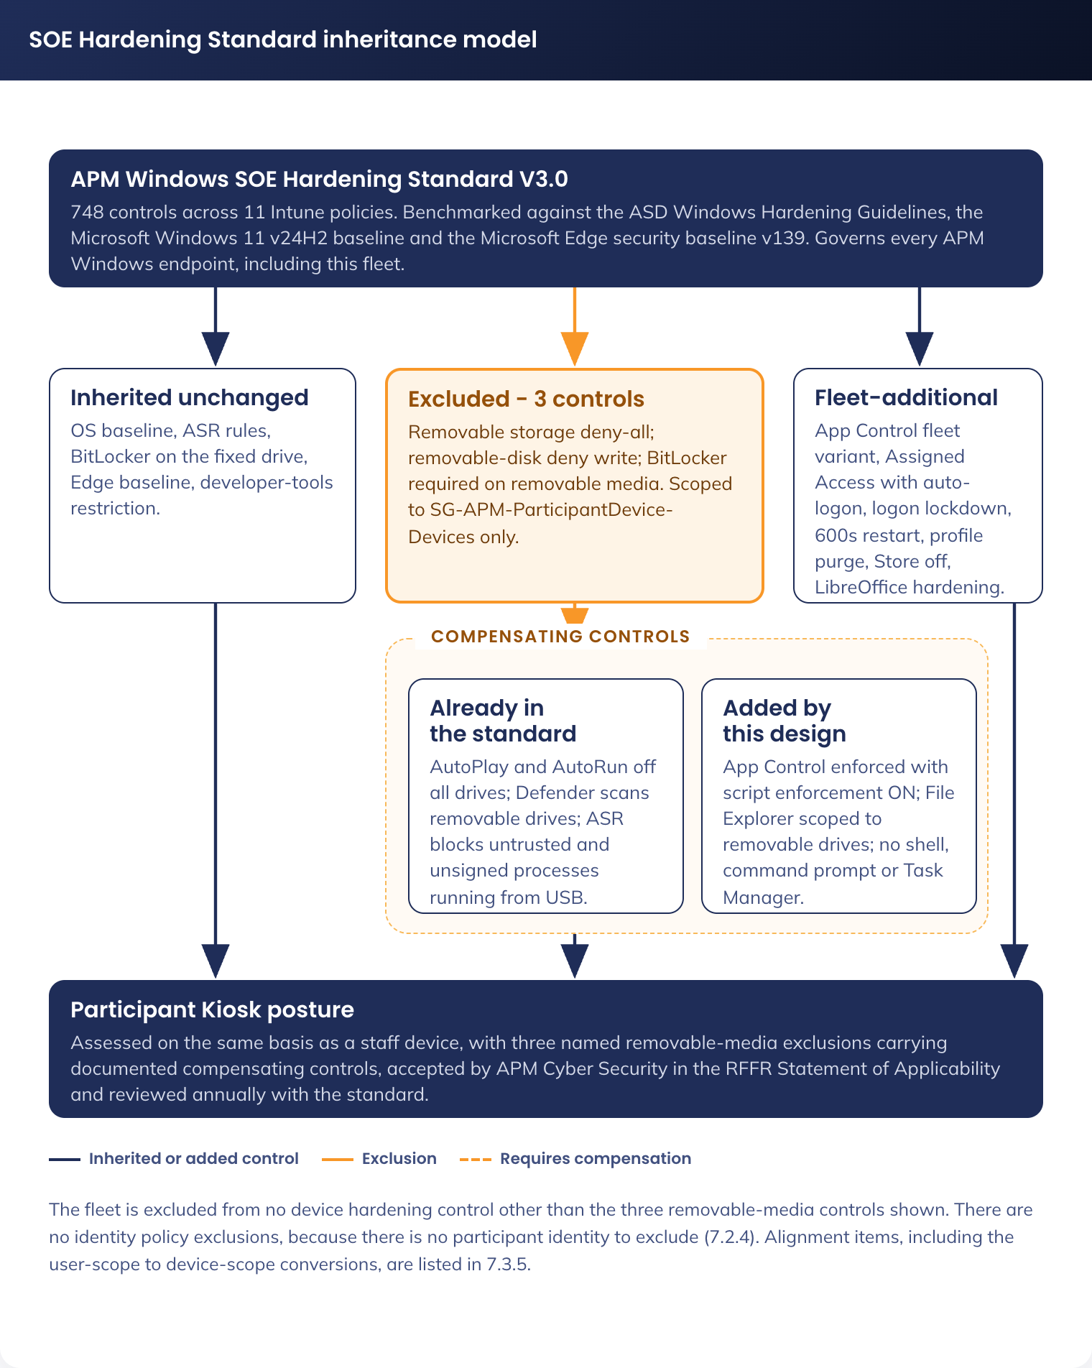
Figure 10. SOE Hardening Standard inheritance model - inherited, excluded and compensated, and fleet-additional controls

7.3.2 Policies inherited without change
The following policies from the standard apply to sg-dyn-dvc-cdg-participant-kiosk as written. No fleet variant of these policies is created, so the fleet stays on the same policy objects as the rest of the estate and inherits future revisions automatically. Application control is the single exception and is treated separately in 7.3.4, because this fleet needs a tighter policy than the estate one rather than the same policy.
Policy (standard) | Intune profile | Relevance to the Participant Kiosk
Windows 11 security baseline (OS) | APM-W11-SEC-Baseline-P-1.2 | 594 controls. Carries the AutoPlay and AutoRun blocks on all drives, Credential Guard with UEFI lock, virtualisation-based security, SMB v1 disabled, anonymous SAM enumeration denied, PowerShell signed-scripts-only execution policy with script block logging, Remote Assistance and Remote Shell disabled, the audit policy set, and the built-in Administrator and Guest accounts disabled and renamed
Attack surface reduction rules | APM-WIN-SEC-ASR-P-1.0 | 20 controls. Includes "Block untrusted and unsigned processes that run from USB", which is the primary compensating control for the USB exception, plus LSASS credential-theft blocking, obfuscated-script blocking and prevalence-based executable blocking
BitLocker drive encryption | APM-W11-SEC-Bitlocker-P-1.1 | 20 controls. XTS-AES 256-bit on the OS drive, pre-boot authentication required, recovery key escrowed to Entra ID before encryption with client-driven rotation. Applies in full to the fixed drive; the removable-drive control is excluded (see 7.3.3)
Microsoft Edge security baseline | APM-W11-SEC-Edge Baseline-P-1.2 | Password Manager disabled, about:flags blocked, certificate error overrides prevented, SmartScreen enforced with no override, DNS-over-HTTPS off so that Zscaler retains visibility, extension install allow-list and block-list enforced
Developer tools restriction | APM-W11-SEC-Edge Dev Baseline-P-2.0 | Developer Tools availability disabled. The fleet is never in the developer exception group
Windows compliance policy | CDG-W11-COM-Participant Kiosk-P-1.0 | A fleet-specific policy object rather than an inherited one: the corporate compliance policies are excluded from this fleet (4.3.8), while the nine device-health and system-security gates they set are reproduced unchanged, with a minimum OS version added (7.2.5)

Two places where this fleet is deliberately stricter than the staff SOE. The standard records the Microsoft Store as set below the benchmark, because some government contracts require Store-delivered applications; this fleet has no such requirement, so "Turn off the Store application" is enabled on the Participant Kiosk and the deviation does not carry across. The standard sets an interactive logon machine inactivity limit of 900 seconds; the Participant Kiosk restarts after 600 seconds and purges the profile, rather than locking the session (see 4.3.2).

7.3.3 Excluded controls and compensating controls
Three controls in the standard are incompatible with the approved participant use case. All three relate to removable media, and all three exist because participants must be able to carry a resume to and from the device on a USB drive: this is an approved business requirement (user story 15) and there is no printing capability on the fleet to substitute for it.
Control excluded | Standard | Participant Kiosk | Compensating controls
All Removable Storage classes: Deny all access | Enabled (ASD, Met) | Not enabled | Removable storage is the only document transfer path on the fleet. Compensated by: AutoPlay and AutoRun disabled on all drives; "Scan removable drives" enabled in Defender; ASR "Block untrusted and unsigned processes that run from USB" enforced; the fleet App Control policy in enforced mode with script enforcement enabled (4.3.9), so neither an executable nor a script carried in on USB is on the trusted-signer list and neither will run; Assigned Access exposes File Explorer scoped to the participant folders and removable drives (4.3.1.2), with no shell, command prompt or task manager
Removable Disks: Deny write access | Enabled (ASD, Met) | Disabled | As above. Write access is required to save a resume. The device holds no corporate data and the tenant holds no corporate content, so the exfiltration surface is the participant’s own document
Write access to removable data-drive not protected by BitLocker | Block (Microsoft baseline, Met) | Not configured | Participants bring personal, unencrypted USB drives; requiring BitLocker would make the transfer path unusable and would encrypt a member of the public’s own media. Compensated by the controls above, and by the fact that the data written is the participant’s own document, created by them, in their possession

7.3.4 Controls the Participant Kiosk Adds Beyond the Standard
Control | Value | Purpose
Application Control - fleet variant | CDG-W11-SEC-AppControl Audit-T-1.0 and CDG-W11-SEC-AppControl Enforced-P-1.0, replacing the estate policy assignment | The one policy where the fleet does not stay on the estate policy object. The estate policy trusts 18 signers, permits supplemental policies and a managed installer, and leaves script enforcement off. This fleet installs nothing after provisioning, so its policy trusts six publishers, forbids supplemental policies and a managed installer, enables script enforcement and is itself signed. Full specification in 4.3.9
Multi-app Assigned Access | Edge, LibreOffice, File Explorer (Downloads, Desktop and removable drives), Zscaler tray, TeamViewer | Removes the shell, Settings, command prompt and Task Manager. The standard has no equivalent, because a staff device needs a full desktop
Automatic logon with a named local account | Kiosk-[SERIAL], standard user, credential generated on-device and held in the LSA secret (4.3.1) | No credential exists for a member of the public to obtain, guess or be given. No published credential exists anywhere in the solution
Logon lockdown | Allow log on locally restricted to Administrators and the Kiosk-[SERIAL] session account | Extends the standard’s Deny Local Log On approach from a deny-list to an allow-list
Inactivity restart | 600 seconds, restart rather than lock | Stricter than the standard’s 900-second inactivity limit, and it destroys the session rather than locking it
Session purge | Three layers (6.4) | Guarantees no participant data survives a session, including after a hard power-off
Turn off the Store application | Enabled | Closes the one control the standard records as set below the benchmark
LibreOffice application hardening | Macros disabled, active content blocked, no autorecovery, no recent documents (4.3.6.2) | The standard has no LibreOffice section. These settings are the equivalent of the Office macro and active-content controls the standard applies to Microsoft Office

7.3.5 Alignment Items
Reading this design against the standard raises the items below. Three are not applicable to this design; four remain open and must be resolved rather than accepted.
Ref | Finding | Action
SOE-01 | Met. The standard sets a minimum device password length of 14 characters | No participant-typed password exists. The session account credential is 32 random characters (4.3.1), and the LAPS-managed administrator password is 20 characters (7.2.3). Both exceed the minimum
SOE-02 | Open. The Windows 11 baseline sets the PowerShell execution policy to signed scripts only. This design depends on device-side scripts: the idle watchdog, the shutdown and startup purge, and the device rename | Every script must be signed with the APM code-signing certificate, as must the App Control policy itself (4.3.9). Both are gated on that certificate being issued, which remains a program dependency and the single largest build gate. Owner: AVD Build Engineer (Twiki Corp), with APM Cyber Security to issue
SOE-03 | Variation submitted. The standard disables all remote-access paths. This design allow-lists TeamViewer | Remote support access model documented in 4.3.10: attended consent for participant-present sessions, LAPS-managed per-device credentials, named operator accounts with multi-factor authentication, file transfer disabled, session logging to Sentinel. Remote Desktop, Remote Assistance and Remote Shell remain disabled. Submitted to APM Cyber Security as a documented variation
SOE-04 | Not applicable. The baseline enables "Block user from showing account details on sign-in" | Nothing is displayed at sign-in and no lock screen is presented, because the device signs itself in with a credential no human ever sees (DR-011). There is no deviation to argue
SOE-05 | Open. The standard requires BitLocker pre-boot authentication. A device that signs itself in unattended cannot prompt for a pre-boot PIN, so pre-boot authentication cannot be used on this fleet | Request an approved variation: TPM-only unlock with Secure Boot integrity validation, recovery key escrowed to Entra ID, and the compensating controls of a device holding no persistent data and no corporate credential. This applies to any unattended device and should be closed formally rather than carried. Owner: Shaun Struik, for APM Cyber Security acceptance
SOE-06 | Open. The corporate Edge hardening configuration is largely user-scoped. A user-scoped policy does not apply to a device with no corporate user, so those controls would silently not land on this fleet | Convert the Edge configuration to device scope for this fleet and validate against CIS Microsoft Edge Benchmark Level 2 as the minimum bar (7.3.6). Owner: End User Computing, with Digital Delivery
SOE-07 | Open. The same problem applies to any Windows 11 baseline control that APM currently assigns at user scope | Audit the ISM Windows 11 baseline assignment for user-scoped components and reproduce them at device scope for this fleet, with any functional exception documented (7.3.7). Owner: End User Computing, with APM Cyber Security

7.3.6 Edge Hardening at Device Scope (CIS Level 2)
Microsoft Edge is the participant’s entire view of the internet on this device, so it carries more of the security weight here than on a staff device that also has a managed application estate behind it. Two things follow.
First, every Edge policy must be device-scoped. The corporate Edge configuration relies in part on user-scoped policy, which does not apply where no corporate user signs in; a control that does not apply is worse than one that was never claimed, because it is recorded as met. The conversion is tracked as SOE-06.
Second, the target is the CIS Microsoft Edge Benchmark Level 2 as a minimum, layered on the Microsoft Edge security baseline the standard already assigns (APM-W11-SEC-Edge Baseline). The settings in 4.3.4 are the fleet-specific ones; the benchmark supplies the rest. Where a benchmark control conflicts with a functional requirement, the exception is recorded rather than silently dropped.
Benchmark control | Position on this fleet | Reason
Browser sign-in disabled | Applied, stricter than the benchmark | No account of any kind may be added to Edge
Password manager and autofill disabled | Applied | A public device must never retain a credential
Developer tools disabled | Applied | Inherited from APM-W11-SEC-Edge Dev Baseline. This fleet is never in the developer exception group
DNS over HTTPS disabled | Applied | Zscaler must retain DNS visibility
SmartScreen enforced, no override | Applied | Inherited from the Edge security baseline
Extension installation blocked, allow-list empty | Applied | No extension is required by the participant use case
InPrivate browsing disabled | Applied | The whole profile is ephemeral; a second private mode adds no protection and complicates support
Translation and Read Aloud | Retained, exception to a stricter reading of the benchmark | Accessibility requirement 03. Documented as a functional exception
Downloads permitted | Retained, exception | Requirement 15 depends on saving a file. Downloads are destroyed with the profile and scanned by Defender

7.3.7 ISM Windows 11 Baseline at Device Scope
The fleet takes the APM ISM-aligned Windows 11 baseline as written, at device scope, with the exclusions in 7.3.3 and the additions in 7.3.4. Three checks are required before the pilot, all of them the same class of problem as SOE-06: a control assigned at user scope, or granted through a corporate group, does not land on a device with no corporate user.
1. Audit every baseline component the estate assigns at user scope and reproduce it at device scope for sg-dyn-dvc-cdg-participant-kiosk
2. Confirm that no policy, application or access grant reaches the fleet through a corporate group membership, per the exclusion register in 4.3.8
3. Record any control that cannot be applied for a functional reason as an exception with a compensating control, in the same form as 7.3.3, rather than leaving it unassigned
The fleet-specific functional exceptions expected are the three removable-media controls already documented in 7.3.3, the BitLocker pre-boot authentication item (SOE-05), and the remote-access variation (SOE-03). No other exception is anticipated; any further one found during the baseline audit is raised with APM Cyber Security before the pilot completes.

7.4 Web Filtering
Action | Categories / Sites
Block | Adult, gambling, explicit content, violence, illegal content
Block | TikTok, Instagram, X (Twitter)
Block | Microsoft 365 and Azure corporate service URLs (7.2.6)
Allow | Facebook (community job boards), public AI tools unless categorised high risk
Allow | Personal webmail (Webmail category), including Outlook.com and Gmail
Whitelist | All URLs in the managed favourites (4.3.5, 3.2.2)

7.5 Risk Register
Every risk carries a treatment and a named owner. Where the residual risk is accepted, the accepting party is named.
ID | Risk | Likelihood | Impact | Treatment | Owner
R-01 | A device in a public area is tampered with or stolen | Medium | Low | BitLocker on the fixed drive, Secure Boot, App Control enforced, no persistent data, no corporate credential on the device, asset register and site physical controls. Residual accepted by APM Cyber Security | Digital Operations
R-02 | Malware is introduced on a participant USB drive | Medium | Medium | AutoPlay and AutoRun disabled, Defender scan of removable drives, ASR rule blocking untrusted and unsigned processes from USB, App Control enforced with script enforcement on. See 7.3.3 | APM Cyber Security
R-03 | A staff member signs in to a corporate service from a Participant Kiosk | Medium | Medium | Three-layer block (7.2.6). Residual: a non-federated third-party service not covered by Conditional Access, treated by Zscaler category policy and accepted by APM Cyber Security | APM Cyber Security
R-04 | A participant recovers the previous participant’s data | Low | High | Three purge layers (6.4), Edge ephemeral profiles, restart-triggered purge. Validated by test case in 9.6 | Digital Delivery
R-05 | The Assigned Access profile fails to apply and the device exposes a full desktop | Low | High | Fail-secure by design: no automatic logon occurs and no usable account is presented (5.1.2). Intune reports the failure and the compliance alert routes to Digital Operations | Digital Operations
R-06 | A remote support session is misused | Low | Medium | Attended consent for participant-present sessions, LAPS-managed per-device credentials, named operator accounts with multi-factor authentication, file transfer disabled, session logging to Sentinel (4.3.10) | Digital Operations
R-07 | An unpatched LibreOffice vulnerability is exploited by a malicious document | Medium | Medium | Vulnerability exposure is managed by automated patching, not by manual effort: Patch My PC publishes each LibreOffice release into Intune and Windows Update for Business rings deliver the operating system, Edge and Defender platform updates (9.3). Macros and active content are disabled outright, Defender vulnerability management reports the installed version on every device, and App Control prevents any dropped payload from executing | APM Cyber Security
R-08 | A device is used to attack the site or corporate network | Low | High | Default-deny egress on the APM-KIOSK VLAN, no route to corporate systems, Meraki enforcement, Zscaler inspection, device-initiated outbound traffic only | Network team
R-09 | The Zscaler provisioning model is not settled in time for rollout (DR-013) | Medium | Medium | Workshop scheduled with Zscaler once a validated device exists. The design is buildable on location-based forwarding without change, so this delays confirmation rather than the build | APM Cyber Security with Stratus
R-10 | The APM code-signing certificate is not issued in time (SOE-02) | Medium | High | Escalated as a program dependency. Without it the session scripts cannot run under the signed-scripts-only execution policy and App Control cannot be deployed signed. No workaround is proposed; the alternative of relaxing the execution policy is rejected | Shaun Struik, escalated to the PM

8. Service Availability and Disaster Recovery

8.1 Business Service Tiering
The Participant Kiosk solution supports participant access to employment services, and its availability affects APM’s ability to meet Workforce Australia service deed obligations. It is classified as a Tier 3 service: important but not mission-critical, where an outage is disruptive but does not immediately stop core business operations.
There is no cloud dependency in the sign-in path. A Participant Kiosk with no internet connection still powers on, signs itself in and presents LibreOffice, because the session account is local and its credential is held by Windows. Connectivity is required for browsing, management and patching, not for the device to be usable.

8.2 Service Availability
Component | Availability Target | Dependency
Device session (power on to usable session) | No external dependency | Local only. Assigned Access and the local account are on the device
Microsoft Entra ID | 99.99% (Microsoft SLA) | Required for device authentication and compliance reporting, not for the session to start
Microsoft Intune | 99.9% (Microsoft SLA) | Required for policy and application delivery, not for the session to start
Internet access via Zscaler | Per existing APM SLA | Required for browsing. A Zscaler outage leaves the device usable for LibreOffice work only
Physical device | Hardware dependent | Dell hardware warranty and Wi-Fi coverage at the site
Patch My PC publishing | Not runtime-critical | An outage delays a LibreOffice update; it does not affect a device in service

8.3 Disaster Recovery and Resilience
The architecture is inherently resilient because it is stateless:
• No persistent data. There is nothing to recover. Every session starts from clean device state by design
• No cloud identity. There is no account to restore, no password to reissue and no directory dependency for a device to be used
• Device failure. Replace the device, register its hardware hash in Autopilot, and it self-provisions with no data migration
• Site failure. Devices at other sites are unaffected; there is no shared component between sites other than the Microsoft and Zscaler services
• Tenant-level failure. A Participant Kiosk continues to run its current configuration and remains usable for local document work; policy and application changes resume when the service returns
• App Control recovery. Because the enforced policy is signed, it cannot be removed by deleting an Intune profile. A replacement policy, signed with the same APM code-signing certificate and set to audit mode, is produced and held in escrow with the certificate before the enforced policy is deployed. Applying it is the documented rollback, tested on a pilot device (T-21). Boot Audit On Failure is enabled, so a policy fault degrades to audit rather than preventing boot

9. Service Management

9.1 Service Management Principles
• All changes to the solution follow APM’s existing change management process
• Intune policy and application changes are deployed to the pilot device group before broad rollout
• Operational runbooks are maintained for routine tasks: device replacement, remote support, application updates and the decommissioning activity in 9.4
• There is no participant identity to administer, so no account, password or licensing runbook exists for this fleet
Incident reporting follows the APM Cyber Incident Response Plan. A suspected or actual security incident involving a Participant Kiosk is reported immediately through APM Assist and logged as a ServiceNow ticket; a P1 or P2 incident is additionally recorded in the Major Cyber Security Incident Register. Site staff use the same reporting path they use for any other APM device. Where the alert originates in Intune, Defender for Endpoint or Sentinel, Digital Operations raises the ticket and notifies APM Cyber Security.

9.2 Monitoring, Logging, Reporting and Alerting
All sources below export to Microsoft Sentinel through the existing APM connectors. Sentinel is the correlation and retention layer (180 days per policy) and the RFFR evidence source; the Alerting column states where each alert is raised and who acts on it.
Platform | Metrics | Alerting
Microsoft Intune | Device compliance state, configuration profile success and failure, application install state, Autopilot enrolment outcomes | Alert to Digital Operations on any Assigned Access profile failure, which is the condition that would leave a device without automatic logon (R-05)
Microsoft Defender for Endpoint | Device alerts, attack surface reduction events, removable-media events, installed software inventory and vulnerability findings | Alert to APM Cyber Security on any device alert of medium severity or above
Defender vulnerability management | Installed software inventory and CVE exposure per device, and the exposure score for the fleet | Reviewed at the existing weekly vulnerability review meeting. Because both patch channels are automated (Patch My PC for applications, Windows Update for Business rings for the operating system, Edge and the Defender platform), a finding that persists beyond one patch cycle is the exception that is actioned, not the norm
Microsoft Entra ID | Device authentication and compliance events, and any sign-in attempt blocked by APM-USER-CAP-Block Participant Kiosk Access-P-1.0 | Alert to APM Cyber Security on a blocked corporate sign-in from a Participant Kiosk, which indicates either staff misuse or a device outside the fleet carrying the enrolment profile
Windows LAPS | Password retrieval events from the Entra ID audit log | Report monthly to Digital Operations. An unexpected retrieval is investigated
Zscaler | Web activity logs per the existing APM standard | Per the existing APM alerting policy, with logs to Microsoft Sentinel
Purge and idle scripts | Scheduled task result and script exit codes, collected by Intune remediation reporting | Alert on repeated failure of the purge script on the same device. A device whose purge fails is remediated or removed from service
Microsoft Sentinel | The aggregate: Intune device and compliance events, Defender for Endpoint alerts and device inventory, Entra ID device authentication and blocked sign-ins, Windows LAPS retrieval events, Windows security log, TeamViewer connection reports and Zscaler web activity | The correlation and retention layer for the fleet, and the source for RFFR evidence. Alert rules and playbooks follow the existing APM Sentinel practice; nothing fleet-specific is required beyond scoping the existing rules to include these devices

There is no user sign-in anomaly detection for this fleet, because there is no user identity to watch and no credential rotation to monitor. The device-centred equivalent is in the table above: a blocked corporate sign-in from Participant Kiosk hardware is itself the anomaly worth alerting on, because legitimate use of this fleet never involves an APM identity.

9.3 Patching Lifecycle
The Participant Kiosks are added to dedicated Windows Update ring policies, CDG-W11-UPD-Windows Update-T-Ring 1 and CDG-W11-UPD-Windows Update-P-Ring 2, which install quality and security updates and restart on a daily 03:00 cycle. Feature updates are deferred and pinned to a validated feature version through the ring policy.
Windows 11 Enterprise on the fleet receives monthly quality and security updates through Windows Update for Business, managed by the ring policies above. Feature updates also apply on Windows 11 Enterprise; they are deferred and pinned to a validated feature version so the fleet build changes only after APM validation.
Update Ring Design
Two rings. A pilot validates each monthly update before the fleet receives it, matching the pilot-before-rollout principle in 9.1. The rings mirror the estate ring design; the only reason the fleet carries its own pair is the unattended daily 03:00 install and restart, which a staffed device does not need. Where an existing estate ring already provides that window, the fleet joins it rather than duplicating a policy object (4.3.8).
Ring | Intune policy name | Assigned group | Quality deferral | Purpose
Pilot | CDG-W11-UPD-Windows Update-T-Ring 1 | sg-stc-dvc-cdg-participant-kiosk-ring1 (approx. 10 devices: staging lab plus one or two low-traffic sites) | 0 days | Validate the monthly update before fleet rollout
Production | CDG-W11-UPD-Windows Update-P-Ring 2 | sg-dyn-dvc-cdg-participant-kiosk-autopilot, excluding sg-stc-dvc-cdg-participant-kiosk-ring1 | 3 days | Fleet rollout after pilot validation

Pilot devices install at the first 03:00 after release. The fleet follows after the three-day deferral. Full fleet compliance lands inside about four days of release, within the ISM and Essential Eight two-week window for operating system patching.
Ring Settings
Settings for the Intune Update rings for Windows 10 and later profile. Where a value differs between the pilot and production rings it is shown in the value.
Update Settings
Setting | Value | Purpose
Microsoft product updates | Allow | Patches Edge, the Defender platform and other Microsoft components
Windows drivers | Allow | Delivers Dell firmware and driver updates. The pilot ring validates them before the fleet.
Quality update deferral period | Pilot 0 days, Production 3 days | Pilot validates first, the fleet follows
Feature update deferral period | Deferred; feature version pinned to a validated build | Feature updates apply on Windows 11 Enterprise and are deferred/pinned so the fleet build changes only after APM validation
Upgrade to latest Windows 11 release | No | The fleet is held to a validated Windows 11 Enterprise feature version
Set feature update uninstall period | Configured (default feature-update uninstall window) | Retains the feature-update rollback window on Windows 11 Enterprise
Enable pre-release builds | No | No Insider builds on this fleet

User Experience Settings
Setting | Value | Purpose
Automatic update behaviour | Auto install and restart at a scheduled time | Installs pending updates and restarts at the set time
Scheduled install day | Every day | Daily cycle
Scheduled install time | 03:00 local | Restarts outside business hours (Requirement 06)
Restart checks | Allow | Windows runs safety checks before restart
Option to pause Windows updates | Disable | There is no end user to defer an update
Option to check for Windows updates | Disable | Hides update UI
Change notification update level | Turn off all notifications, including restart warnings | Suppresses update messages on the public display

Deadline Settings
Setting | Value | Purpose
Use deadline settings | Not configured | The daily 03:00 install and restart is the enforcement mechanism

Devices stay powered on overnight. Each device downloads updates during the day, then installs and restarts at 03:00 local time. No restart occurs during business hours or while a participant is using the device. The device is back in the participant session before the site opens. This meets Requirement 06.
Windows diagnostic data is set to Required through the device configuration baseline to enable Intune update compliance reporting. It is a prerequisite for reporting, not for update installation.
On Windows 11 Enterprise these feature-update controls are configured to hold the fleet on a validated feature version: feature-update deferral and deadline are set, pre-release builds are disabled, and the target feature version is pinned. The Participant Kiosk group is assigned a Feature updates for Windows 10 and later profile that pins the validated version.
Expedited Updates
A separate expedite policy covers actively exploited vulnerabilities. It bypasses the deferral and the 03:00 cycle to meet the ISM 48-hour requirement for known-exploited vulnerabilities.
Setting | Value
Policy name | CDG-W11-UPD-Expedite-P-1.0
Type | Expedite Windows quality updates
Assigned group | sg-dyn-dvc-cdg-participant-kiosk-autopilot
Behaviour | Bypasses deferral and the 03:00 cycle. Forces install and restart within a short window.

Delivery Optimization
Each site has a 20 Mbps link and up to five devices, and that link is shared with the participants using it. Delivery Optimization is the control that stops five devices each pulling the same monthly update across it: one device downloads from Microsoft and its neighbours take the bytes from that device over the site LAN. A Windows 11 cumulative update is roughly 700 MB to 1 GB, so peering that works turns about 5 GB per site per cycle into about 1 GB, and a LibreOffice release does the same again at a few hundred megabytes.
Why the peer boundary is the subnet, not a group. Delivery Optimization has to be told which devices count as neighbours. Group mode derives that from an Active Directory site, a domain SID, a DNS suffix, a DHCP option or the Entra tenant. This fleet is Entra-joined with no Active Directory, so the first two do not exist, and deriving the group from the tenant would make a device at one site treat a device at another as a peer and attempt discovery across the WAN, which is worse than no peering at all. Each site is already a discrete /26 from the Meraki template (5.3.1.1), so the subnet is the correct peer boundary and LAN mode expresses it with no group plumbing to maintain.
Own policy, not the estate policy. Unlike the update rings, where the fleet joins an existing estate ring wherever one meets the 03:00 restart window (4.3.8), Delivery Optimization is configured as a dedicated fleet policy. The bandwidth ceilings below are tuned to a 20 Mbps site link shared with members of the public; applying those ceilings to a corporate office would throttle staff devices, and applying the estate office values here would let a patch download crowd out a participant.
Setting | Value | Purpose
Policy name | CDG-W11-CFG-Delivery Optimization-P-1.0 | Dedicated fleet policy, Intune Delivery Optimization profile
Assigned group | sg-dyn-dvc-cdg-participant-kiosk | Every device in the fleet
Download mode (DODownloadMode) | 1 - LAN | Peers within the same subnet. The per-site /26 is the boundary, so no GroupID or GroupIdSource is required
Restrict peer selection (DORestrictPeerSelectionBy) | 1 - Subnet mask | Makes the subnet boundary explicit rather than inferred
Delay background download from HTTP (DODelayBackgroundDownloadFromHttp) | 60 seconds | Waits a minute for a peer before falling back to Microsoft. Without it the first device to ask simply downloads over the WAN and the peer cache is never used
Minimum background QoS (DOMinBackgroundQoS) | 500 KB/s | The default of 2500 KB/s tops the download up from Microsoft to hit that rate, which defeats the point of peering on a slow link. Lowering it makes Windows prefer the peer
Maximum background bandwidth (DOPercentageMaxBackgroundBandwidth) | 40% | Caps patch traffic at about 8 Mbps of the 20 Mbps link, leaving the rest for participants
Business-hours limit (DOSetHoursToLimitBackgroundDownloadBandwidth) | 20% between 08:00 and 18:00 local | Tightens the cap while a site is open. Downloads continue, more slowly
Maximum foreground bandwidth (DOPercentageMaxForegroundBandwidth) | 80% | Provisioning and on-demand application installs are foreground; a device building at a site should finish quickly
Minimum file size to cache (DOMinFileSizeToCache) | 10 MB | The default 50 MB excludes Edge and Defender platform updates from peering. At five devices a site, the smaller payloads are worth caching
Maximum cache age (DOMaxCacheAge) | 259200 seconds (3 days) | Matches the fleet’s three-day quality update deferral, so the pilot device’s copy is still cached when the rest of the site asks for it
Absolute maximum cache size (DOAbsoluteMaxCacheSize) | 10 GB | Bounded on a 128 GB SSD (5.1.1)
Cache server host (DOCacheHost) | Not configured | No Microsoft Connected Cache is deployed at sites. Peering is device to device

Two network conditions have to hold for any of this to work, and both are outside Intune. Wireless client isolation must be off for the APM-KIOSK SSID, and TCP 7680 must be permitted between devices on the VLAN. The SSID is exactly the profile on which client isolation is usually enabled, and if it is, no Delivery Optimization setting will produce a single peer transfer: the feature fails silently back to downloading from Microsoft, so the symptom is a slow link at patch time rather than an error anyone sees. Both conditions are in the network responsibilities table (5.3.7), and peering is confirmed on the pilot by test T-22 rather than assumed.
Verification | How
Peering is actually happening | Get-DeliveryOptimizationStatus on a pilot device reports BytesFromPeers greater than zero for the monthly update, and the Intune Delivery Optimization report shows a non-zero peer efficiency for the site
The cap is holding | Site link utilisation during the download window stays inside the configured ceiling

Windows Update Endpoints
The APM-KIOSK VLAN is default-deny on TCP 443. The following endpoints are added to the Meraki egress allow-list so devices can download updates. Confirm the current set against Microsoft’s published Windows Update endpoint list at build.
Endpoint (add to Meraki egress allow-list)
*.windowsupdate.com, download.windowsupdate.com
*.dl.delivery.mp.microsoft.com, *.delivery.mp.microsoft.com
*.update.microsoft.com, *.windowsupdate.microsoft.com
*.prod.do.dsp.mp.microsoft.com (Delivery Optimization)

LibreOffice is patched on the same rhythm but through a different channel: Patch My PC publishes each Fresh release into Intune as a superseding Win32 application, which installs on the pilot ring first and on the fleet three days later (5.2.4). Zscaler and TeamViewer are updated as controlled changes, TeamViewer together with its App Control publisher rule.
Vulnerability management position. Vulnerability exposure on this fleet is managed by automated patching rather than by a remediation backlog. Two channels cover everything installed: Windows Update for Business rings deliver the operating system, Microsoft Edge and the Defender platform on a daily 03:00 cycle, and Patch My PC delivers LibreOffice as each release ships. Both land inside the ISM two-week window for operating system and application patching, and the expedite policy covers actively exploited vulnerabilities inside 48 hours. Defender for Endpoint vulnerability management reports the installed software inventory and CVE exposure for every device, and those findings are reviewed at the existing weekly vulnerability review meeting (9.2) rather than in a process specific to this fleet. Because the device installs nothing after provisioning and App Control (WDAC) permits only five publishers to execute, the exposure surface is fixed and known: anything Defender reports is one of four applications or the operating system itself.

9.4 Decommissioning the Retired Kiosk Components
The kiosk solution in place today carries identities, cloud resources, policies and a domain that this design does not use. Dormant components are an unowned attack surface and a source of audit findings, so each is removed under change control rather than left in place (DR-016).
The decommissioning is raised as a separate change request and is not specified in this document. Two reasons. A decommissioning activity is a change to the running environment, with its own approval, sequence, rollback and evidence obligations, and it does not belong inside a design that is approving a new build. More importantly, a material part of what was built is not being deleted: the Azure landing zone, its private DNS resolution, the Log Analytics workspace and the test network were built to the pattern the Standard User AVD SOE and the Developer AVD SOE both consume, and those components are retained, renamed and handed over rather than removed. Sorting that out is a change request with two receiving designs, not a section of this one.
Reference: APM Change Request - Kiosk Decommissioning (designs/kiosk-decommission). It carries the full disposition register (delete, retain, repurpose, rename) for every component, the components the AVD use cases inherit, the RFFR evidence exports and DEWR notification, the seven-stage sequence, and the rollback and validation position.
Two dependencies run from this design into that change request. Decommissioning does not start until the Participant Kiosk pilot has passed the test plan in 9.6, so that no fallback is removed while it might still be needed. And the Zscaler identity objects are not removed until the provisioning workshop under DR-013 has concluded, because that workshop determines which of them the replacement forwarding model still requires.

9.5 Implementation Sequence
The implementation is structured in seven phases. Phases 1 and 2 can run in parallel once the code-signing certificate is issued (SOE-02).

9.5.1 Phase 1 - Foundation
1. Create the Entra ID device groups (7.2.2) and register hardware in Autopilot
2. Configure the Autopilot self-deploying profile and the Enrolment Status Page
3. Create the compliance policy and the Conditional Access policy in report-only mode
4. Apply the corporate assignment exclusion register (4.3.8) before the first device enrols
5. Confirm licensing with SoftwareOne: Windows 11 Enterprise E5 and Intune device licences (A-04)

9.5.2 Phase 2 - Build
1. Configure the Assigned Access profile with the automatic-logon account and validate the restricted experience
2. Package LibreOffice as a Win32 application and apply the locked configuration (4.3.6)
3. Configure Windows LAPS, the Edge device-scoped policies and the USB and BitLocker exception profiles
4. Sign and deploy the idle watchdog, shutdown purge and startup purge scripts
5. Deploy the App Control policy in audit mode to the pilot ring
6. Configure Patch My PC publishing for LibreOffice and validate a test update

9.5.3 Phase 3 - Pilot
1. Provision 5 to 10 devices across 2 to 3 sites through the Deployment Team
2. Execute the validation and test plan in 9.6 in full
3. Move App Control from audit to enforced once no unexpected block is observed
4. Move the Conditional Access policy from report-only to enforced

9.5.4 Phase 4 - Penetration Testing
1. Conduct pre-production penetration testing against a pilot device, with breakout from the restricted session, USB execution and network egress as the primary test objectives

9.5.5 Phase 5 - National Rollout
1. Deploy 540 devices site by site, priority sites first
2. Monitor enrolment, compliance and application install state under production load
3. Resolve site-specific network and Wi-Fi issues as they arise

9.5.6 Phase 6 - Decommissioning
1. Execute the decommissioning plan in 9.4, one change record per component
2. File the RFFR evidence exports before any deletion that removes an audit trail

9.5.7 Phase 7 - Operational Handover
1. Document operational runbooks: device replacement, remote support, application update, purge failure
2. Hand over to APM Digital Operations
3. Establish monitoring and alerting per 9.2
4. Conduct the RFFR alignment review and update the Statement of Applicability

9.6 Validation and Test Plan
Every test has a pass criterion that is objectively true or false. The pilot is not complete until all of them pass on a production-configured device.
Ref | Test | Pass criterion
T-01 | Power on a provisioned device | The device reaches the participant session with no credential prompt and no user interaction, signed in as Kiosk-[SERIAL] (whoami confirms). Edge and LibreOffice are present
T-02 | Break out of the restricted session | Ctrl+Alt+Del presents the standard logon screen. The LAPS-managed administrator signs in. No other account can, including Kiosk-[SERIAL], whose password is not known to anyone
T-03 | Attempt to launch a blocked application | Command Prompt, PowerShell, Settings, Task Manager and Registry Editor cannot be launched from the restricted session by any route
T-04 | Run an unsigned executable from USB | The executable does not run. An App Control block event is recorded in the CodeIntegrity log
T-05 | Run an unsigned PowerShell script from USB | The script does not run. Script enforcement records the block
T-06 | Save and reload a document on USB | A file saved from LibreOffice Writer to USB opens correctly on a separate Windows computer. Files saved to Downloads and Desktop are visible in File Explorer alongside the USB drive (4.3.1.2)
T-07 | LibreOffice configuration | New documents default to .docx, .xlsx and .pptx. A macro in a test document does not execute. No recent-documents list is shown
T-08 | Inactivity restart | With no input, the warning appears at 9 minutes and the device restarts at 10 minutes, returning to the participant session
T-09 | Session purge on restart | Files created in Documents, Downloads and on the Desktop, and the browsing history, are all absent after the restart. No profile directory for the previous session remains
T-10 | Purge after power loss | With data created and the power removed at the wall, the data is absent after the device is powered back on
T-11 | Corporate sign-in block | An APM staff account attempting to sign in to Outlook on the web from the device is blocked, and the Entra ID sign-in log names APM-USER-CAP-Block Participant Kiosk Access-P-1.0
T-12 | Browser URL controls | office.com and login.microsoftonline.com are blocked in Edge. outlook.live.com and mail.google.com load normally
T-13 | Web filtering | A site in a blocked category is denied by Zscaler with the standard notification, a managed favourite loads, and both events appear in Sentinel
T-14 | Device compliance and Defender | The device reports compliant in Intune, and appears in Defender for Endpoint as onboarded with current security intelligence
T-15 | Patching | A pilot-ring device installs a quality update and restarts at 03:00, and is back in the participant session before site opening
T-16 | Application update | A LibreOffice update published by Patch My PC installs on the pilot ring and runs, with no App Control policy change required
T-17 | Printing | No printer is reachable and Edge printing is unavailable
T-18 | Accessibility | Narrator, Magnifier, voice access and the on-screen keyboard each launch from within the restricted session, the contrast-theme shortcut works, and Edge Read Aloud operates
T-19 | Password expiry on the session account | With the system clock advanced past the baseline maximum password age, the device still signs itself in automatically. PasswordExpires reports False on the Kiosk-[SERIAL] account, and no cleartext DefaultPassword value exists in the Winlogon registry keyn the Assigned Access account
T-20 | Application patch path under App Control | A Patch My PC published update installs end to end on a pilot device with script enforcement enabled, and the CodeIntegrity log records no block for the wrapper script or the vendor MSI
T-21 | App Control rollback | The pre-signed replacement policy applies to a pilot device and returns it to audit mode, proving the fleet can be recovered without reimaging (8.3)
T-22 | Delivery Optimization peering | After a monthly update on a multi-device pilot site, Get-DeliveryOptimizationStatus reports BytesFromPeers greater than zero on at least one device, and site link utilisation during the download window stays inside the configured cap
T-23 | Device rename | A pilot device assigned to its location group is renamed to APM-PK-[RRR][LLLL] by the rename job, carries the new name after the next restart, and remains a member of sg-dyn-dvc-cdg-participant-kiosk throughout

10. Appendix A - Acronyms
Acronym | Meaning
ADMX | Administrative template file format used by Windows Group Policy and Intune
APM | Advanced Personnel Management
ASD | Australian Signals Directorate
ASR | Attack Surface Reduction
CA | Conditional Access
CIS | Center for Internet Security
CSP | Configuration Service Provider
DEWR | Department of Employment and Workplace Relations
DNS | Domain Name System
EDR | Endpoint Detection and Response
ESP | Enrolment Status Page
FQDN | Fully Qualified Domain Name
IPSEC | Internet Protocol Security
ISM | Information Security Manual (ASD)
ISMS | Information Security Management System
LAPS | Local Administrator Password Solution
MDM | Mobile Device Management
MFA | Multi-Factor Authentication
MSI | Microsoft Installer package
OOBE | Out of Box Experience
PII | Personally Identifiable Information
RFFR | Right Fit For Risk
SaaS | Software as a Service
SAML | Security Assertion Markup Language
SCEP | Simple Certificate Enrolment Protocol
SCIM | System for Cross-domain Identity Management
SLA | Service Level Agreement
SOE | Standard Operating Environment
SSD | Solid State Drive
SSID | Service Set Identifier
TLS | Transport Layer Security
TPM | Trusted Platform Module
UEFI | Unified Extensible Firmware Interface
UPN | User Principal Name
USB | Universal Serial Bus
VLAN | Virtual Local Area Network
WDAC | Windows Defender Application Control, now App Control for Business
ZIA | Zscaler Internet Access

11. Appendix B - participant-multiapp-launcher.xml
The Assigned Access configuration applied per device by the remediation CDG-W11-REM-Kiosk Session Account-P-1.0 (4.3.1). The remediation substitutes this device's session account into the Account element and applies the result through the WMI bridge; [SERIAL] below marks the substitution. The account, its credential and the autologon configuration are created by the same remediation before this configuration is applied.
<?xml version="1.0" encoding="utf-8" ?>
<!-- APM Participant Kiosk - multi-app Assigned Access, named session account -->
<AssignedAccessConfiguration
xmlns="http://schemas.microsoft.com/AssignedAccess/2017/config"
xmlns:rs5="http://schemas.microsoft.com/AssignedAccess/201810/config"
xmlns:v3="http://schemas.microsoft.com/AssignedAccess/2020/config"
xmlns:v5="http://schemas.microsoft.com/AssignedAccess/2022/config">
<Profiles>
<Profile Id="{4B1E9A0C-6D7F-4A31-9C52-8E0A73B5D411}">
<AllAppsList>
<AllowedApps>
<App DesktopAppPath="%ProgramFiles(x86)%\Microsoft\Edge\Application\msedge.exe" />
<App DesktopAppPath="%ProgramFiles(x86)%\Microsoft\Edge\Application\msedge_proxy.exe" />
<App DesktopAppPath="%ProgramFiles%\LibreOffice\program\swriter.exe" />
<App DesktopAppPath="%ProgramFiles%\LibreOffice\program\scalc.exe" />
<App DesktopAppPath="%ProgramFiles%\LibreOffice\program\simpress.exe" />
<App DesktopAppPath="%ProgramFiles%\LibreOffice\program\soffice.exe" />
<App DesktopAppPath="%ProgramFiles%\Zscaler\ZSATray\ZSATray.exe" />
<App DesktopAppPath="%ProgramFiles%\TeamViewer\TeamViewer.exe" />
<App DesktopAppPath="%SystemRoot%\System32\Narrator.exe" />
<App DesktopAppPath="%SystemRoot%\System32\Magnify.exe" />
<App DesktopAppPath="%SystemRoot%\System32\osk.exe" />
<App DesktopAppPath="%SystemRoot%\System32\VoiceAccess.exe" />
<App DesktopAppPath="%SystemRoot%\explorer.exe" />
</AllowedApps>
</AllAppsList>
<rs5:FileExplorerNamespaceRestrictions>
<v3:AllowedNamespace Name="Downloads" />
<v3:AllowedNamespace Name="Desktop" />
<v3:AllowRemovableDrives />
</rs5:FileExplorerNamespaceRestrictions>
<v5:StartPins><![CDATA[{"pinnedList":[{"desktopAppLink":"%ALLUSERSPROFILE%\\Microsoft\\Windows\\Start Menu\\Programs\\Microsoft Edge.lnk"},{"desktopAppLink":"%ALLUSERSPROFILE%\\Microsoft\\Windows\\Start Menu\\Programs\\LibreOffice Writer.lnk"},{"desktopAppLink":"%ALLUSERSPROFILE%\\Microsoft\\Windows\\Start Menu\\Programs\\LibreOffice Calc.lnk"},{"desktopAppLink":"%ALLUSERSPROFILE%\\Microsoft\\Windows\\Start Menu\\Programs\\LibreOffice Impress.lnk"},{"desktopAppLink":"%APPDATA%\\Microsoft\\Windows\\Start Menu\\Programs\\File Explorer.lnk"},{"desktopAppLink":"%ALLUSERSPROFILE%\\Microsoft\\Windows\\Start Menu\\Programs\\Accessibility\\Narrator.lnk"},{"desktopAppLink":"%ALLUSERSPROFILE%\\Microsoft\\Windows\\Start Menu\\Programs\\Accessibility\\Magnify.lnk"},{"desktopAppLink":"%ALLUSERSPROFILE%\\Microsoft\\Windows\\Start Menu\\Programs\\Accessibility\\On-Screen Keyboard.lnk"}]}]]></v5:StartPins>
<Taskbar ShowTaskbar="true" />
</Profile>
</Profiles>
<Configs>
<Config>
<Account>.\Kiosk-[SERIAL]</Account>
<DefaultProfile Id="{4B1E9A0C-6D7F-4A31-9C52-8E0A73B5D411}" />
</Config>
</Configs>
</AssignedAccessConfiguration>
Confirm the LibreOffice Start Menu shortcut paths at packaging time. The installer may place them in a versioned folder, in which case the StartPins entries and this appendix are updated with the packaged paths before the pilot. Confirm the accessibility shortcut paths on the same bench: the Accessibility folder name and the presence of a Voice access shortcut vary by Windows 11 feature version, and where a shortcut does not exist the tool is pinned by its AUMID instead. Confirm on the same bench that the Desktop namespace value is honoured by the deployed feature version: AllowedNamespace supports Downloads on all supported builds, while Desktop was added later, and if the build in use ignores it the design position is Downloads plus removable drives with the wallpaper directing participants to Downloads.

